Annex:
Data Presentation and PEA Results Analysis ON INCLUSIVE EDUCATION from Fives (5) States & FCT

1A
ANALYSIS OF PEA RESULTS ON INCLUSIVE EDUCATION FROM THE FEDERAL CAPITAL TERRITORY (FCT), ABUJA

  - ANALYSIS OF NUMERICAL DATA FOR PEA ON IE IN FCT:
This section presents the numerical data presentation and its analysis on IE from the Federal Capital Territory Abuja.
1.1.1 Numerical Data Presentation and Analysis for PEA on IE in FCT
This numerical data collected from the FCT, Abuja from the following categories of respondents, viz; Learners with Disabilities (UA students), JONAPWD, Representative of Federal Ministry of Education (MoE), Parents of Learners with Disabilities, Representatives of Ministry of Finance, and Administrators of Primary and Higher learning institutions.
    - Data Analysis by Category of Respondents from FCT

Table 1: Distribution of Questionnaire by Category of Respondents (FCT)
Gender | UA  Students | Reps of  MoE Abuja | Reps of  MOF Abuja | Admin UA | Parents of Persons with Disabilities | JONAPWD Chairperson/  4 Cluster HEADs | Rep of  NUC  Abuja
Male | 15 | 2 | 1 | 1 | 1 | 4 | 1
Female | 5 | 0 | 1 | 0 | 0 | 0 | 0
Total No. of Respondents | 20 | 2 | 2 | 1 | 1 | 4 | 1

Figure 1.1 present the histogram showing the categories of respondents interviewed from FCT based on the gender

From Figure 1.1, seven (7) categories of respondents were interviewed, which comprises 20 students (15 males and 5 females) from University of Abuja, FCT JONAPWD chairperson and 3 cluster heads (NAPPWD, NAB, SPINAL and NAD), 1 representative from PPWD, 2 representatives: 1 from each of Ministries of Education and Finance Abuja and 1 representative each from University of Abuja and NUC Abuja. From the gender perspective, 19% of the 31 total respondents commented on gender dimensions.

1.2 Analysis Socio-Demographic Information of Respondents from FCT
Table 2 presents the socio-demographic information of the respondents from FCT, Abuja. Column 2 of Table 2. indicated the ranges of age of respondents from FCT and columns 3 and 4 indicated the number of respondents and their corresponding percentages based on range of ages respectively.
Table 2. Analysis of Socio-demographic information of the respondents from FCT
S/N | AGE OF  RESPONDENT  (years) | NO. OF  RESPONDENTS | RESPONDENTS No.  (%)
1 | 18 – 25 | 18 | 58.1
2 | 25 – 40 | 4 | 12.9
3 | 40 – 65 | 9 | 29
4 | 65 and above | 0 | 0
 | Total | 31 | 100

Table 2 presents the socio-demographic information of respondents indicating their ranges of age (years) as well the number interviewed. From both Table 2. and Figure 1., 58.1% of the respondents are in the age range of 18 – 25 years, 12.9% ranged between 25 and 40 years of age and 29% ranged between 40 and 65 years and no respondent were found to have over 65 years age. This may be due circumstances that retirement age starts from 60 years especially for non-teaching cadre in tertiary institutions.

Figure 2.2. Socio-Demographic Information of Respondents in the FCT

2.2 Data Analysis of Respondents Based on Disability (FCT)
Table 2.2 presents categories of Respondents on the basis of disability and the number of respondents interviewed from each category. From the Table, 7 out of the 31 respondents doesn’t have any kind of disability and this number come from other stakeholders such as NUC, Ministries of Education and Finance and Administrative staff of University of Abuja.

Table 2.2. Category of Respondents on the Basis of Disability (FCT)
S/N | DISABILITY | NO. OF RESPONDENT | RESPONDENTS NO.  (%)
1 | Physical (P) | 5 | 16.1
2 | Blind (B) | 6 | 19.4
4 | Albinism (Al) | 2 | 6.5
5 | Spinal Cord Injury (SCIAN) | 2 | 6.5
6 | Deaf (D) | 7 | 22.6
7 | Psychosocial (Psy) | 2 | 6.5
8 | None (N) | 7 | 22.6
 | Total | 31 | 100

Figure 2.3 presents a histogram indicating the categories of respondents who participated in the interview exercise on the basis of disability. From the figure, the respondents without disability are seven (7) out 31 with the corresponding percentage of 2.3.

Figure 2.3. Category of Respondents on the Basis of Disability (FCT)

2.4 Data Analysis on General Questions on Inclusive Education vis-à-vis Special Needs Education in the FCT
Table 2.3 presents the data analysis of the general questions on IE vis-à-vis SNE to the respondents who participated in the interview exercise. In the table, number of respondents and percentages of the statements based on rate scaling are indicated by the choices: Excellently Well, Well Enough, Partly Well and Not at All.

Table 2.3. Analysis of Response to General Questions on IE vis-à-vis SNE (FCT)
S/N | STATEMENT | Responses and  No. of Respondents
S/N | STATEMENT | Excellently Well | Well  Enough | Partly  Well | Not  at All
1 | How well do you understand the concept of inclusive education? | 2  (6.5% of 31) | 8  (25.8% of 31) | 19  (61.3 of 31) | 2  (6.5% of 31)
2 | How well do you understand the concept of Special Needs Education? | 1  (3.2% of 31) | 5  (16.1% of 31) | 23  (74.2% of 31) | 2  (6.5% of 31)
3 | How well do you understand the Nigerian Discrimination Against Persons with Disabilities Act? | 3  (9.7% of 31) | 7  (22.6% of 31) | 21  (66.7% of 31) | 0  (0% of 31)
4 | How well do you understand Goal 4 of the Sustainable Development Goals? | 0  (0% of 31) | 1  (3.2% of 31) | 16  (51.6% of 31) | 14  (45.2% of 31)
5 | How well do you understand Article 24 of the Convention on the Rights of Persons with Disabilities? | 3  (9.7% of 31) | 7  (22.6% of 31) | 21  (66.7%) | 0  (0% of 31)
6 | How well do you know national policies and reforms on education in Nigeria? | 1  (3.2% of 31) | 7  (22.6% of 31) | 21  (67.7% of 31) | 2  (6.5% of 31)
7 | How well do you know national plan on education in Nigeria? | 1  (3.2% of 31) | 2  (6.5% of 31) | 23  (73.3%) | 5  (16.1% of 31)
8 | How well do you understand the difference between Special Needs and Inclusive Education? | 1  (3.2% of 31) | 3  (10%) | 25  (80%) | 2  (6.5% of 31)
9 | How well do you think learners with disabilities and without disabilities can co-learn? | 5  (16.1% of 31) | 20  (64.5% of 31) | 6  (19.4% of 31) | 0  (0% of 31)
10 | How well do you know the Salamanca Statement and framework for action on special needs education? | 0  (0% of 31) | 0  (0% of 31) | 0  (0% of 31) | 31  (100% of 31)

Table 2.3 shows the summary of the responses (%) by the respondents participated in the interview exercise. The table summarizes figure 2.3 above.

Table 2.4. Analysis of Responses (%) on the General Concepts of Education Rights for Persons with Disabilities in the FCT
STATEMENT | Response:  Excellently Well | Response:  Well Enough | Response:  Partly Well | Response:  Not At All
Statement 1 | 2  (6.5% of 31) | 8  (25.8% of 31) | 19  (61.3 of 31) | 2  (6.5% of 31)
Statement 2 | 1  (3.2% of 31) | 5  (16.1% of 31) | 23  (74.2% of 31) | 2  (6.5% of 31)
Statement 3 | 3  (9.7% of 31) | 7  (22.6% of 31) | 21  (66.7% of 31) | 0  (0% of 31)
Statement 4 | 0  (0% of 31) | 1  (3.2% of 31) | 16  (51.6% of 31) | 14  (45.2% of 31)
Statement 5 | 3  (9.7% of 31) | 7  (22.6% of 31) | 21  (66.7%) | 0  (0% of 31)
Statement 6 | 1  (3.2% of 31) | 7  (22.6% of 31) | 21  (67.7% of 31) | 2  (6.5% of 31)
Statement 7 | 1  (3.2% of 31) | 2  (6.5% of 31) | 23  (73.3%) | 5  (16.1% of 31)
Statement 8 | 1  (3.2% of 31) | 3  (10% of 31) | 25  (80% of 31) | 2  (6.5% of 31)
Statement 9 | 5  (16.1% of 31) | 20  (64.5% of 31) | 6  (19.4% of 31) | 0  (0% of 31)
Statement 10 | 0  (0% of 31) | 0  (0% of 31) | 0  (0% of 31) | 31  (100% of 31)

Figure 2.3 presents the responses by the respondents (%) on the general concept of Inclusive Education vis-à-vis Special needs education in the FCT. From this figure, about 60% of the respondents partially understand statement 1 which is referring to the general concepts of IE and none of the respondents knew the Salamanca statement and framework of action on special needs action which indicated 100% of the respondents stated that they don’t have idea on the framework.

Figure 2.4. Responses on level of Understanding the Concept of IE vis-à-vis SNE_FCT
2.2.1.5 Analysis of Barriers Faced by Persons with Disabilities in Learning Environment (University of Abuja), FCT Abuja
Table 2.4 presents the Analysis of barriers faced by Persons with Disabilities in learning environment. Each of the barriers was classified (a) to (e). From Table 2.4, each option selected by the respondents has been ticked in their respective columns. In this case also, we have all the thirty (31) respondents as learners with disabilities from the tertiary institution and the other stakeholders.
Table 2.4. Analysis of barriers faced by Persons with Disabilities in Learning Environment in the FCT (Note: number represents number of respondents)
S/N | BARRIERS | (a) | (b) | (c) | (d) | (e)
1 | Physical Barriers: e.g  - Inaccessible services  - Long distances  - damaged infrastructure  - No ramp | 20  (64.5% of 31) | 15  (48.4% of 31) | 18  (58.1% of 31) | 6  (19.4% of 31) | NIL
2 | Institutional Barriers: e.g  - Limited availability of services,  - Limited technical capacity/training of service providers  - Policies and curriculum  - Funding | 15  (48.4% of 31) | 25  (80.6% of 31) | 10  (32.3% of 31) | 28  (90.3% of 31) | 31  (100%of 31)
3 | Attitudes and Perceptions: e.g.  - Stigma  - Fear  - Bullying and harassment  - Discrimination | 15  (48.4% of 31) | 2  (6.5% of 31) | 5  (16.1% of 31) | 13  (41.9%) | NIL
4 | Communication Barriers: e.g.  - No Assistive Technology Devices  - No Brail  - No Sign language Interpreters  - Obstacles to access or conveying information  - Untrained staff | 28  (90.3% of 31) | 22  (71% of 31) | 10  (32.3% of 31) | 11  (35.5%) | 31  (100% of 31)
5 | Intersectional Identities: e.g.  - Age  - Ethnicity  - Religion,  - Poverty,  - Gender | 8  (25.8% of 31) | 5  (16.1% of 31) | 17  (54.8% of 31) | 2  (6.5% of 31) | 31  (100% of 31)
Figure 2.4 present the histogram on data analysis with regard to barriers faced Persons with Disabilities in learning environment (University of Abuja).

Thirty-one (31) respondents from among those with and without disabilities were interviewed around FCT. For instance, for physical barriers in learning institutions around FCT, 20 respondents (16 learners with disabilities from UA and 4 respondents - 1 for each from MOE, NCPWD, NUC staff and UA academic staff) all identified inaccessible services and structures as a physical barrier faced by learners with disabilities at UA. Also, 15 respondents (12 from UA students and 2 from JONAPWD Abuja and 2 cluster heads) identified long distances as a physical barrier to persons with disabilities in tertiary institutions. Furthermore, damaged infrastructure and lack of ramp have also been identified by 18 respondents and 6 respondents from students/MOE/NCPWD/NUC staff and students respectively. Other barriers faced learners with disabilities in learning environments which needs attentions of the stakeholders such as government or private sectors include institutional barriers (e.g. limited availability of services, limited technical capacity/training of service providers, policies & curriculum and funding), attitudes and perception barriers (e.g. stigma, fear, bullying and harassment, discrimination), communication barriers (e.g. lack of assistive technology devices, lack of braille, lack of sign language interpreters in lecture halls, presence of obstacles to access or conveying information and lack of trained staff) and finally intersectional identities as barriers (e.g. age, ethnicity, religion, poverty and age).
Notably, these analyses identified ‘untrained staff/personnel” as the most (100% of respondents) critical barriers faced by learners with disabilities within learning environments. Inferentially, there are strong pointers around attitude and abilities of affected educators (lecturers and teachers in basic education environment) as major constraint against the achievement of inclusive education at all levels. Irrespective of some level of recognition around the need for inclusive education designs, procedures and practices, most educators are highly unskilled regarding the workability of inclusive education models.
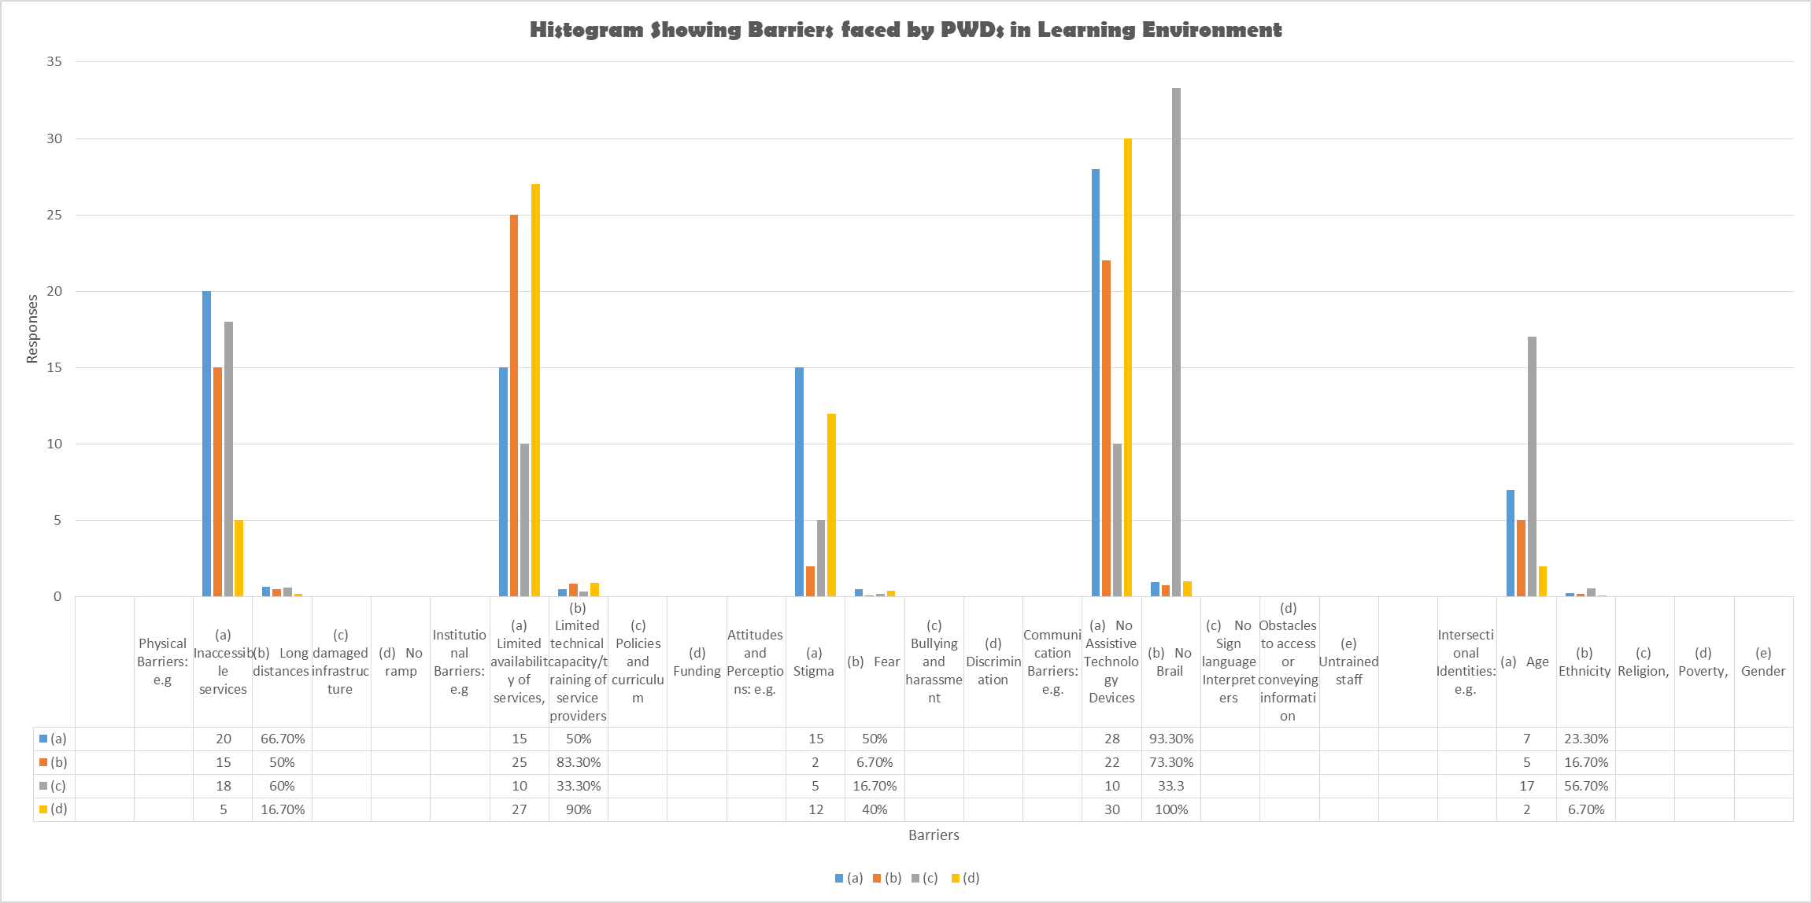
Figure 2.5. Histogram Analyzing the Barriers faced by Persons with Disabilities in Learning Environment
2.2.1.6 Analysis of Hierarchy of the Structures and Systems that Support Person with Disabilities in Learning Environment (FCT)
Here we present the analyzed data regarding ranges of support systems particularly available for learners with disabilities in learning environment. From the 20 responses received in this regard, the tabled analysis is evident as showed in table 2.7 below:

Table 2.5. Hierarchy of Structures that Support Person with Disabilities in Learning Environment (FCT)
S/N | SUPPORT AREA | TICKED BY RESPONDENTS  (UA STUDENTS)
1 | School Governing Body | None
2 | Traditional/Religious Entities | None
3 | Counselling Learning Support Specialist (Remedial Teacher) | None
4 | - Career Advisor | - Respondents  (100% of 20)
5 | - Parents | - Respondents  (100% of 20)
6 | - JONAPWD | - Respondents  (100% of 20)
7 | - Disability Commission | - Respondents  (70% of 20)
8 | - Co-students | 20 Respondents  (100% of 20)
 | Other (please specify) | None

From Table 2.5, all the respondents selected the following hierarchical structure: career advisor, parents, JONAPWD, disability commission and co-students respectively. This section only applies to learners with disabilities.
Figure 2.5 indicates the hierarchical of support structures of learning environment selected by 20 respondents from learners with disabilities. From the figure, 100% of the respondents selected career advisor, parents, JONAPWD and disability commission respectively as the most preferable areas that Person with Disabilities needs more support in the learning environment.
Figure 2.5. Hierarchy of Support Structures of Learning Environment for Person with Disabilities

2.2.1.7 Summary Analysis of the Responses of Specific Questions to Learners with Disabilities in all the States and the FCT
Table 2.6 presents the analysis of the responses of specific questions to learners with disabilities (students). The questions were administered to students from UA.
Table 2.6 Analysis of Respondents of Specific Questions to Learners with Disabilities (20 Students) in the FCT
S/N | SPECIFIC QUESTIONS TO LEARNERS WITH DISABILITIES | Highlights from triangulated RESPONSES
1 | What are the problems you face in school?  (Interrogate on design co-learners, curriculum, develop assessment systems, teachers, staff and physical facilities, and formulate and adapt operation policies etc)? | - For learners with physical impairments  Inadequate ramps/ramps that are below standards; predominant lack of electronic lifts; inadequate tiled roads to classes; uncleared pathways;  - Blind or partially sighted students  Lack of: Training in Orientation and Mobility (O/M); Braille Reading and Writing; use of computer with Job Access with Speech (JAWS); braille embosser; Closeness to the writing board; low vision aids and  Devices and others; additional time when reading braille materials  - Deaf students or Student who are Hard of Hearing  Lack of: Training in Sign Language for educators /provision of the services of SLIs; Funding for hearing aids; Caption services and others  - Female learners with disabilities  Besides cross cutting barriers, female learners with disabilities are often faced with high level of attitudinal barriers/show of pity especially from co-student; some level of emotion torture which are great rooted in safeguarding elements;  The following categories of learners were not identified at UA but the following responses were similarly deduced from responses:  - Learners with deafblindness: Lack of tactile interpretation; and Unattended sensory breaks  - People with mental or psychosocial disabilities/People with autism/People with intellectual disability/ People with a conative impairment: Lack of sensory breaks, Note-taking Assistants, Test-taking Accommodations; Simplified directions and information, Overcrowded classes  - Learners with albinism: Large Print, Copying, or Reading Text  - Learners with short stature/little people: Elevated services  - Learners affected by leprosy: Cultural stigma and prejudices  On a broad scale, all learners with disabilities agreed to be faced with generic barriers ranging from attitudinal disposition from co-learners and teachers, curriculum and operation policies that are non-sensitive to reasonable accommodation requirements; elongated classes; irresponsive water, sanitation and hygiene services (WASH); inaccessible hotel standards;
2 | Do you think the government is doing enough to support your parents to advance your right to education? | No (All 20 respondents)
3 | How do you expect government/your school to help learners with disabilities get education easily? - What would enable you to access school in an equal matter? | According to learners with disabilities, government should:  - Increase scholarship schemes for all learners with disabilities irrespective of the demography  - Provide adequate funding to learning institutions for necessary modifications and adjustments to address structural, institutional and communication barriers  - Engage private sector services to provides assistive devices where needed
4 | How are your relationships with your co-learners? Segregated, Integrated, Inclusive | On a broad scale, respondents’ relationships with co-learners are:  - Cordial with very few co-learners and segregated with many  - Integrated when learning together but with unequal opportunities to learn optimally
5 | Is there funding for your student supports (scholarships, loans, etc.?  Have you been able to access any? If yes, what the process of accessing it challenging or otherwise? | According to students with disabilities, there were:  - No adequate funding  - They have no access to loan or scholarship. Information process to be informed in this regard is same for all students hence decisions about such services and supports are not particularly different for students with disabilities
6 | Do you experience any form of attitude that promotes any form of abuse, exploitation or exclusion at school? | Yes; Mostly systemic and institutional
7 | Are there specific coping strategies employed by you to address barriers faced at school? If so, what are they, and how can they be supported or strengthened? Who facilitated it | Yes;  What are they: Sharing experiences with study-mates, religious mates, families, hostel mates; involving in sporting and entertainment exercises; engrossed with solitary studying  How can they be supported? Creating safes for learners with disabilities/networks of learners with disabilities; articulating disability discussions during mainstream student orientation exercises; sensitizing educators and school administrators on disability issues  Who facilitates: Study-mates; Room/Hostel mates; Religious bodies;
8 | Is there any form of remote and/or home-based learning initiatives with close engagement of focused support to enable you to catch up, prevent drop-out and/or re-enroll in formal education? | Yes; Support from co-learners; Very few lecturers

Figure 2.6 presents the analysis of the responses to the questions specifically developed for learners with disabilities (students). The data used in plotting was collated from the respondents from FCT.

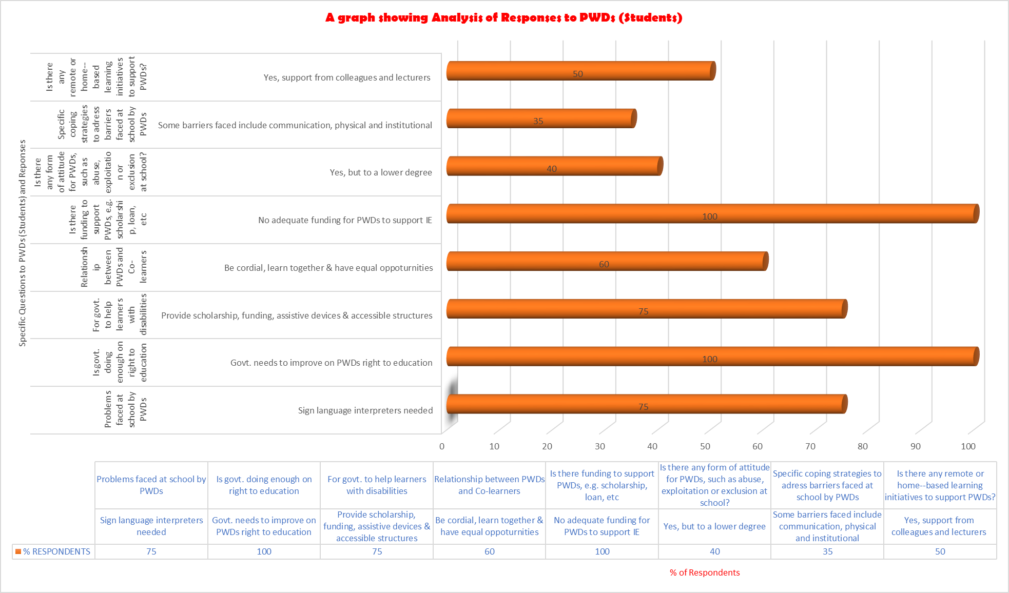
Figure 2.6. A Chart Showing Specific Responses by Person with Disabilities (UA Students, Abuja)

2.2.2 ANALYSIS OF NON-NUMERICAL (TEXT) DATA FOR PEA ON IE IN THE FCT
This section presents the text data collated from the other stakeholders in all states and the FCT such as MOE, MOF, NUC, admin UA and JONAPWD FCT Lead/Cluster Heads.
2.2.2.1 Triangulated Responses for JONAPWD Lead/ Cluster Heads/MoE/UA/MoF/Learners/Education Institutions
Table 2.6 presents the data on the responses to the questions administered to respondents on the implementations of policies of Inclusive Education.

Table 2.7 Data Presentation on the Responses of Questions
S/N | Question | Triangulated Responses
1 | What is the context of education for persons with disabilities in the state (s)?  (Interrogate on design curriculum, develop assessment systems, teachers, staff and physical facilities, and formulate and adapt operation policies etc)? |  | Policy: Policy on SNE exist in FCT but there is no approved IE policy. JONAPWD has been part of conversations on both policies. A draft policy on IE however exists for adoption.  There are very few existing policies guiding school administrations on the provisions with inclusive education  Procedure for design these policies are usually not exercised in participatory mode with affected stakeholders, especially across the representation of different clusters of disabilities and their parents  Monitoring and evaluation exercise of the implementation process of existing education policies are usually not assessed in collaborations with persons with disabilities  Curriculum: Existing curriculums in mainstream institutions are generally not appropriate to fully address the needs of learners with disabilities across their diversity  Academic/Non-academic Staff: Most teacher training courses are predominantly trainings on SNE models which are segregative in designs and not to practically advance skill-sets which deal with the diversity in classrooms and be equipped with relevant teaching, and learning competencies and strategies to meet inclusive education designs.  Physical facilities: There are more primary and secondary environment with construction of physically and environmentally accessible designs. At tertiary levels, a lot of actions need to be taking in terms of modifications of existing schools to be made accessible  Enrollment: Very poor for learners with disabilities due to physical, institutional and communication barriers
2 | What do you think about the progress of Inclusive Education Vis-à-vis Special Needs Education? | Parents: Not very inclusive with current implementation system. At times, there are forms of discriminations manifesting as distinctions  JONAPWD/Cluster Heads: SNE is largely adopted and misplaced as appropriate design for learners with disabilities  NCPWD: Having adequate funding to implement already finalized policy will better ensure the progress better, especially given the already exiting SNE facilities  MoE: The Ministry of Education is preparing to conduct the assessment of schools that are inclusive as soon as the 2023 budget is released.  MoF: There are no separate policy guiding the enforcement of budget provision the education of persons with disabilities at all stages. All categories of funding are cross cutting.  Additionally, we MoF do not look at the budget as inclusive. The Universities doesn’t give it priority.  Learners with Disabilities: Not practicable given the current education systems. Polices do not recognize the disability needs, systems are not equipped enough to address communication and physical barriers and there is huge funding gap in funding requirement for IE  SNE is a system deeply rooted in practice when government plans to fulfill the education rights of person with disabilities in Nigeria
3 | What are the means you employ to collate data on rates of enrolments of Person with Disabilities in relations to education (primary, secondary, tertiary educational institutions, vocational training, lifelong learning courses, as compared to others, disaggregated by sex, age, disability, minority or indigenous background, grade and level of education)? The progress of Inclusive Education Vis-à-vis Special Needs Education? | Parents: Not sure of any  JONAPWD: None is passing years but JONAPWD National is at preparatory stage to begin data collation in this regard, with supports from relevant government agencies and partners  NCPWD: Working with relevant partners to better articulate the data across the states  MoE: The Ministry doesn’t have the data of Person with Disabilities but may, when need collate it through schools.  MoF: Nigerian Bureau of Statistics  Institutions/Learners: Enrollment forms
4 | What are the methods of awareness raising campaigns and activities employed to promote inclusive education (Please insert whether: government, students, education staff, families and the general public of the duty to provide, and the right to inclusive education and related benefits for society)? | JONAPWD: Advocacy actions, social and traditional medias, professional gatherings (local, regional and international)  NCPWD: Work through all partners and platforms  Ministry: No any kind of awareness unless during the Disability Day (i.e., 3rd December)  MoF: No any form of awareness but if the NCPWD request we provides the fund  Learners: Through friends and colleagues
5 | How is the budget allocated to ensure the right of Person with Disabilities to inclusive education in mainstream settings, as compared to budget allocated to segregated/separated education settings, whether in mainstream or special schools? | MoE: No exclusive budget specifically for IE unless the budget on education generally. Although it covers elements of IE, funding for person with disabilities are largely skewed in the directions of SNE models but not adequate.  Some listed funding sources are The Tertiary Education Trust Fund (TETFund), Universal Basic Education Commission (UBEC), International Agencies and Development Partners, Private Actors  MoF: Nothing has been done to ensure budget are responsive to IE needs but MoF is ready to provide the fund is it tallies with strategic mandate  NCPWD: Through annual education budget with negotiations for education rights for person with disabilities (adjustments and modifications negotiated as well). UBEC, TETFUND and other relevant partners are also engaged for supports in order to address gaps  Parents/Learners: No consulted on budgetary provisions by the government
6 | What are the consultation processes undertaken to ensure the active involvement of Person with Disabilities, notably parents of children with disabilities, including through their representative organizations, in the design, implementation and monitoring of laws, regulations, policies and programmes, related to education initiatives and reform? | Parent: Very low  JONAPWD: Inadequate  MoE: Adequate. Through invitations to JONAPWD  MoF: No
7 | What proportion of received complains on the right to education alleging discrimination on the basis of disability and/or involving children, youth and adults with disabilities that have been investigated and adjudicated? How have they been addressed? | Parent: Complains are channeled to the school authority and through JONAPWD  JONAPWD: Complains are received from students and their parents. These complains are either address directly with the school administrations or escalated to the NCPWD for joint actions  NWPWD: Complains are received and escalated for actions through relevant government systems. If this has to do with any kind of violence or violations, NWPWD takes this very serious and sometimes apply legal alternatives  MoE: The Ministry does not handle such issues because they are neither the National Commission for Persons with Disabilities or any law enforcement Agency.
8 | Have you ever purposely visited any of the learning institutions belonging to either Federal or State government or private in your state to witness the implementation of policies leading to equal education rights for persons with disabilities? If not, why? If yes, what were your findings? | JONAPWD: Yes, we embark on unstructured visits and witnessed that some school facilities are in compliance with provisions in the DAAD given the moratorium period of 5 years which ends in year 2024  NCPWD/MoE: Yes, we embark on planned visits and witnessed that some school facilities are in compliance with provisions in the DAAD given the moratorium period of 5 years which ends in year 2024  Parents: Advocacies/visits are done unitarily and not collectively  Learners: Through friends
9 | Does your Ministry/Agencies/Association/Cluster provide any forms of training of technical personnel “on managing inclusive education and delivering special needs education? | MoE/Parent/NUT/JONAPWD/NCPWD: There is training of teachers but not adequate.
10 | Are there any ongoing engagements with the private sector to support the education rights of Person with Disabilities? | Private/NUC/NCPWD: JONAPWD: Yes, by very few OPDs for awareness program but not coordinated or adequate
11 | Have your agencies/association procured or received any learning aid for Person with Disabilities in the past? | MoE/NCPWD: Yes, we procure but not to needed capacity  JONAPWD: Inadequate, due to lack of fund. But some organizations give learning aids to Persons with Disabilities through the MOE.  Parents/Learners: Mostly Self-funded

2.3 THEMATIC METHOD OF ANALYSIS FOR NON-NUMERICAL (TEXT) DATA COLLATED FROM FCT FOR PEA ANALYSIS FOR FCT
The following steps were strictly adhered in the analysis of non-numerical data collated for PEA in FCT:
Step 1: Familiarization of Collated Data from FCT: In this step, the responses of the administered questionnaires distributed to various stakeholders have been thoroughly read to have the general idea on the collated data.
Step 2: Coding of Non-numerical (Text) Collated Data from FCT: This includes highlighting or labelling certain words or group of words or even phrases in the data that all together indicates something that will grab the essence of the data. Table 2.13 present the coding of the non-numerical collated data from FCT on IE for PEA Analysis.

Table 2.8 Analysis and Coding of Non-numerical (Text) Data Collated for PEA on IE from focal State and the FCT
S/N | INTERVIEW  QUESTIONS | INTERVIEW  EXTRACT REPONSES BY VARIOUS RESPONDENTS | CODE(S)
 | GENERAL CONTEXT OF IE IN FOCAL STATES AND THE FCT
1 | What is the context of education for persons with disabilities in the state? (Interrogate on design curriculum, develop assessment systems, teachers, staff and physical facilities, and formulate and adapt operation policies etc)? | - The Federal government established NCPWD to ensure the rights of Persons with Disabilities  - No adequately trained teachers for IE  - The existing University curriculum doesn’t take care of disability requirements in FCT  - Most physical structures in UA are disability friendly  - The Universities curriculum may be reviewed through NUC to coopt IE requirements in General Studies (GS) courses | - Curriculum Review required  - No trained Staff on IE  - Not all structures are disability friendly around the institutions of FCT
 | INCLUSIVE EDUCATION VIS-À-VIS SPECIAL NEEDS EDUCATION
2 | What do you think about the progress of Inclusive Education Vis-à-vis Special Needs Education? | - The MoE is preparing for the Assessment of inclusive schools  - Strategic plans for the two (2), i.e. IE and SNE needs to be separated.  - The government is not to make all schools inclusive.  - Real knowledge on SNE or IE are majorly relatable with staff of MoE and JONAPWD. | - There are policies on SNE  - There is a draft policy on IE  - The Government established NCPWD for disability matters  - There very limited schools (usually privately owned, and operating at primary education level) inclusive schools around FCT
 | ENROLMENTS/DATA OF PERSON WITH DISABILITIES IN SCHOOLS_ABUA
3 | What are the means you employ to collate data on rates of enrolments of Person with Disabilities in relations to education (primary, secondary, tertiary educational institutions, vocational training, lifelong learning courses, as compared to others, disaggregated by sex, age, disability, minority or indigenous background, grade and level of education)? The progress of Inclusive Education Vis-à-vis Special Needs Education? | - Data may be collated through schools since MOE doesn’t have the data of Person with Disabilities  - Some stakeholders don’t have specific means data collation  - University admission forms provide space for the candidate to specify whether or not they are have any form of impairment | - No specific means of Data Collection unless through schools  - University admission forms provide space to be filled by Person with Disabilities. The coordination on this is very ineffective
 | METHODS OF PROMOTING INCLUSIVE EDUCATION_ABUJA
4 | What are the methods of awareness raising campaigns and activities employed to promote inclusive education (Please insert whether: government, students, education staff, families and the general public of the duty to provide, and the right to inclusive education and related benefits for society)? | - No any kind of awareness unless during DISABILITY DAY (3rd December of every year)  - By partnership with Non-profit Organizations working on IE for advocacy | - The only awareness campaign holds during disability day (3rd day of every December)  - Other stakeholders’ partner with OPDs/OfPDs working on IE policies
 | BUDGET ALLOCATION TO INCLUSIVE EDUCATION_ABUJA
5 | How is the budget allocated to ensure the right of Person with Disabilities to inclusive education in mainstream settings, as compared to budget allocated to segregated/separated education settings, whether in mainstream or special schools? | - No exclusive budget specifically for IE, unless the general budget to cover SNE, but also not adequate  - Nothing has been done to ensure budget SNE implementation budget mainstreams IE,  - Other Stakeholders such MoF are ready to provide funding for IE if requested  - NUC has discussed with MoE to improve on funding for the purpose of IE. There is plan for scholarship to Persons with Disabilities.  - University budget specifies nothing on IE  - The MoE is planning to prepare the budget and assessment of schools based on needs  - The MoF doesn’t look at the budget from the disability inclusive lens  - The fund may be granted by MoF upon the request by NCPWD  - Many institutions complain on funding as barrier in implementing principles of IE  - UBEC and TETFUND fundings are structured towards SNE | - No exclusive budget allocations for IE unless the general budget for education  - NUC has had a roundtable discussion on the improvement on funding for IE  - MoE is preparing for budget and assessment of schools based on needs  - Funds may be granted by MoF upon request NCPWD
 | CONSULTATIONS AND MONITORING/IMPLEMENTATION OF LAWS & IE POLICIES IN FCT
6 | What are the consultation processes undertaken to ensure the active involvement of Person with Disabilities, notably parents of children with disabilities, including through their representative organizations, in the design, implementation and monitoring of laws, regulations, policies and programmes, related to education initiatives and reform? | - Parents of Person with Disabilities are advised to send their children to schools, as basic education is free at primary level  - Scholarship for all students exist at university level  - No any form of consultation by MoF  - No consultation employed by Institutions with parents of Person with Disabilities  - NCPWD are not specific about having parents decide programmes | - In general terms, no formal consultations with Parents of Persons with Disabilities regarding policy and program designs, implementation and monitoring
 | COMPLAINTS ON DISCRIMINATION FOR PERSON WITH DISABILITIES
7 | What proportion of received complaints on the right to education alleging discrimination on the basis of disability and/or involving children, youth and adults with disabilities that have been investigated and adjudicated? How have they been addressed? | - Learners with Disabilities are offered admissions in the University, but very few in number.  - Particular cluster of disabilities (e.g Leprosy, DeafBlindeness, Autism, Intellectual, etc) are usually denied or restricted from gaining admission into tertiary institutions  - Learners with physical disabilities (especially persons affected by Polio) are most represented in tertiary institution due to their disability access needs, which are considered manageable  - There may be cases of discrimination for Person with Disabilities in the institution (UA) but not reported to the University Authority  - UA teaches a course that highlight on awareness creation between Persons with Disabilities and how to interact with them their colleagues | - There may be cases alleging discrimination for Learners with Disabilities but not officially reported  - Leaners with disabilities due not understand their rights from a Rights-Based Based perspective
 | COURTESY VISIT TO INSTITUTIONS LEADING TO IMPLEMENTATIONS OF IE POLICIES
8 | Have you ever purposely visited any of the learning institutions belonging to either Federal or State government or private in your state to witness the implementation of policies leading to equal education rights for person with disabilities? If not, why? If yes, what were your findings? | - Most management of institutions (mainstream tertiary and primary) do not have understanding on IE hence no policy and implementation plan  - MoE is working to ensure accessibility to structures for Persons with Disabilities  - No appropriate or adequate reasonable accommodation provision or assertive devices (Sign Language Interpreters, Large Prints, Captions, Braille book etc.) in most lecture halls  - TETFUND currently ensure that new buildings should be disability compliant  - No policy guiding the enforcement of the budget provision for IE  - Most SNE facilities are grossly under resourced in terms of human and assertive facilities needed | There are strong institutional and communication barriers for learners with disabilities across their diversities in current learning institutions (primary to tertiary)
 | COURTESY VISIT TO AGENCIES FOR DISABILITY MATTERS/BOARDS/NCPWD
9 | Have you ever visited any of the relevant Agencies/Boards and Parastatals, National Commission for Persons with Disabilities and/or State Agencies for Disability Matters for details implementations of equal rights for Person with Disabilities? Please explain? | - Some stakeholders paid visits to institutions/agencies and relevant boards e.g. inclusive schools in Kuje and Gwagwalada  - NUC has visited TETFUND on tertiary education matters  - NCPWD receive partners, OPDs, OfPDs on education right matters  - NCPWD has visited MoE and other government agencies on scholarship agenda for learners with disabilities | Consultations and advocacy matters are growing o education rights of person with disabilities in the country
 | TRAINING OF TECHNICAL PERSONNELS BY MINISTRIES/AGENCIES
10 | Does your Ministry/Agencies/Association/Cluster provide any forms of training of technical personnel “on managing inclusive education and delivering special needs education? | - There are specialize trainings for educators on education policies and programmes but not intensively on provisions of Salamanca, UNCRPD, SDGs  - Teachers trained on SNE are currently very few but mostly engaged at SNE learning facilities  - Teachers trained on SNE are potentially with capacities to take in trainings on the provision of Salamanca, CRPD 24 and SDG 4 | No record of Intensive Training of Teachers on IE
 | ENGAGEMENT OF PRIVATE SECTORS/PARTNERS
11 | Are there any ongoing engagements with the private sector to support the education rights of Person with Disabilities? | - Some stakeholders engaged NGOs for awareness program  - Few stakeholders have engagement with private sector actors, but mostly on mainstream scholarship or medical payment related issues  - Most stakeholders do not engage private sectors or make partnership to implement IE policies  - Corporate Social Responsibility (CSR) of Private sector actors are mostly never aligned with IE models for learners with disabilities. CSR are mostly channeled for Non-food Item, Food items and other mainstream scholarship matters | Record of engagement with private sectors, on IE related issues are very limited
 | PROVISIONS OF LEARNING AIDS TO Person with Disabilities
12 | Have your agencies/association procured or received any learning aid for Person with Disabilities in the past? | - Provision of assistive technology devices are distributed to SNE facilities  - Procurement of learning aids for learners with Disabilities are usually procured by PPWDs. Hence appropriate supports in learning are borne by the parents  - NCPWD has braille machines to convert books to braille, which is very inadequate to service the community | There is no adequate learning Aids/Assistive Devices, e.g. braille machines at existing SNE facilities

2.B ANALYSIS OF PEA RESULTS ON INCLUSIVE EDUCATION FROM KADUNA STATE

2.5 POLITICAL CONTEXT OF IE FOR KADUNA STATE
In order to ensure the rights of Persons with Disabilities, the Kaduna State government has created Disability Affairs Board (DAB) to be in charge of the welfare and rights of all Person with Disabilities around the State.

2.6 ANALYSIS OF NUMERICAL DATA FOR PEA ON IE IN KADUNA STATE
This section presents the numerical data presentation and PEA analysis on IE from Kaduna State in the North West geopolitical zone of the Federation.
    - Numerical Data Presentation and PEA Analysis on IE for Kaduna State: The numerical data was collated from Kaduna State was from the following categories of respondents, viz;, government, learning institution, i.e. Kaduna State University (KASU), learners with disabilities (KASU students), JONAPWD Kaduna Lead/Cluster Heads in the State, parents of persons with disabilities (Parent of Persons with Disabilities) in the State, tradition and religious (T_R) leaders in the State as well as the private sectors.
    - Data Analysis by Category of Respondents from Kaduna State: Table 2.16 presents the collated data by categories of respondents. For the purpose of data collection 30 persons including those with and without disabilities were interviewed across the different stakeholders involved in the PEA analysis on IE in the State. Detail of the categories of respondents considered in Kaduna State were presented in Table 2.15 and these include KASU staff and students, private sector, parents of persons with disabilities (PPWD), Representation from government sector such as Disability Affairs Board (DAB) Kaduna State, Planning and Budget Commission (PBC) Kaduna State, Private sectors such as Thifix Foundation Kaduna (TFK), Citizen Co-Chair Kaduna (CCCK) & Partnership to Engage Reform and Learn (PERL), Bureau of Statistics (BOS) Kaduna State and JONAPWD Kaduna Lead/Cluster Heads in the State.

Table 2.9 presents a histogram indicating categories and number of respondents from Kaduna State on the basis of gender.

Table 2.9 Distribution of Questionnaire by Category of Respondents (Kaduna State)
Gender | KASU  Students | Kaduna State  Government |  |  | PPWD  Kaduna | T_R  Leaders |  |  | Learning Institution  (KASU) |  |  | JONAPWD Lead Kaduna/  Cluster Heads |  | Private  Sector
Gender | KASU  Students | DAB | PBC | BOS | PPWD  Kaduna | JNI | CAN | DHD | DSA  KASU | AS  KASU | SUG  KASU | JSL  Kaduna | ACH  Kaduna | CALPED | PERL | CCCK | TFK
Male | 12 | 1 | 1 | 1 | 0 | 1 | 1 | 1 | 1 | 1 | 1 | 1 | 1 | 1 | 1 | 0 | 1
Female | 3 | 0 | 0 | 0 | 1 | 0 | 0 | 0 | 0 | 0 | 0 | 0 | 0 | 0 | 0 | 1 | 0
Total | 15 | 3 |  |  | 1 | 3 |  |  | 3 |  |  | 2 |  | 1 | 4

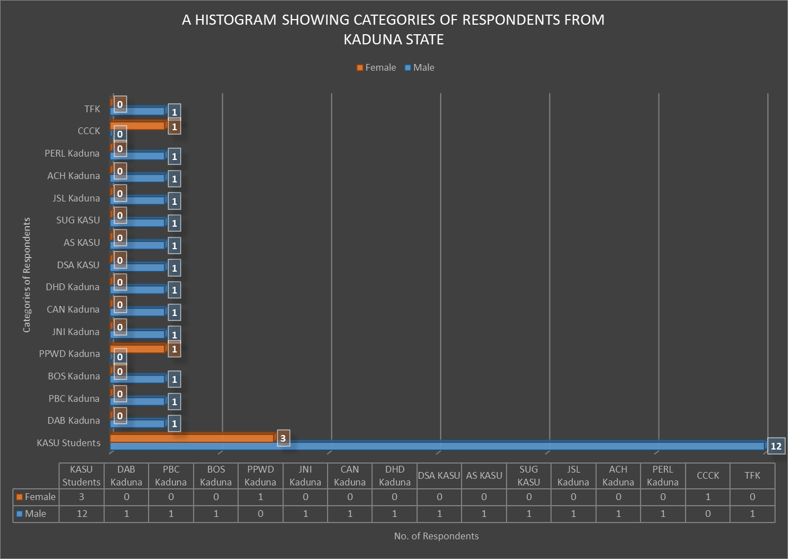
Figure 2.7. A Histogram Showing Categories of Respondents Based on Gender for Kaduna State

From both Table 2.9 and Figure 2.7, seven (7) categories of respondents participated in the exercise, which comprises of sixteen (16) stakeholders and total number of 30 interviewed persons. From Table 2.9 and Figure 2.7, 25 of the interviewed persons were male and 2 are females. Considering for instance, the student’s category, out of the 15 students interviewed, only 3 are females. This may be due to the fact that, more male Person with Disabilities attends school than female in the State.

Figures 2.8a and 2.8b shows a pie chart for male and female respondents in Kaduna State with the corresponding number of participants in percentage.

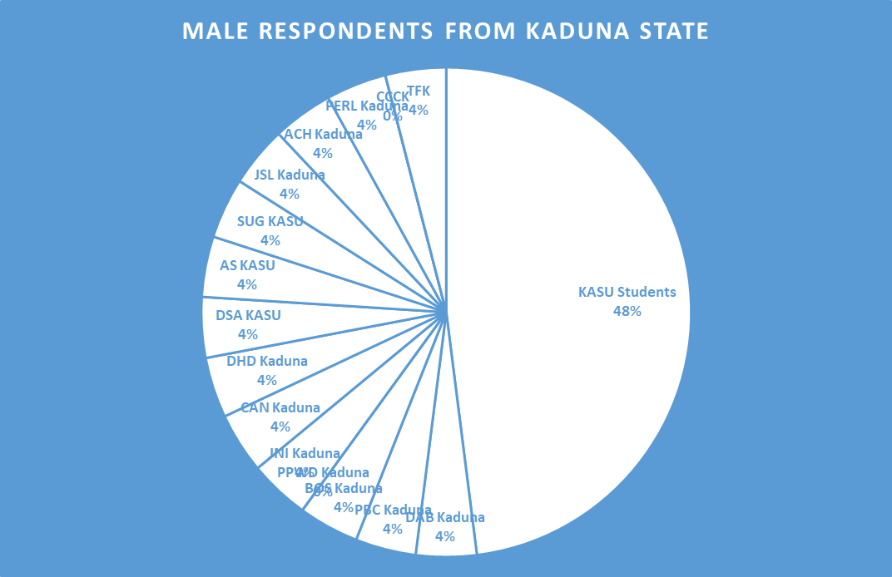
Figure 2.8a. Pie Chart Showing Number of Male Respondents (%) for Kaduna State

Figure 2.8b. Pie Chart Showing Number of Female Respondents (%) for Kaduna State

2.6.3 Analysis Socio-Demographic Information of Respondents from Kaduna State
Table 2.10 presents the socio-demographic information of the respondents from Kaduna State in the North Western part of Nigeria. Column 2 of Table 2.16 indicated the ranges of age of respondents from this geopolitical zone and columns 3 and 4 indicated the number of respondents and their corresponding percentages based on the range of ages respectively. Majority of the respondents are between the age of 18 and 25 years and are predominantly students with disabilities. Only 2 out of the 30 respondents are above 60 years.

Table 2.1 Analysis of Socio-demographic information of the respondents from Kaduna State
S/N | AGE OF  RESPONDENT  (years) | NO. OF  RESPONDENTS | RESPONDENTS No.  (%)
1 | 18 – 25 | 10 | 33.3
2 | 25 – 40 | 8 | 26.7
3 | 40 – 65 | 10 | 33.3
4 | 65 and above | 2 | 6.7
 | Total | 30 | 100

Figure 2.9. presents the socio-demographic information of respondents from Kaduna State indicating their ranges of age (years) as well the number of persons participated in the interview. From both Table 2.8 and Figure 2.9, 33.3% of the respondents from Kaduna State are in the age range of 18 – 25 and 40 – 65 years of age, and 26.7% ranged between 25 and 40 years and 2 out of 30 respondents (6.7%) were interviewed.

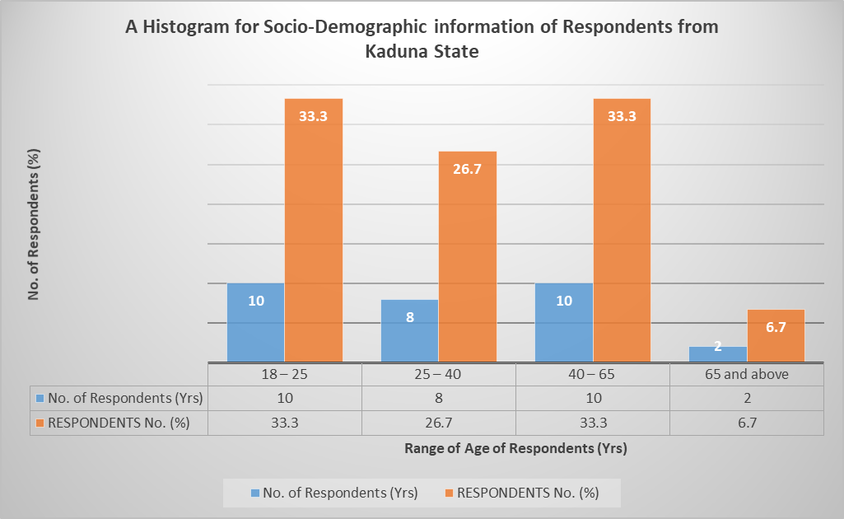
Figure 2.9. Socio-Demographic Information of Respondents Indicating Age Range (Kaduna State)

2.6.4 Data Analysis of Respondents Based on Disability (Kaduna State)
Table 2.11 presents categories of respondents from Kaduna State on the basis of disability and the number of respondents interviewed from each category. From the Table, 14 out of the 30 respondents doesn’t have any kind of impairment and this number come from the categories of other stakeholders such as PPWD, T_R leaders, KASU staff, functionaries of the State government and private sector.

Table 2.11. Category of Respondents on the Basis of Disability (Kaduna State)
S/N | DISABILITY | NO. OF RESPONDENT | RESPONDENTS NO.  (%)
1 | Physical (P) | 4 | 13.3
2 | Blind (B) | 5 | 16.7
3 | Leprosy/IDEA (L) | 0 | 0
4 | Albinism (Al) | 1 | 3.3
5 | Spinal cord injury (SCIAN) | 3 | 10.0
6 | Deaf (D) | 3 | 10.0
7 | Deaf/Blind (DB) | 0 | 0
8 | Psychosocial (Psy) | 0 | 0
9 | Mental (M) | 0 | 0
10 | None (N) | 14 | 46.7
 | Total | 30 | 100

Figure 2.10. presents a histogram indicating the categories of respondents who participated in the interview exercise on the basis of disability. From the figure, for instance, the respondents without disability are six (6) out 30 with the corresponding percentage of 20. None of the respondents interviewed were found to be mental, deaf/blind or affected by leprosy.
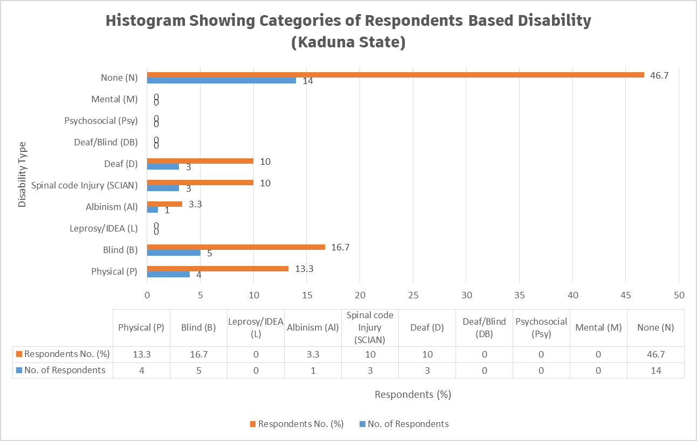
Figure 2.10. Categories of Respondents on the Basis of Disability (Kaduna State)

2.6.5 Data Analysis on General Questions on Education Rights of Persons with Disabilities (Kaduna State)
Table 2.12 presents the data analysis of the general questions on Inclusive Education vis-à-vis special needs education to the respondents who participated in the interview exercise in Kaduna State. In the Table, number of respondents and percentages of the statements 1 – 10 are indicated by the choices: Excellently Well, Well Enough, Partly Well and Not At All.

Table 2.12. Response to General Questions on Inclusive Education vis-à-vis Special Needs Education (Kaduna State)
S/N | STATEMENT | Responses and  No. of Respondents
S/N | STATEMENT | Excellently Well | Well Enough | Partly Well | Not at All
1 | How well do you understand the concept of inclusive education? | 1  (3.3% of 30) | 4  (13.3% of 30) | 23  (76.7% of 30) | 2  (6.7% of 30)
2 | How well do you understand the concept of Special Needs Education? | 2  (6.7% of 30) | 2  (6.7% of 30) | 24  (80% of 30) | 2  (6.7% of 30)
3 | How well do you understand the Nigerian Discrimination Against Persons with Disabilities Act? | 0  (0% of 30) | 5  (16.7% of 30) | 22  (73.3% of 30) | 3  (10% of 30)
4 | How well do you understand Goal 4 of the Sustainable Development Goals? | 0  (0% of 30) | 0  (3.3% of 30) | 4  (13.3% of 30) | 26  (86.7% of 30)
5 | How well do you understand Article 24 of the Convention on the Rights of Persons with Disabilities? | 0  (0% of 30) | 1  (3.3% of 30) | 2  (6.7% of 30) | 27  (90% of 30)
6 | How well do you know national policies and reforms on education in Nigeria? | 1  (3.3% of 30) | 2  (6.7% of 30) | 9  (30% of 30) | 18  (60% of 30)
7 | How well do you know national plan on education in Nigeria? | 1  (3.3% of 30) | 2  (6.7% of 30) | 5  (16.7% of 30) | 22  (73.3% of 30)
8 | How well do you understand the difference between Special Needs and Inclusive Education? | 3  (10% of 30) | 3  (10% of 30) | 7  (23.3% of 30) | 17  (56.7% of 30)
9 | How well do you think learners with disabilities and without disabilities can co-learn? | 2  (6.7% of 30) | 6  (20% of 30) | 21  (70% of 30) | 1  (3.3% of 30)
10 | How well do you know the Salamanca Statement and framework for action on special needs education? | 0  (0% of 30) | 0  (0% of 30) | 0  (0% of 30) | 30  (100% of 30)

Table 2.9 shows the summary of the responses (%) to the general questions to the respondents who participated in the interview exercise in Kaduna State. The Table 2.20 is summary of Table 2.19 above for easy analysis and plotting.

Table 2.12. Responses (%) on the General Concepts of IE vis-a-via SNE (Kaduna State)
STATEMENT | Response:  Excellently Well | Response:  Well Enough | Response:  Partly Well | Response:  Not At All
Statement 1 | 3.3% | 13.3% | 76.7% | 6.7%
Statement 2 | 6.7% | 6.7% | 80% | 6.7%
Statement 3 | 0% | 16.7% | 73.3% | 10%
Statement 4 | 0% | 3.3% | 13.3% | 86.7%
Statement 5 | 0% | 3.3% | 6.7% | 90%
Statement 6 | 3.3% | 6.7% | 30% | 60%
Statement 7 | 3.3% | 6.7% | 16.7% | 73.3%
Statement 8 | 10% | 10% | 23.3% | 56.7%
Statement 9 | 6.7% | 20% | 70% | 3.3%
Statement 10 | 0% | 0% | 0% | 100%

Figure 2.11 presents the responses by the respondents (%) from Kaduna State on the general concept of Inclusive Education vis-à-vis Special needs education. From this figure, about 76.7% of the respondents partially understand statement 1 which is referring to the general concepts of IE and none of the respondents knew the Salamanca statement and framework of action on special needs action which indicated 100% of the respondents stated that they don’t have idea on the scenario.

Figure 2.11. Responses on General Concepts of IE Vs SNE (Kaduna State)
2.6.6 Analysis of Barriers faced by Person with Disabilities in Learning Environment (Kaduna State)
Table 2.12 presents the Analysis of barriers faced by Person with Disabilities in learning environment around Kaduna State. Each barrier was classified (a) to (e). From the Table, each option selected by the respondents has been ticked in their respective columns. In this case also, thirty (30) respondents from Kaduna State and from learners with disabilities and other stakeholders in the State.
Table 2.12. Analysis of barriers faced by Person with Disabilities in Learning Environment

(Kaduna State)
S/N | BARRIERS | (a) | (b) | (c) | (d) | (e)
1 | Physical Barriers: e.g  - Inaccessible services  - Long distances  - damaged infrastructure  - No ramp | 30  (100% of 30) | 30  (100% of 30) | 30  (100% of 30) | 30  (100% of 30)
2 | Institutional Barriers: e.g  - Limited availability of services,  - Limited technical capacity/training of service providers  - Policies and curriculum  - Funding | 30  (100% of 30) | 30  (100% of 30) | 30  (100% of 30) | 30  (100% of 30)
3 | Attitudes and Perceptions: e.g.  - Stigma  - Fear  - Bullying and harassment  - Discrimination | 28  (93.3% of 30) | 27  (90% of 30) | 26  (86.7% of 30) | 27  (90% of 30)
4 | Communication Barriers: e.g.  - No Assistive Technology Devices  - No Brail  - No Sign language Interpreters  - Obstacles to access or conveying information  - Untrained staff | 30  (100% of 30) | 30  (100% of 30) | 30  (100% of 30) | 27  (90% of 30) | 30  (100% of 30)
5 | Intersectional Identities: e.g.  - Age  - Ethnicity  - Religion,  - Poverty,  - Gender | 28  (93.3% of 30) | 26  (86.7% of 30) | 30  (100% of 30) | 25  (83.3% of 30) | 0  (0% of 30)

Figure 2.12 present the histogram on data analysis with regard to the barriers faced by Persons with Disabilities in learning environment around Kaduna State. We have 30 respondents in this section who participated in the interview. Some of the respondents identified all the barriers from (a) to (e), and some respondents identified some barriers and silent on the others. From both Table 2.21 and Figure 2.13, for instance, the communication barrier; 100% of the respondents (30 No,) ticked option (a) as a barrier faced by Person with Disabilities in their learning environment, i.e lack of assistive technology devices. Therefore, for communication barrier, 100%, 100%, 100%, 90% and 100% of the respondents involved in Kaduna PEA analysis respectively ticked lack of assistive technology devices, brails, sign language interpreters, obstacles to access or conveying information and untrained staff.

Figure 2.12. Histogram Analyzing the Barriers faced by Person with Disabilities in Learning Environment (Kaduna State)
2.6.8 Analysis of Hierarchy of the Structures that Support Person with Disabilities in Learning Environment (Kaduna State)
Table 2.23 presents the data analysis on the hierarchy of the structures that support Person with Disabilities in the learning environment for Kaduna PEA analysis on IE in the North Western part of Nigeria.

Table 2.13. Analysis Hierarchy of Structures that Support Person with Disabilities in Learning Environment (Kaduna State)
S/N | SUPPORT AREA | TICKED BY RESPONDENTS  (KASU STUDENTS)
1 | School Governing Body | - Respondents  (66.7% of 15)
2 | Traditional/Religious Entities | Respondents  (53.3% of 15)
3 | Counselling Learning Support Specialist (Remedial Teacher) | - Respondents  (46.7% of 15)
4 | Career Advisor | - Respondents  (66.7% of 15)
5 | Parents | - Respondents  (100% of 15)
6 | JONAPWD | - Respondents  (100% of 15)
7 | Disability Commission | - Respondents  (100% of 15)
8 | Co-students | - Respondents  (80% of 15)
9 | Other (please specify) | 0  (0% of 15)

From Table 2.13, for instance, 66.7% (10 No. out 15 students) of the respondents ticked governing body as a hierarchical structure that support Person with Disabilities around Kaduna State, 100% of the respondents each ticked parents, JONAPWD, and disability commission as the most preferable areas that Person with Disabilities needs more support in the learning environment.

2.6.9 ANALYSIS OF NON-NUMERICAL (TEXT) DATA FOR PEA ON IE FOR KADUNA STATE
The data collated is categorized as numerical or non-numerical for the purpose of analysis. This section presents the non-numerical (text) data collated from the various stakeholders in Kaduna State such as administrators of learning institutions; KASU in this case, government, Parent of Persons with Disabilities, JONAPWD Kaduna Lead/Cluster Heads, T_R leaders in the State, etc.
2.6.9.1 ANALYSIS OF RESPONSES FOR JONAPWD KADUNA LEAD/CLUSTER HEADS /GOVERNMENT (DAB KADUNA STATE)

Table 2.14 presents the data on responses to the questions administered to respondents on the implementations of policies of IE.

Table 2.14. Data Presentation on the Responses to Questions for across Stakeholders in Kaduna
S/N | Question | SMoE | Responses from Disability Affairs Board | OPD (National Association of Persons with Physical Disabilities) | OfPD: Partnership to Engage Reform and Learn | Education Institute: Citizen Co-Chair Kaduna | Private Education Actor | JONAPWD | Education Institution (Tertiary)
1 | What is the context of education for persons with disabilities in the state? (Interrogate on design curriculum, develop assessment systems, teachers, staff and physical facilities, and formulate and adapt operation policies etc)? | The Kaduna State government has provided high budget on education but partnership between DAB and MOE will translate such issues | We are the stage of revising both Federal/State policies and develop inclusive curriculum that will everyone along | The Kaduna State government has shown high level of commitments by creating laws, policies and reforms | The Kaduna State government has IE policies but the challenge is the implementation | IE Policy implementation could be achieved with all relevant stakeholders | The Kaduna State educational policy highlighted IE at all levels only that teachers may hardly cater for the needs of Learners with Disabilities due to limited capacities and disability friendly environments  The disability community seems to be forgotten during planning and monitoring | From our engagements, The Kaduna state government has been highly interested IE, long before the passage of disability law | There exist IE policies in Kaduna, but implementation process have ben very unrealistic
2 | What do you think about the progress of Inclusive Education Vis-à-vis Special Needs Education? | Government needs to partner with critical stakeholders to engage with all stakeholders to transit from SNE models to IE | Much effort is needed to strengthen process in SNE. Implementing IE is still very idealistic | The government has done a lot but not adequate | Government is giving little effort to the issues of IE and more on SNE | The policy implementation is generally slow. As currently, some physical structures are inaccessible to Persons with Disabilities | There is little or no progress on IE but SNE significantly progressed as compared to IE | The government has for long gave more emphasis on SNE and little on IE | Policy implementations of SNE are ahead of IE in Kaduna
3 | What are the means you employ to collate data on rates of enrolments of Person with Disabilities in relations to education (primary, secondary, tertiary educational institutions, vocational training, lifelong learning courses, as compared to others, disaggregated by sex, age, disability, minority or indigenous background, grade and level of education)? The progress of Inclusive Education Vis-à-vis Special Needs Education? | The BOS in collaboration with MOE has the responsibilities of data collection through Annual School Census | From annual school census from BOS in collaboration with Kaduna State MOE | The BOS collects data through survey and annual approach by visiting schools to get primary data and also collects secondary data from MOE | Data on school census has never been disaggregated based on disability | Through annual school census and is not inclusively captured | You rarely find information about Person with Disabilities during Annual Schools Census | No specific data collection method but only from cluster heads from the list of their registered members | This is in the hands of DAB
4 | What are the methods of awareness raising campaigns and activities employed to promote inclusive education (Please insert whether: government, students, education staff, families and the general public of the duty to provide, and the right to inclusive education and related benefits for society)? | The MOE needs to do more to provide education for all | The awareness campaign is made through School Based Management Committee (SBMC) to call the attention of stakeholders | Such actions are being taken by MOE and JONAPWD | The Kaduna State government and Civil Society Organizations (CSOs) have made effort to sustain town hall meeting leading to awareness campaign | A lot has been done, e.g. through media, engagement with disability communities, development partners to facilitate private dialogue, town hall meeting, etc | - Media campaign is being used  - CSOs organized drama series to create awareness  Through social media | - By engagement of relevant stakeholders through advocacy visit and media | The government has Accountability Mechanism such as Kaduna Basic Education Accountability Mechanism (KADBEAM) and Local Government Accountability Mechanism (LGAM) that raise awareness campaign while JONAPWD has structures for step down training
5 | How is the budget allocated to ensure the right of Person with Disabilities to inclusive education in mainstream settings, as compared to budget allocated to segregated/separated education settings, whether in mainstream or special schools? | Stakeholders needs to be advocated for separate budget to effectively fund IE | The Executive Secretary of DAB doesn’t have the information of IE budget | Not familiar with the process of budget allocation | No special provision for IE | The only reliable fund that is purposely for IE is the one coming from Universal Basic Education Commission (UBEC) and is not adequate | The budget allocation is minimal, because the only budget is the one under MOHSASD | Currently the government doesn’t have specific budget for IE except that of Kaduna SUBEB which focused on primary schools | The organizations such as CALPED and partnership with PERL, Sight savers and Save the Children International (SCI) help to advance the capacity
6 | What are the consultation processes undertaken to ensure the active involvement of Person with Disabilities, notably parents of children with disabilities, including through their representative organizations, in the design, implementation and monitoring of laws, regulations, policies and programmes, related to education initiatives and reform? | The Kaduna State government instituted the Open Government Partnership (OGP) to join hands with all relevant stakeholders including Person with Disabilities in developing IE policies | Both children and Parent of Person with Disabilities have significant role to play but are ignorant of the laws and policies of IE | Not aware of this, but DAB will tell more | Consultations were made across the 23 LGAs in Kaduna State with relevant stakeholders | By Accountability mechanism and efforts from school management | Through NGOs especially development partners CALPED mobilizes Person with Disabilities to participate in the budget process through JONAPWD | - DAB engages Person with Disabilities to come up with initiatives that will enhance wellbeing of our community  - There is move to create a cluster under JONAPWD to Parent of Persons with Disabilities together | We have roundtable discussions, town hall meeting and engagement of CALPED, PERL and SCI
7 | What proportion of received complaints on the right to education alleging discrimination on the basis of disability and/or involving children, youth and adults with disabilities that have been investigated and adjudicated? How have they been addressed? | Not aware of such complaints | The complains on abuse are being received at tertiary institution despite the disability law that has been passed into law in the State | Not aware of this, but it is the responsibilities of Ministry of Human Service and Social Development (MOHSASD) and DAB | There are agencies and government centres to address such issues in Kaduna State | Reporting mechanism exist but largely unknown and perhaps ineffective | - The data is little, as such, no deliberate effort to open up complaints  JONAPWD called on CALPED and DAB to support them in some key areas to address such discriminations when reports are received | Lots of complaint have been tendered on denying especially persons with disabilities admission on the basis of disability | The management of school in Kaduna with over 34 students with albinism want to combine them into single on the basis of disability  Some parents withdrawn their children from school and take them to farm and the parents were threatened to be sued to court, then they bought them back to school
8 | Have you ever purposely visited any of the learning institutions belonging to either Federal or State government or private in your state to witness the implementation of policies leading to equal education rights for person with disabilities? If not, why? If yes, what were your findings? | Yes, but not all public structures are disability friendly | The ES of DAB paid visits to schools made commitments towards strengthening on SNE using inclusive models but with collective efforts by stakeholders | Courtesy visits have been paid to many public and private schools.  Only about 30% of them have ramps for access of Person with physical impairments | Many schools (Federal/State/Private) have been visited but a lot needs to be done to protect the rights of Person with Disabilities | Yes, some schools are inclusive and some are not | Yes, 95% of structures in the schools visited are not designed for Persons with Disabilities | Federal and state institutions have been visited to assess the level of accessibility to Persons with Disabilities but all the structures are not disability friendly in terms of accessibility demand | Yes, we do, but there are challenges of learning aids
9 | Have you ever visited any of the relevant Agencies/Boards and Parastatals, National Commission for Persons with Disabilities and/or State Agencies for Disability Matters for details implementations of equal rights for Person with Disabilities? Please explain? | Has not personally visited but engaged in advocacy for inclusiveness of Person with Disabilities | The ES of DAB visited NCPWD and State Universal Basic Education Board (SUBEB) to promote issues affecting Person with Disabilities | Yes | PERL supported the advocacy for the rights of Persons with Disabilities before the passage of disability law | Yes, Department for International Development (DFID), now Foreign Commonwealth and Development Office (FCDO) is doing great to ensure the rights of Person with Disabilities | MOE, SUBEC and DAB have been visited on some issues derived surveys | Always with DAB for support and advocacy | We visited Quality Assurance Unit of MOE and found that exam questions are printed with smaller font size that is difficult for students with low vision to access
10 | Does your Ministry/Agencies/Association/Cluster provide any forms of training of technical personnel “on managing inclusive education and delivering special needs education? | PBC only allocate budget to elements that concerns PBC | No training | No | No, but only work with CSOs | CCCK has a very strong support especially for Person with Disabilities | CALPED is not involved in training of personnel but only advocacy | Not at the moment but JONAPWD intends to kick-off trainings on disability inclusion for all stakeholders in education | Sensitization holds on Disability Days
11 | Are there any ongoing engagements with the private sector to support the education rights of Person with Disabilities? | No, at this moment | About to engage private sector | Yes, there are ongoing engagements | As development partners, training of personnel is not within thematic area of PERL | CCCK provides a lot of technical support to many organizations aiming to promote IE | Currently engaging IHIFIX Technology Foundation to provide digital skills for disability community | The disability law state that the issues of disabilities should be left in the hand of government | Yes, with private sectors
12 | Have your agencies/association procured or received any learning aid for Person with Disabilities in the past? | Not aware of such | The DAB received support from Sight Savers and SUBEB | No, at this moment | PERL does that | CCCK received learning materials from one of its partners and was distributed to Person with Disabilities | No | JONAPWD and other stakeholders are engaged as beneficiaries and first point of reference, on education programs for persons with disabilities in Kaduna State | Yes, through collaboration with other stakeholders

Table 2.15 presents the data on the responses to the questions administered to T_R Leaders (Religion: Islam_JNI Kaduna) on the implementations of policies of IE.
Table 2.15. Data Presentation on the Responses to the Questions for Religious Leader (Religion: Islam_JNI Kaduna) _KADUNA STATE
S/N | Question | Responses
1 | What is your perception about Person with Disabilities? | Religiously speaking, they are human being like us
2 | What do you think about IE? | IE address the problems of discrimination for Person with Disabilities
3 | What do you think about SNE? | SNE makes students happy but they are unaware of the future discrimination is could breed
4 | Have you been approached by any person/entity/ etc. concerning the education of someone with a disability? If yes, what kinds of supports did you offer? | JNI received philanthropy for support to Person with Disabilities
5 | Will your Organization do more to improve advocacy support for disability rights? | JNI promised to sustain awareness creation through media chat and religious engagement
6 | Any other comments? | Has made commitment to support advocacy campaign on IE

Table 2.16 presents the data on the responses to the questions administered to T_R Leaders (Religion: Christianity_CAN Kaduna) on the implementations of policies of IE.

Table 2.16. Data Presentation on the Responses to the Questions for Religious Leader (Religion: Christianity_CAN Kaduna)_KADUNA STATE
S/N | Question | Responses
1 | What is your perception about Person with Disabilities? | They are human beings like us, as such they need adequate care and total inclusiveness
2 | What do you think about IE? | IE is an educational system that is open for everyone irrespective of religion, ethnicity or disability
3 | What do you think about SNE? | SNE is an educational system that is designed for special needs or disabled children
4 | Have you been approached by any person/entity/ etc. concerning the education of someone with a disability? If yes, what kinds of supports did you offer? | Yes, we were approached by two students who find it difficult to apprehend where they were learning due to bullying, stigma and other communication barriers, as such, we supported the school by allowing one of our teachers to teach the students twice a week.
5 | Will your organization do more to improve advocacy support for disability rights? | Yes, if we have the opportunity, we will do more
6 | Any other comments? | If all stakeholders do the right thing, society will be a better place for all of us

Table 2.17 presents the data on the responses to the questions administered to T_R Leaders (Traditional Ruler: DHD Kaduna) on the implementations of policies of IE.

Table 2.17. Data Presentation on the Responses to the Questions for T_R Leader (Traditional Ruler: DHD Kaduna)_KADUNA STATE
S/N | Question | Responses
1 | What is your perception about Person with Disabilities? | Person with Disabilities can excel to any height if opportuned
2 | What do you think about IE? | IE is desirable because it brings about better understanding of peers and population
3 | What do you think about SNE? | SNE is an educational system that is designed for special needs or disabled children
4 | Have you been approached by any person/entity/ etc. concerning the education of someone with a disability? If yes, what kinds of supports did you offer? | Yes, Parent of Person with Disabilities consults traditional rulers for assistance
5 | Will your Organization do more to improve advocacy support for disability rights? | Yes, we will do more to ensure the rights and wellbeing of Person with Disabilities
6 | Any other comments? | All tiers of government and other relevant stakeholders should work together to provide budget line for Person with Disabilities

2.6.9.2 Analysis of Responses to Questions to Learning Institutions (KASU)
Table 2.18 presents the data on the responses to the questions administered to Learning Institutions (KASU) on the implementations of policies of IE. Questionnaire was administered to Dean of Students Affairs (DSA) Kaduna State University (KASU).
Table 2.18. Data Presentation on the Responses to Questions for Learning Institution (DSA KASU) _KADUNA STATE
S/N | Question | Responses
1 | What are the realities with learners and persons with disabilities in the institution? (Interrogate on design curriculum, develop assessment systems, teachers, staff and physical facilities, and formulate and adapt operation policies etc.)(ambiguous) | - No special provision for Person with Disabilities,  - No ramps or policy documents for now in KASU
2 | What are the means you employ to collate data on rates of enrolments of learners with disabilities in relation to their education? | - Such actions have not been taken from the Students’ Affairs Division; however, it is possible that the Director of Academic Planning might have a form to collect data
3 | Do your curriculum/ policies reflect disability requirements? Please explain | No
4 | Do you have a percentage for actualizing disability inclusion in your annual budget? If yes, what are the specified needs? | KASU doesn't have any
5 | What are the methods of awareness raising campaigns and activities employed to promote inclusive education (or education rights) and inform students and staff, and the general public of the duty to provide, and the right to inclusive education and related benefits for society? | None at this moment
6 | What are the consultation processes undertaken to ensure the active involvement of persons with disabilities, notably parents of children with disabilities, including through their representative organizations, in the design, implementation and monitoring of laws, regulations, policies and programmes, related to education initiatives and reform of the institution? | None at this moment
7 | What proportion of received complaints on the right to education alleging discrimination on the basis of disability and/or involving children, youth and adults with disabilities that have been investigated and adjudicated? How have they been addressed? | The school has not yet received such complains
8 | Have you ever engaged any association/agency/Department on the implementation of policies leading to equal education rights for persons with disabilities? If not, why? If yes, what were your findings? | No situation has warranted the school to discuss the issues of students with disabilities
9 | Are there ongoing any form of engagements with the private sector to support the educational rights of Person with Disabilities? Please enlist | None at this moment
10 | Does your Institution provide any forms of training of technical personnel “on managing inclusive education and delivering special needs education? Please elaborate | To the best of my knowledge, No
11 | Has your institution procured or received any learning aid for Person with Disabilities in the past? Please explain? | Not aware, but the University library might have received or HODs

Table 2.19 presents the data on the responses to the questions administered to Learning Institutions (AS KASU) on the implementations of policies of IE. Questionnaire was administered to Academic Staff KASU (AS KASU).
Table 2.19. Data Presentation on the Responses to Questions for Learning Institution (AS KASU)_KADUNA STATE
S/N | Question | Responses
1 | What are the realities with learners and persons with disabilities in the institution? (Interrogate on design curriculum, develop assessment systems, teachers, staff and physical facilities, and formulate and adapt operation policies etc.)(ambiguous) | None is available not even ramp
2 | What are the means you employ to collate data on rates of enrolments of learners with disabilities in relation to their education? | - From the collated from application form, few Person with Disabilities usually applies for admission because the structures on ground doesn’t support their learning
3 | Do your curriculum/ policies reflect disability requirements? Please explain | It does not reflect disability requirements
4 | Do you have a percentage for actualizing disability inclusion in your annual budget? If yes, what are the specified needs? | There is little or no awareness
5 | What are the methods of awareness raising campaigns and activities employed to promote inclusive education (or education rights) and inform students and staff, and the general public of the duty to provide, and the right to inclusive education and related benefits for society? | Even Parent of Persons with Disabilities doesn’t have confidence in the participation of the activities for education of their children
6 | What are the consultation processes undertaken to ensure the active involvement of persons with disabilities, notably parents of children with disabilities, including through their representative organizations, in the design, implementation and monitoring of laws, regulations, policies and programmes, related to education initiatives and reform of the institution? | Not witnessed such
7 | What proportion of received complaints on the right to education alleging discrimination on the basis of disability and/or involving children, youth and adults with disabilities that have been investigated and adjudicated? How have they been addressed? | Not witnessed such
8 | Have you ever engaged any association/agency/Department on the implementation of policies leading to equal education rights for persons with disabilities? If not, why? If yes, what were your findings? | No, but Person with Disabilities are encouraged to take lead in the advocacy support
9 | Are there ongoing any form of engagements with the private sector to support the educational rights of Person with Disabilities? Please enlist | None at this moment
10 | Does your Institution provide any forms of training of technical personnel “on managing inclusive education and delivering special needs education? Please elaborate | None at this moment
11 | Has your institution procured or received any learning aid for Person with Disabilities in the past? Please explain? | To the best of my knowledge, No

Table 2.20 presents the data on the responses to the questions administered to Learning Institutions (SUG President KASU) on the implementations of policies of IE. Questionnaire was administered to Student Union lead KASU (SUG President KASU).
Table 2.20. Data Presentation on the Responses to Questions for Learning Institution (SUG President KASU)_KADUNA STATE
S/N | Question | Responses
1 | What are the realities with learners and persons with disabilities in the institution? (Interrogate on design curriculum, develop assessment systems, teachers, staff and physical facilities, and formulate and adapt operation policies etc.)(ambiguous) | Some facilities are not disability friendly. The structures don’t support the accessibility of Person with Disabilities
2 | What are the means you employ to collate data on rates of enrolments of learners with disabilities in relation to their education? | - No budget
3 | Do your curriculum/ policies reflect disability requirements? Please explain | The student’s bio data form make provisions for Person with Disabilities
4 | Do you have a percentage for actualizing disability inclusion in your annual budget? If yes, what are the specified needs? | No idea on that
5 | What are the methods of awareness raising campaigns and activities employed to promote inclusive education (or education rights) and inform students and staff, and the general public of the duty to provide, and the right to inclusive education and related benefits for society? | Nothing for now
6 | What are the consultation processes undertaken to ensure the active involvement of persons with disabilities, notably parents of children with disabilities, including through their representative organizations, in the design, implementation and monitoring of laws, regulations, policies and programmes, related to education initiatives and reform of the institution? | Not sure this exists in KASU
7 | What proportion of received complaints on the right to education alleging discrimination on the basis of disability and/or involving children, youth and adults with disabilities that have been investigated and adjudicated? How have they been addressed? | SUG never received such complains
8 | Have you ever engaged any association/agency/Department on the implementation of policies leading to equal education rights for persons with disabilities? If not, why? If yes, what were your findings? | JONAPWD Kaduna State Chapter is the first to make such engagement
9 | Are there ongoing any form of engagements with the private sector to support the educational rights of Person with Disabilities? Please enlist | None at this moment
10 | Does your Institution provide any forms of training of technical personnel “on managing inclusive education and delivering special needs education? Please elaborate | None at this moment
11 | Has your institution procured or received any learning aid for Person with Disabilities in the past? Please explain? | No
12 | Any further comment? | The project will support and build capacity of other students to help advocate for IE

2.7 THEMATIC METHOD OF ANALYSIS FOR NON-NUMERICAL (TEXT) DATA COLLATED FROM KADUNA FOR PEA ANALYSIS FOR KADUNA STATE
The following steps were strictly adhered in the analysis of non-numerical data collated for PEA in Kaduna State.
Step 1: Familiarization of Collated Data from Kaduna State
In this step, the responses of the administered questionnaires distributed to various stakeholders have been thoroughly read to have the general idea on the collated data.
Step 2: Coding of Non-numerical (Text) Collated Data from Kaduna State
This includes highlighting or labelling certain words or group of words or even phrases in the data that all together indicates something that will grab the essence of the data. Table 2.41 present the coding of the non-numerical collated data from Kaduna State on IE for PEA Analysis.

Table 2.21. Analysis and Coding of Non-Numerical (Text) Data Collated for PEA on IE from
KADUNA STATE
S/N | INTERVIEW  QUESTIONS | INTERVIEW  EXTRACT REPONSES BY VARIOUS RESPONDENTS | CODE(S)
 | POLITICAL CONTEXT OF IE IN KADUNA STATE
1 | What is the context of education for persons with disabilities in the state? (Interrogate on design curriculum, develop assessment systems, teachers, staff and physical facilities, and formulate and adapt operation policies etc)? | - Curriculum review is necessary  - The Kaduna State government has shown high level of commitments in creating IE laws and policies  - No enough skilled teachers to cater for the need of Person with Disabilities  - Physical structures in KASU are not disability friendly, e.g. no provision of ramps for wheelchair users  - The KASU curriculum doesn’t reflect disability requirement | - Curriculum Review is necessary  - Lack of skilled/trained teachers  - Physical structures in KASU are not disability friendly
 | INCLUSIVE EDUCATION VIS-À-VIS SPECIAL NEEDS EDUCATION
2 | What do you think about the progress of Inclusive Education Vis-à-vis Special Needs Education? | - The Kaduna State government has for long give for emphasis on SNE than IE | - There are standard IE & SNE Policies in Kaduna
 | ENROLMENTS/DATA OF PERSON WITH DISABILITIES IN SCHOOLS_KADUNA STATE
3 | What are the means you employ to collate data on rates of enrolments of Person with Disabilities in relations to education (primary, secondary, tertiary educational institutions, vocational training, lifelong learning courses, as compared to others, disaggregated by sex, age, disability, minority or indigenous background, grade and level of education)? The progress of Inclusive Education Vis-à-vis Special Needs Education? | - DAB Kaduna collates data from Annual school census by BOS in collaboration with Kaduna MOE  - BOS collates data by visiting schools during Annual census and secondary data from MOE  - According PERL, data on school census has never been disaggregated based on disability  - Kaduna JONAPWD collates data through cluster heads from the list of their registered members  - The data collation on the enrollments of Person with Disabilities in KASU may only be achieved from the students biodata forms | - DAB collates Person with Disabilities data in collaboration with MOE Kaduna State  - BOS collates Person with Disabilities data by visiting schools during Annual census  - Person with Disabilities data is not disaggregated from the annual census of schools  - The Person with Disabilities data is achieved from students biodata forms
 | METHODS OF PROMOTING INCLUSIVE EDUCATION_KADUNA STATE
4 | What are the methods of awareness raising campaigns and activities employed to promote inclusive education (Please insert whether: government, students, education staff, families and the general public of the duty to provide, and the right to inclusive education and related benefits for society)? | - The awareness campaign is made through SBMC in order the attention relevant stakeholders  - The Kaduna State government and CSOs have made effort to sustain town hall meeting leading to awareness campaign  - According to CALPED, awareness campaign is made in following ways: media campaign, organization of drama series by CSOs, social media, etc  - CALPED mobilizes Person with Disabilities to participate in the budget process though JONAPWD  - TFK advocates with JONAPWD on the rights of Person with Disabilities  - The awareness campaign lye on the hands on KADBEAM and LGAM  - Some parents in Kaduna withdrawn their children with disabilities from school and send them to farm until they were threatened to be suit in court they return them  - T_R leaders in Kaduna promised to support advocacy for IE  - CAN Kaduna sponsored a teacher to teach twice a week as a result of PWD who was bullied and harassed in a class  - T_R leaders e.g. DHD admitted that some Parent of Persons with Disabilities seeks assistance of the district and they were supported by the district  - There is little or no awareness campaign on the rights of Person with Disabilities in KASU  - Even Parent of Persons with Disabilities in Kaduna State are not confidence in the participation of the activities of education of their children | - Awareness campaign by SBMC, CALPED, PERL, KADBEAM, and LGAM  - T_R leaders such as DHD, JNI, CAN and Parent of Persons with Disabilities also advocates support for the awareness campaign
 | BUDGET ALLOCATION TO INCLUSIVE EDUCATION_KADUNA STATE
5 | How is the budget allocated to ensure the right of Person with Disabilities to inclusive education in mainstream settings, as compared to budget allocated to segregated/separated education settings, whether in mainstream or special schools? | - The Executive Secretary of DAB Kaduna State doesn’t have the information on IE budget  - According to PBC, the Kaduna State provides high budget on education but partnership with DAB and MOE will translate this  - Stakeholders needs to be advocated for separate budget to effectively fund IE  - According to BOS, only 30% of the schools visited have ramp facilities  - According PERL, no special budget provision for IE  - The only reliable fund is that of UBEC and is inadequate  - No specific budget for IE except that of Kaduna SUBEB which focused on primary schools  - According DHD, all tiers of government should work together towards the provision of budget line for Person with Disabilities | - ES of DAB doesn’t have information on IE Budget Allocations  - The PBC provides high budget on education but partnership with DAB and MOE gives highlight  - The budget allocation through UBEC is not adequate  - DHD advocates that tiers of government could work together toward the budget
CONSULTATIONS AND MONITORING/IMPLEMENTATION OF LAWS & IE POLICIES IN
KADUNA STATE

6 | What are the consultation processes undertaken to ensure the active involvement of Person with Disabilities, notably parents of children with disabilities, including through their representative organizations, in the design, implementation and monitoring of laws, regulations, policies and programmes, related to education initiatives and reform? | - Some children and Parent of Persons with Disabilities are ignorant of laws and IE policies  - The Kaduna State government joins OGP to join hands with all relevant stakeholders in developing IE policies  - According PERL, Kaduna has standard IE policies but implementation is the problem  - According PERL, consultations are usually done across all the 23 LGAs in Kaduna with relevant stakeholders  - Through NGOs especially development partners  - There is a move create a cluster for Parent of Persons with Disabilities under JONAPWD to carry parents along  - There exist roundtable discussions, town hall meeting, and engagement of CALPED, PERL and SCI  - JNI Kaduna received philanthropy for advocacy supports to Person with Disabilities | - Kaduna has standard IE policies implementation is the major issue  - Consultations is made through roundtable discussions, town hall meetings and engagement of CALPED, PERL and SCI
 | COMPLAINTS ON DISCRIMINATION FOR PERSON WITH DISABILITIES IN KADUNA STATE
7 | What proportion of received complaints on the right to education alleging discrimination on the basis of disability and/or involving children, youth and adults with disabilities that have been investigated and adjudicated? How have they been addressed? | - The Kaduna State has already passed into the abuse and harassment of Person with Disabilities before the National Disability law (Prohibition), act  - PBC has never received any complaint alleging discrimination on Person with Disabilities  - According to BOS, it is the responsibilities MOHSASD and DAB to address this kind of complaints  - There are agencies and Centres who were responsible for handling issues alleging discrimination for Person with Disabilities in Kaduna State  - A complaint has been received by Kaduna JONAPWD on denying a PWD in one of the Institution in Kaduna  - The management of school in Kaduna intended to combine persons affected by albinism in a single class due to their number (34 No.)  - ACH Kaduna visits quality assurance unit of MOE and found that exam questions were printed in smaller font sizes that is difficult to be read by persons with vision  - No complaint alleging discrimination is recorded in KASU yet | - No official record of complaints alleging discrimination for Person with Disabilities by stakeholders, e.g. DAB  - ACH visits complaints on the negative effect of smaller font size for exam questions for persons with visual impairments
COURTESY VISIT TO INSTITUTIONS LEADING TO IMPLEMENTATIONS OF IE POLICIES IN
KADUNA STATE

8 | Have you ever purposely visited any of the learning institutions belonging to either Federal or State government or private in your state to witness the implementation of policies leading to equal education rights for person with disabilities? If not, why? If yes, what were your findings? | - The ES DAB has been visiting learning institutions in the State with a view to the implementation IE policies. But it also requires collective efforts of all relevant stakeholders  - PBC visits learning institutions but not all their structures are disability friendly  - ACH Kaduna visits learning institutions and found that learning aids are needed by Person with Disabilities | - There was record of courtesy visit to Institutions by stakeholders
 | COURTESY VISIT TO AGENCIES FOR DISABILITY MATTERS/BOARDS/NCPWD
9 | Have you ever visited any of the relevant Agencies/Boards and Parastatals, National Commission for Persons with Disabilities and/or State Agencies for Disability Matters for details implementations of equal rights for Person with Disabilities? Please explain? | - The ES DAB has visited NCPWD and SUBEB for ensuring rights of Person with Disabilities in the State  - CCCK visited DFID/FCDOs  - CALPED visits MOE, SUBEB and DAB Kaduna | - DAB visited NCPWD and other stakeholders such as CCCK, CALPED visited DFID/FCDOs, MOE, UBEB and DAB
 | TRAINING OF TECHNICAL PERSONNELS BY MINISTRIES/AGENCIES
10 | Does your Ministry/Agencies/Association/Cluster provide any forms of training of technical personnel “on managing inclusive education and delivering special needs education? | - The DAB is yet to conduct training of technical personnel on managing IE policies  - PBC has not visited any agency but engaged in advocacy for inclusiveness  - PERL doesn’t provide any form of training of technical personnel but work with CSOs  - CCCK only advocate in training of personnel  - KASU has never conducted any form of technical training for personnel on the rights of Person with Disabilities | - No record of Intensive Staff Training of Teachers on IE and SNE
 | ENGAGEMENT OF PRIVATE SECTORS/PARTNERS
11 | Are there any ongoing engagements with the private sector to support the education rights of Person with Disabilities? | - Preparation is being made by DAB towards engaging private sectors  - CCCK provides a lot of technical support to many organizations  - According ACH Kaduna, the organizations such as CALPED, partnership with PERL, sight savers and SCI increases the capacity of Person with Disabilities  - KASU doesn’t have any kind of engagement with private sector | - Preparation is being made by stakeholders to partner with private sectors, NGOs & CSOs
 | PROVISIONS OF LEARNING AIDS TO Person with Disabilities
12 | Have your agencies/association procured or received any learning aid for Person with Disabilities in the past? | - The DAB received supports from Sight savers and SUBEB  - CCCK received learning materials from one its partners and distributed to Person with Disabilities  - KASU doesn’t have any record of the received or procurement of learning aids in the past | - There was record of received of learning Aids/Assistive Devices by DAB from sightsavers, CCCK.

Step 3: Theme(s) Generation
The created themes were read through and patterns were also created among them. Themes are generally broader than codes. In broad sense, several codes could be combined and also transform into single theme.
However, Table 2.42 present the data transformation from code to theme(s).

Table 2.22. Data Coding – Theme Transformation for Non-numerical Data from
KADUNA STATE
S/N | CODES | THEMES
1 | - Curriculum Review is necessary  - Lack of skilled/trained teachers  - Physical structures in KASU are not disability friendly | Curriculum review and infrastructural access
 | - There are standard IE & SNE Policies in Kaduna | IE/SNE policies
 | - DAB collates Person with Disabilities data in collaboration with MOE Kaduna State  - BOS collates Person with Disabilities data by visiting schools during Annual census  - Person with Disabilities data is not disaggregated from the annual census of schools  - The Person with Disabilities data is achieved from students biodata forms | Data is enrolled in collaboration with stakeholders like MOE and BOS
 | - Awareness campaign by SBMC, CALPED, PERL, KADBEAM, and LGAM  - T_R leaders such as DHD, JNI, CAN and Parent of Persons with Disabilities also advocates support for the awareness campaign | There is awareness campaign by SBMC and others
 | - ES of DAB doesn’t have information on IE Budget Allocations  - The PBC provides high budget on education but partnership with DAB and MOE gives highlight  - The budget allocation through UBEC is not adequate  - DHD advocates that tiers of government could work together toward the budget | State General education budget is high but no IE exclusive budget
 | - Kaduna has standard IE policies implementation is the major issue  - Consultations is made through roundtable discussions, town hall meetings and engagement of CALPED, PERL and SCI | Consultations on IE policies made through roundtable discussions & town hall meetings
 | - No official record of complaints alleging discrimination for Person with Disabilities by stakeholders, e.g. DAB  - ACH visits complaints on the negative effect of smaller font size for exam questions for persons with visual impairments | No official complaint alleging discrimination recorded
 | - There was record of courtesy visit to Institutions by stakeholders | There is visitation to learning institutions
 | - DAB visited NCPWD and other stakeholders such as CCCK, CALPED visited DFID/FCDOs, MOE, UBEB and DAB | There is visitation by DAB to NCPWD
 | - No record of Intensive Staff Training of Teachers on IE and SNE | No staff training
 | - Preparation is being made by stakeholders to partner with private sectors, NGOs & CSOs | Preparation is made to partner with private sector
 | - There was record of received of learning Aids/Assistive Devices by DAB from sightsavers, CCCK. | Learning aids are procured and/or received by DAB

Step 4: Reviewing Theme(s)
In this steps, themes were checked and certified to be the accurate representation of the data sets. The themes were also really testified to be present in the data set.
Step 5: Defining and Naming Theme(s)
This involved formulating exactly what each theme mean and how it will help understand the data set.
Table 2.23. Definition of Themes for Non-Numerical Data from KADUNA STATE
S/N | THEMES | Meaning
1 | Curriculum review and infrastructural access | The existing curriculum should be reviewed to reflect disability requirements and also modification of physical structures for Person with Disabilities
2 | IE/SNE policies | IE/SNE policies are there
3 | Data is enrolled in collaboration with stakeholders like MOE and BOS | Specific method of enrolment of Person with Disabilities must be identified
4 | There is awareness campaign by SBMC and others | There exist awareness campaign on educational rights of Person with Disabilities
5 | Kaduna State General education budget is high but no IE exclusive budget | Exclusive budget for IE may improve the funding
6 | Consultations on IE policies made through roundtable discussions & town hall meetings | Consultations is being done across all LGAs in Kaduna State
7 | Complaint alleging discrimination recorded | No record on discrimination for Person with Disabilities is officially recorded
8 | There is visitation to learning institutions | Stakeholders paid courtesy visits to learning institutions in the State
9 | There is visitation by DAB to NCPWD | Stakeholders also paid courtesy visits to agencies on disability matters both at State and Federal level
10 | No staff training | Technical staff must be trained on managing the educational rights of Person with Disabilities
11 | Preparation is made to partner with private sector | Development partners such as sight savers, SCI provides technical support to increase the capacities of Person with Disabilities
12 | Learning aids are procured and/or received by DAB | Development partners such as sight savers provides learning aids to Person with Disabilities

Step 6: Summary of PEA Analysis on Inclusive Education for Non-numerical Data from Kaduna State
To implement the policies of IE in Kaduna State:
- The Kaduna State government established DAB for disability matters.
- The DAB and BOS Kaduna State collates data from annual school census during sessional students registration and in collaboration with MOE.
- There must revised curriculum that reflect disability requirements to accommodate IE policies in the State.
- There was no disability friendly structures in the learning institutions of Kaduna State.
- There was no record of training of teachers/lecturers and other technical personnel to manage Person with Disabilities educational rights and wellbeing.
- The Kaduna State PBC provides high budget allocation on education, but no exclusive budget for IE.
- There was neither IE operational policies nor involvement of Person with Disabilities in decision making on matters that affect them.
- There was communication barriers,.e.g. lack of sign language interpreters in lecture halls/theatres in learning institutions
- There was record of visitation by stakeholders to learning institution and engagement of private sectors and/or NGOs/CSOs on managing Person with Disabilities in the State.
- There was record of receiving and procurement of learning aids/assistive devices.
2.7.1 GAPS IDENTIFIED IN PEA RESAERCH ON IE FOR KADUNA STATE (NORTH – WEST GEOPOLITICAL ZONE)
The gap(s) identified as a result of PEA analysis on IE around Kaduna using “Thematic Method” of qualitative analysis include the following:
- Lack of revised curriculum the reflect disability requirements
- Lack of disability friendly structures and other barriers around institutions in the State, e.g. KASU.
- Lack of exclusive budget for IE policy implementations
- Lack of operational IE policies and non-involvement of Person with Disabilities in decision making.
- There was communication barriers,.e.g. lack of sign language interpreters in lecture halls/theatres in learning institutions

2C:
ANALYSIS OF PEA RESULTS ON INCLUSIVE EDUCATION FROM
ANAMBRA STATE

2.8 POLITICAL CONTEXT OF IE IN ANAMBRA STATE
In order to ensure the rights of Person with Disabilities, the Anambra State government has created Disability Rights Commission (DRC) to be in charge of the welfare and rights of Person with Disabilities around the State. The Anambra DRC was inaugurated in 2022. The commission is headed by a chairman with supporting members.

2.8 ANALYSIS OF NUMERICAL DATA FOR PEA ON IE IN ANAMBRA STATE
This section presents the numerical data presentation and PEA analysis on IE from Anambra State of the South Eastern part of Nigeria.

2.9.1 Numerical Data Presentation and Analysis for PEA on IE in Anambra State
The numerical data from Anambra State was collated from the following categories of respondents, viz; Learners with disabilities, government, PPWD, T_R leaders, JONAPWD State lead and/or cluster heads.

2.9.1.1 Data Analysis by Category of Respondents from Anambra State
Table 2.44 presents the collated data by categories of respondents. 20 persons (with and without disabilities) participated in the exercise across the different stakeholders involved in PEA analysis on IE. The categories of respondents participated in the exercise in Anambra State include Nnamdi Azikwe University (NAU), UNIZIK staff and students, Centre for Disability and Special Needs Research Unizik (CENDASNER), parents of persons with disabilities (PPWD), Representation from government sector such as the Disability Rights Commission (DRC) Anambra State, Traditional and Religious (T_R) leaders; Catholic Diocese of Nnewi Anambra State (CDNAS), Anambra JONAPWD State Lead and Cluster Head for Spinal Cord Injury Association of Nigeria (SCIAN).

Figure 13. presents a histogram indicating categories and number of respondents from Anambra State on the basis of gender.

Table 2.24. Distribution of Questionnaire by Category of Respondents
(Anambra State)
Gender | UNIZIK  Students | Anambra State  Government  (DRC) | PPWD  Anambra | T_R  Leaders  (CDNAS) | Learning Institution  (UNIZIK):  CENDASNER | JONAPWD Lead Anambra/  Cluster Heads
 |  |  |  |  |  | JONAPWD | SCIAN
Male | 11 | 0 | 0 | 1 | 1 | 1 | 1
Female | 3 | 1 | 1 | 0 | 0 | 0 | 0
Total | 14 | 1 | 1 | 1 | 1 | 2

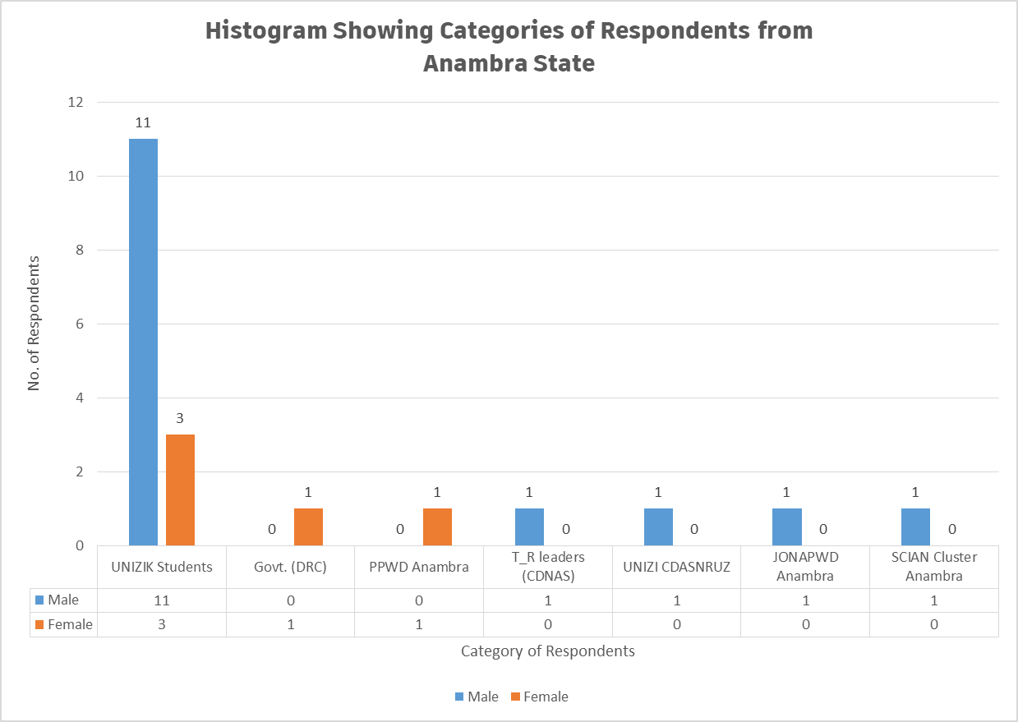
Figure 2.13. A Histogram Showing Categories of Respondents Based on Gender for Anambra State

From both Table 2.24 and Figure 2.13, six (6) categories of respondents participated in the interview, which comprises of seven (7) stakeholders and total number of 20 interviewed persons. From the Table 2.24 and Figure, 2.13 of the interviewed persons were male and 5 female respondents. For instance, the students category, out of the 14 students interviewed from UNIZIK, only 3 are females and 11 are male respondents. This may be due to the fact that, more male Person with Disabilities attends school than female in the State. For the learning institution, a male staff of CENDASNER was interviewed as stakeholder. The centre conducts research on the needs to improve the welfare and the rights of Person with Disabilities.

Figures 2.15a and 2.15b shows a pie chart indicating the percentages of the male and female respondents from Anambra State.

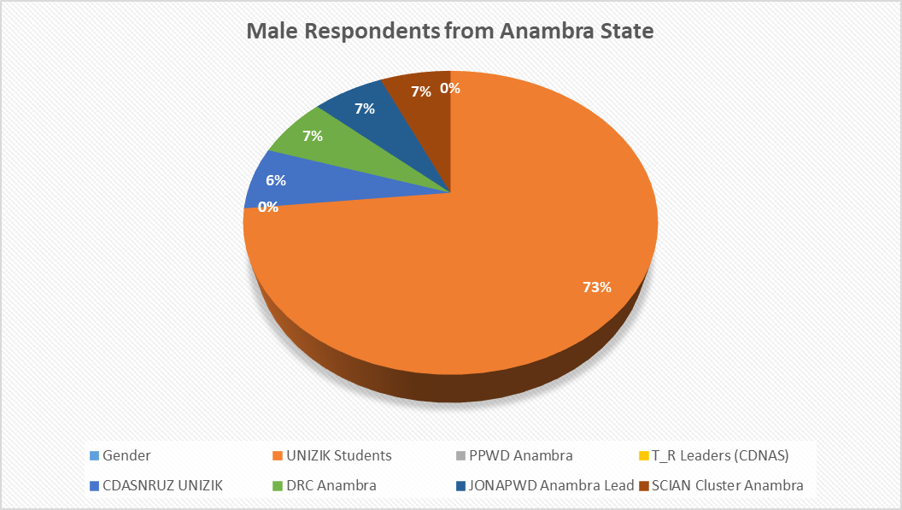
Figure 2.15a. Pie Chart Showing Number of Male Respondents (%) for Anambra State

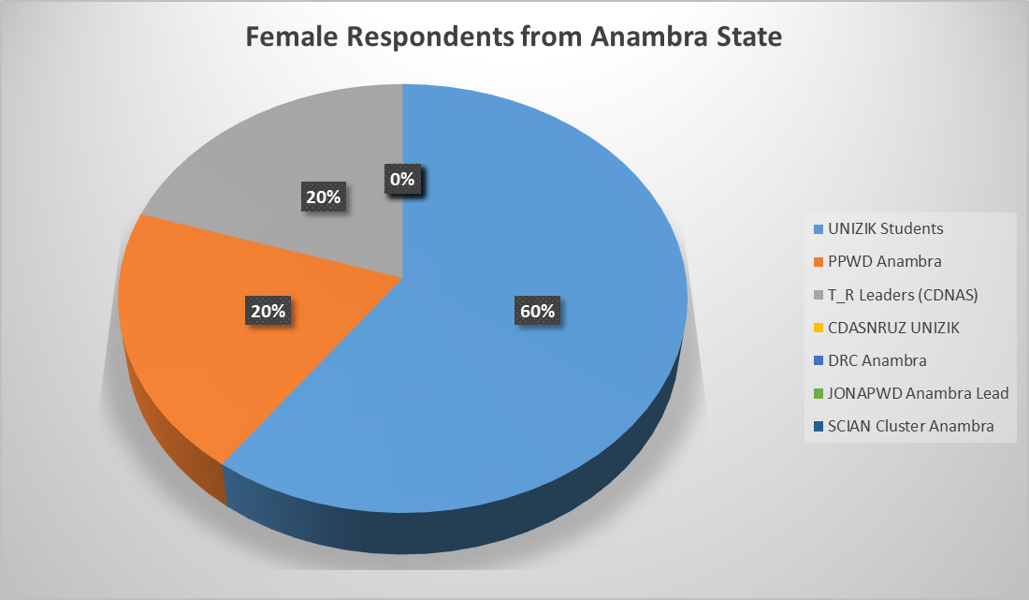
Figure 2.15b. Pie Chart Showing Number of Female Respondents (%) for
Anambra State

2.9.1.2 Analysis Socio-Demographic Information of Respondents from Anambra State
Table 2.25 presents the socio-demographic information of the 20 respondents from Anambra State. Column 2 of Table 2.25 indicated the ranges of age of respondents from Anambra State and columns 3 and 4 indicated the number of respondents and their corresponding percentages based on range of ages respectively.

Table 2.16. Analysis of Socio-demographic information of the respondents from Anambra State
S/N | AGE OF  RESPONDENT  (years) | NO. OF  RESPONDENTS | RESPONDENTS No.  (%)
1 | 18 – 25 | 14 | 70
2 | 25 – 40 | 2 | 10
3 | 40 – 65 | 4 | 20
4 | 65 and above | 0 | 0
 | Total | 20 | 100

Figure 2.16 presents the socio-demographic information of respondents from Anambra State indicating their ranges of age (years) as well the number of persons participated in the interview. From both Table 2.45 and Figure 2.16, 70% of the respondents from Anambra State are in the age range of 18 – 25 and 20% are between 40 – 65 years of age, and 10% ranged between 25 and 40 years. No respondents among the interviewees were found to have over 65 years age.

Figure 2.16. Socio-Demographic Information of Respondents Indicating Age Range (Anambra State)
2.9.1.3 Data Analysis of Respondents Based on Disability (Anambra State)
Table 2.26 presents the categories of respondents on the basis of disability and the number of respondents participated from each category in Anambra State. From the Table, 4 out of the 20 respondents doesn’t have any kind of disability and this number come from other stakeholders such as DRC Anambra State, PPWD, CDNAS, CENDASNER UNIZIK, etc.

Table 2.26. Category of Respondents on the Basis of Disability (Anambra State)
S/N | DISABILITY | NO. OF RESPONDENT | RESPONDENTS NO.  (%)
1 | Physical (P) | 5 | 25
2 | Blind (B) | 5 | 25
3 | Leprosy/IDEA (L) | 0 | 0
4 | Albinism (Al) | 1 | 5
5 | Spinal cord injury (SCIAN) | 1 | 5
6 | Deaf (D) | 4 | 20
7 | Deaf/Blind (DB) | 0 | 0
8 | Psychosocial (Psy) | 0 | 0
9 | Mental (M) | 0 | 0
10 | None (N) | 4 | 20
 | Total | 20 | 100

Figure 2.17 presents a histogram indicating the categories of respondents who participated in the interview exercise on the basis of disability. From the figure, for instance, the respondents without disability are six (6) out 20 with the corresponding percentage of 20. None of the respondents interviewed were found to be mental, deaf/blind or affected by leprosy in the State.
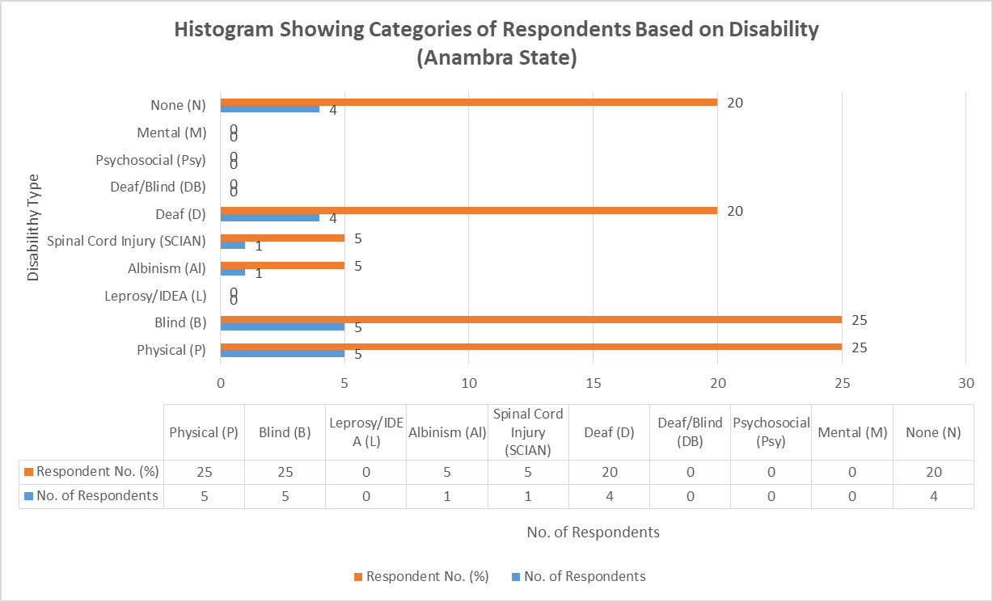
Figure 2.17. Categories of Respondents on the Basis of Disability (Anambra State)

2.9.1.4 Data Analysis on General Questions on IE Vis-à-vis SNE (Anambra State)
Table 2.27 presents the data analysis of the general questions on Inclusive Education vis-à-vis special needs education to the respondents who participated in the interview exercise in Anambra State. In the Table, number of respondents and percentages of the statements 1 – 10 are indicated by the choices: Excellently Well, Well Enough, Partly Well and Not At All.

Table 2.28. Response to General Questions on Inclusive Education vis-à-vis Special Needs Education (Anambra State).
S/N | STATEMENT | Responses and  No. of Respondents
S/N | STATEMENT | Excellently Well | Well Enough | Partly Well | Not at All
1 | How well do you understand the concept of inclusive education? | 1  (5% of 20) | 4  (20% of 20) | 15  (75% of 20) | 0  (0% of 20)
2 | How well do you understand the concept of Special Needs Education? | 1  (5% of 20) | 2  (10% of 20) | 16  (80% of 20) | 1  (5% of 20)
3 | How well do you understand the Nigerian Discrimination Against Persons with Disabilities Act? | 3  (15% of 20) | 3  (15% of 20) | 14  (70% of 20) | 0  (0% of 20)
4 | How well do you understand Goal 4 of the Sustainable Development Goals? | 0  (0% of 20) | 1  (5% of 20) | 1  (5% of 20) | 18  (90% of 20)
5 | How well do you understand Article 24 of the Convention on the Rights of Persons with Disabilities? | 1  (5% of 20) | 1  (5% of 20) | 2  (10% of 20) | 16  (80% of 20)
6 | How well do you know national policies and reforms on education in Nigeria? | 0  (0% of 20) | 1  (5% of 20) | 2  (10% of 20) | 17  (85% of 20)
7 | How well do you know national plan on education in Nigeria? | 1  (5% of 20) | 1  (5% of 20) | 16  (80% of 20) | 2  (10% of 20)
8 | How well do you understand the difference between Special Needs and Inclusive Education? | 2  (10% of 20) | 2  (10% of 20) | 14  (70% of 20) | 2  (10% of 20)
9 | How well do you think learners with disabilities and without disabilities can co-learn? | 2  (10% of 20) | 14  (70% of 20) | 4  (20% of 20) | 0  (0% of 20)
10 | How well do you know the Salamanca Statement and framework for action on special needs education? | 0  (0% of 20) | 0  (0% of 20) | 0  (0% of 20) | 20  (100% of 20)

Table 2.18 shows the summary of the responses (%) by the respondents participated in the interview exercise. The table summarizes Table 2.18 above.

Table 2.29. Responses (%) on the General Concepts of IE vis-a-via SNE
(Anambra State)
STATEMENT | Response:  Excellently Well | Response:  Well Enough | Response:  Partly Well | Response:  Not At All
Statement 1 | 5% | 20% | 75% | 0%
Statement 2 | 5% | 10% | 80% | 5%
Statement 3 | 15% | 15% | 70% | 0%
Statement 4 | 0% | 5% | 5% | 90%
Statement 5 | 5% | 5% | 10% | 80%
Statement 6 | 0% | 5% | 10% | 85%
Statement 7 | 5% | 5% | 80% | 10%
Statement 8 | 10% | 10% | 70% | 10%
Statement 9 | 10% | 70% | 20% | 0%
Statement 10 | 0% | 0% | 0% | 100%

Figure 2.30 presents the responses by the respondents (%) from Anambra State on the general concept of Inclusive Education vis-à-vis Special needs education. From this figure, about 76.7% of the respondents partially understand statement 1 which is referring to the general concepts of IE and none of the respondents knew the Salamanca statement and framework of action on special needs action which indicated 100% of the respondents stated that they don’t have idea on the scenario.

Figure 2.18. Responses on General Concepts of IE Vs SNE (Anambra State)
2.9.1.5 Analysis of Barriers faced by Person with Disabilities in Learning Environment (Anambra State)
Table 2.31 presents the Analysis of barriers faced by Person with Disabilities in learning environment around Anambra State. Each barrier was classified as options (a) to (e). From the Table, each option selected by the respondents has been ticked in their respective columns. In this case also, twenty (20) respondents from Anambra State and from learners with disabilities and other stakeholders in the State.
Table 2.31. Analysis of barriers faced by Person with Disabilities in Learning Environment

(Anambra State)
S/N | BARRIERS | (a) | (b) | (c) | (d) | (e)
1 | Physical Barriers: e.g  - Inaccessible services  - Long distances  - damaged infrastructure  - No ramp | 20  (100% of 20) | 20  (100%) | 20  (100% of 20) | 20  (100% of 20)
2 | Institutional Barriers: e.g  - Limited availability of services,  - Limited technical capacity/training of service providers  - Policies and curriculum  - Funding | 20  (100% of 20) | 20  (100% of 20) | 20  (100% of 20) | 20  (100% of 20)
3 | Attitudes and Perceptions: e.g.  - Stigma  - Fear  - Bullying and harassment  - Discrimination | 18  (90% of 20) | 17  (85% of 20) | 16  (80% of 20) | 17  (85% of 20)
4 | Communication Barriers: e.g.  - No Assistive Technology Devices  - No Brail  - No Sign language Interpreters  - Obstacles to access or conveying information  - Untrained staff | 20  (100% of 20) | 20  (100% of 20) | 20  (100% of 20) | 17  (85% of 20) | 20  (100% of 20)
5 | Intersectional Identities: e.g.  - Age  - Ethnicity  - Religion,  - Poverty,  - Gender | 18  (90% of 20) | 16  (80% of 20) | 20  (100% of 20) | 15  (75% of 20) | 0  (0% of 20)

Figure 2.19 present the histogram on data analysis with regard to the barriers faced by Person with Disabilities in learning environment around Anambra State. We have 20 respondents in this section who participated in the interview. Some of the respondents identified all the barriers from (a) to (e), and some respondents identified some barriers and silent on the others. From both Table 2.59 and Figure 2.19, for instance, the communication barrier; 100% of the respondents (20 No,) ticked option (a) as a barrier faced by Person with Disabilities in their learning environment, i.e lack of assistive technology devices. Therefore, for communication barrier, 100% (20 respondents), 100% (20 respondents), 100% (20 respondents), 85% (17 respondents) and 100% of the respondents involved in Anambra PEA analysis respectively ticked lack of assistive technology devices, brails, sign language interpreters, obstacles to access or conveying information and untrained staff.

Figure 2.19. Histogram Showing Barriers Faced by Person with Disabilities in Learning Environment_ Anambra State.
2.9.1.6 Analysis of the Responses of Specific Questions to Learners with Disabilities (Anambra State)
Table 2.32 presents the analysis of the responses of specific questions to learners with disabilities (students). The questions were administered to 14 students from NAU, UNIZIK in the South Eastern part geopolitical zone of the Federation.
Table 2.32 Analysis of Responses of Specific Questions to Learners with Disabilities (NAU, UNIZIK Students)_Anambra State
S/N | SPECIFIC QUESTIONS TO LEARNERS WITH DISABILITIES | RESPONSES BY  UNIZIK STUDENTS | NO. OF RESPONSES (%)
1 | What are the problems you faces in school? (Interrogate on design co-learners, curriculum, develop assessment systems, teachers, staff and physical facilities, and formulate and adapt operation policies etc)? | - Accessibility to physical structures  - There is need for rest room  - Transport facilities needed  - Communication barrier e. g. interpreters | 12  (85.7% of 14)
2 | Do you think the government is doing enough to support your parents to advance your right to education? | No, government needs to do more to support the parents of Person with Disabilities | 14  (100% of 14)
3 | How do you expect government/your school to help learners with disabilities get education easily? | - Redesign the existing structures to friendly structures for Person with Disabilities | 13  (92.9% of 14)
4 | What would enable you to access school in equal matter? | Provide scholarship to Person with Disabilities to reduce financial burden | 14  (100% of 14)
5 | How are your relationships with your co-learners? Segregated, Integrated, Inclusive | Inclusive | 12  (85.7% of 14)
6 | How do you access/return information as the institution demands? | - Through a created WhatsApp platform and students with visual impairment may sometimes needs interpretations | 10  (71.4% of 14)
7 | Is there funding for your student supports (scholarships, loans, etc.? Have you been able to access any? If yes, what the process of accessing it challenging or otherwise? | Yes, because I personally benefitted ASUU scholarship through ASUU UNIZIK chapter | 9  (64.3% of 14)
6 | Do you experience any form of attitude that promotes any form of abuse, exploitation or exclusion at school? | Yes | 7  (50% of 14)
7 | Are there specific coping strategies employed by you to address barriers faced at school? If so, what are they, and how can they be supported or strengthened? Who/What facilitated it | Yes, my fellow colleagues in our hostel helps me fetch water | 9  (64.3% of 14)
8 | Is there any form of remote and/or home-based learning initiatives with close engagement of focused support to enable you to catch up, prevent drop-out and/or re-enroll in formal education? | None | 10  (71.4% of 14)

2.9.1.7 Analysis of Hierarchy of the Structures that Support Person with Disabilities in Learning Environment (Anambra State)
Table 2.33 presents the data analysis on the hierarchy of the structures that support Person with Disabilities in the learning environment for Anambra PEA analysis on IE in the South Eastern part of Nigeria.

Table 2.22 Analysis Hierarchy of Structures that Support Person with Disabilities in Learning Environment (Anambra State)
S/N | SUPPORT AREA | TICKED BY RESPONDENTS  (UNIZIK STUDENTS)
1 | School Governing Body | - Respondents  (78.6% of 14)
2 | Traditional/Religious Entities | - Respondents  (78.6% of 14)
3 | Counselling Learning Support Specialist (Remedial Teacher) | - Respondents  (57.1% of 14)
4 | Career Advisor | - Respondents  (78.6% of 14)
5 | Parents | - Respondents  (100% of 14)
6 | JONAPWD | 14 Respondents  (100% of 14)
7 | Disability Commission | 14 Respondents  (100% of 14)
8 | Co-students | - Respondents  (92.9% of 14)
9 | Other (please specify) | 0  (0% of 14)

From Table 2.33, for instance, 78.6% (11 No. out 14 students) of the respondents ticked traditional/religious entities as a hierarchical structure that support Person with Disabilities around Anambra State, 100% of the respondents each ticked of the parents, JONAPWD, and disability commission as the most preferable areas that Person with Disabilities needs more support in the learning environment.
2.10 ANALYSIS OF NON-NUMERICAL (TEXT) DATA FOR PEA ON IE IN ANAMBRA STATE
This section presents the text data collated from the various stakeholders in Anambra State such as learning institution (CENDASNER NAU, UNIZIK), learners with disabilities (NAU, UNIZIK students), government (e.g. DRC), Parent of Person with Disabilities, T_R leaders (Christianity: CDNAS), Anambra JONAPWD lead/SCIAN cluster head, etc.
2.10.1 ANALYSIS OF RESPONSES FOR JONAPWD ANAMBRA LEAD/CLUSTER HEADS /GOVERNMENT (DRC ANAMBRA STATE)
Table 2.34 presents the data on the responses to the questions administered to JONAPWD State Leads/Cluster Heads/Government (DRC Awka) on the implementations of policies of IE around Anambra State.
Table 2.34. Data Presentation on the Responses to Questions for Anambra JONAPWD Lead/Cluster Heads/Government (DRC Awka)_ANAMBRA STATE
S/N | Question | Responses
1 | What is the context of education for persons with disabilities in the state? (Interrogate on design curriculum, develop assessment systems, teachers, staff and physical facilities, and formulate and adapt operation policies etc)? | DRC ensure the welfare and rights of all Person with Disabilities in Anambra State
2 | What do you think about the progress of Inclusive Education Vis-à-vis Special Needs Education? | SNE ensure the educational rights of Person with Disabilities in the state
3 | What are the means you employ to collate data on rates of enrolments of Person with Disabilities in relations to education (primary, secondary, tertiary educational institutions, vocational training, lifelong learning courses, as compared to others, disaggregated by sex, age, disability, minority or indigenous background, grade and level of education)? The progress of Inclusive Education Vis-à-vis Special Needs Education? | Data collation for Person with Disabilities is yet to commenced by DRC
4 | What are the methods of awareness raising campaigns and activities employed to promote inclusive education (Please insert whether: government, students, education staff, families and the general public of the duty to provide, and the right to inclusive education and related benefits for society)? | The Ministry of Women Affairs will ensure that the awareness creation
5 | How is the budget allocated to ensure the right of Person with Disabilities to inclusive education in mainstream settings, as compared to budget allocated to segregated/separated education settings, whether in mainstream or special schools? | The budget is usually under Ministry of Women Affairs, Awka.
6 | What are the consultation processes undertaken to ensure the active involvement of Person with Disabilities, notably parents of children with disabilities, including through their representative organizations, in the design, implementation and monitoring of laws, regulations, policies and programmes, related to education initiatives and reform? | The commission is not funded
7 | What proportion of received complaints on the right to education alleging discrimination on the basis of disability and/or involving children, youth and adults with disabilities that have been investigated and adjudicated? How have they been addressed? | No
8 | Have you ever purposely visited any of the learning institutions belonging to either Federal or State government or private in your state to witness the implementation of policies leading to equal education rights for person with disabilities? If not, why? If yes, what were your findings? | No
9 | Have you ever visited any of the relevant Agencies/Boards and Parastatals, National Commission for Persons with Disabilities and/or State Agencies for Disability Matters for details implementations of equal rights for Person with Disabilities? Please explain? | No, but we have plan
10 | Does your Ministry/Agencies/Association/Cluster provide any forms of training of technical personnel “on managing inclusive education and delivering special needs education? | No training yet
11 | Are there any ongoing engagements with the private sector to support the education rights of Person with Disabilities? | Yes, with NGOs for awareness program.
12 | Have your agencies/association procured or received any learning aid for Person with Disabilities in the past? | No

Table 2.24 presents the data on the responses to the questions administered to learning institution (CENDASNER, UNIZK AWKA) on the implementations of policies of IE.

Table 2.35. Data Presentation on the Responses to Questions for learning institution (CENDESNER, UNIZIK AWKA)_ANAMBRA STATE
S/N | Question | Responses
1 | What are the realities with learners and persons with disabilities in the institution? (Interrogate on design curriculum, develop assessment systems, teachers, staff and physical facilities, and formulate and adapt operation policies etc.)(ambiguous) | We have about 5 to 6 workers with visual impairment in CENDASNER
2 | What are the means you employ to collate data on rates of enrolments of learners with disabilities in relation to their education? | - Though sessional registration
3 | Do your curriculum/ policies reflect disability requirements? Please explain | No
4 | Do you have a percentage for actualizing disability inclusion in your annual budget? If yes, what are the specified needs? | No
5 | What are the methods of awareness raising campaigns and activities employed to promote inclusive education (or education rights) and inform students and staff, and the general public of the duty to provide, and the right to inclusive education and related benefits for society? | Sensitization programs on disability matters
6 | What are the consultation processes undertaken to ensure the active involvement of persons with disabilities, notably parents of children with disabilities, including through their representative organizations, in the design, implementation and monitoring of laws, regulations, policies and programmes, related to education initiatives and reform of the institution? | The university support Person with Disabilities
7 | What proportion of received complaints on the right to education alleging discrimination on the basis of disability and/or involving children, youth and adults with disabilities that have been investigated and adjudicated? How have they been addressed? | Yet but the centre is ever ready
8 | Have you ever engaged any association/agency/Department on the implementation of policies leading to equal education rights for persons with disabilities? If not, why? If yes, what were your findings? | We engaged NCPWD
9 | Are there ongoing any form of engagements with the private sector to support the educational rights of Person with Disabilities? Please enlist | No, at this moment
10 | Does your Institution provide any forms of training of technical personnel “on managing inclusive education and delivering special needs education? Please elaborate | None at this moment
11 | Has your institution procured or received any learning aid for Person with Disabilities in the past? Please explain? | No

Table 2.36 presents the data on the responses to the questions administered to Parent of Persons with Disabilities Anambra on the implementations of policies of IE.
dat
Table 2.37. Data Presentation on the Responses to the Questions for Parent of Persons with Disabilities Awka_ANAMBRA STATE
S/N | Question | Responses
1 | What do you think about Inclusive Education? | IE is an educational system that accommodate everyone in the same environment
2 | What do you think about Special Needs Education? | SNE creates exceptional schools for Person with Disabilities
3 | Are you involved in decision making concerning your child’s education? At least explain how you are involved in your child’s education | No
4 | What are some of the major barriers your child encounters in accessing education? | Accessibility to physical structures
5 | Do you think the nature of your child’s disability influences his or her educational progress in school? | Yes
6 | In your opinion, do information barriers exist? Is information regarding availability of assistance accessible your child at school? | No

Table 2.38 presents the data on the responses to the questions administered to T_R Leaders (Religious: Christianity_CDNAS Awka) on the implementations of policies of IE.

Table 2.38. Data Presentation on the Responses to the Questions for T_R Leader (Religion: Christianity_CDNAS Awka)_ANAMBRA STATE
S/N | Question | Responses
1 | What is your perception about Person with Disabilities? | Person with Disabilities are human beings like and as such deserve equal opportunity like everyone
2 | What do you think about IE? | Everyone should be educated
3 | What do you think about SNE? | SNE means educational system for persons with special needs
4 | Have you been approached by any person/entity/ etc. concerning the education of someone with a disability? If yes, what kinds of supports did you offer? | Yes, concerning a student with visual impairment
5 | Will your Organization do more to improve advocacy support for disability rights? | Yes, we will
6 | Any other comments? | We will strive towards the wellbeing of Person with Disabilities

2.11 THEMATIC METHOD OF ANALYSIS FOR NON-NUMERICAL (TEXT) DATA COLLATED FROM ANAMBRA FOR PEA ANALYSIS FOR ANAMBRA STATE
The following steps were strictly adhered in the analysis of non-numerical data collated for PEA in Anambra State.
Step 1: Familiarization of Collated Data from Anambra State
In this step, the responses of the administered questionnaires distributed to various stakeholders have been thoroughly read to have the general idea on the collated data.
Step 2: Coding of Non-numerical (Text) Collated Data from Anambra State
This includes highlighting or labelling certain words or group of words or even phrases in the data that all together indicates something that will grab the essence of the data. Table 2.57 present the coding of the non-numerical collated data from Anambra State on IE for PEA Analysis.

Table 2.39. Analysis and Coding of Non-Numerical (Text) Data Collated for PEA on IE from ANAMBRA STATE
S/N | INTERVIEW  QUESTIONS | INTERVIEW  EXTRACT REPONSES BY VARIOUS RESPONDENTS | CODE(S)
 | POLITICAL CONTEXT OF IE IN ANAMBRA STATE
1 | What is the context of education for persons with disabilities in the state? (Interrogate on design curriculum, develop assessment systems, teachers, staff and physical facilities, and formulate and adapt operation policies etc)? | - The UNIZIK curriculum doesn’t reflect disability requirements  - Accessibility of physical structures is the major barrier faced by Person with Disabilities in learning institution in the State  - Some Parent of Persons with Disabilities felt disability affects their children education | - No Reviewed Curriculum for IE  - Lack of access to physical structures  - Lack of trained teachers
 | INCLUSIVE EDUCATION VIS-À-VIS SPECIAL NEEDS EDUCATION
2 | What do you think about the progress of Inclusive Education Vis-à-vis Special Needs Education? | - SNE ensure the educational rights of Person with Disabilities  - IE is a system of education that accommodate everyone in the same environment, while SNE creates exceptional schools for Person with Disabilities | - Difference between IE & SNE Policies
 | ENROLMENTS/DATA OF PERSON WITH DISABILITIES IN SCHOOLS_ANAMBRA STATE
3 | What are the means you employ to collate data on rates of enrolments of Person with Disabilities in relations to education (primary, secondary, tertiary educational institutions, vocational training, lifelong learning courses, as compared to others, disaggregated by sex, age, disability, minority or indigenous background, grade and level of education)? The progress of Inclusive Education Vis-à-vis Special Needs Education? | - DRC is yet to collate any data on Person with Disabilities  - CENDESNER UNIZIK Awka only collate data of Person with Disabilities during sessional registration | - Even DRC doesn’t have data across the institutions  - CENDESNER UNIZIK collates data during registration
 | METHODS OF PROMOTING INCLUSIVE EDUCATION_ANAMBRA STATE
4 | What are the methods of awareness raising campaigns and activities employed to promote inclusive education (Please insert whether: government, students, education staff, families and the general public of the duty to provide, and the right to inclusive education and related benefits for society)? | - DRC has been created by the State government to ensure Person with Disabilities rights  - The Ministry of Women Affairs (MOWA) ensures awareness campaigns | - The DRC ensure Person with Disabilities rights  - The Anambra State MOWA ensures awareness campaign
 | BUDGET ALLOCATION TO INCLUSIVE EDUCATION_ANAMBRA STATE
5 | How is the budget allocated to ensure the right of Person with Disabilities to inclusive education in mainstream settings, as compared to budget allocated to segregated/separated education settings, whether in mainstream or special schools? | - The budget is wholly under Ministry of Women Affairs , Awka  - The DRC is yet to be funded by the Anambra State government | - The presentation of budget is under MOWA  - DRC is yet to be funded by the government
CONSULTATIONS AND MONITORING/IMPLEMENTATION OF LAWS & IE POLICIES IN
ANAMBRA STATE

6 | What are the consultation processes undertaken to ensure the active involvement of Person with Disabilities, notably parents of children with disabilities, including through their representative organizations, in the design, implementation and monitoring of laws, regulations, policies and programmes, related to education initiatives and reform? | - CENDESNER has engaged NCPWD on the policy implementations of IE  - Parent of Persons with Disabilities in the State are not involved in decision making of their children’s education | - CENDESNER engages NCPWD  - Parent of Persons with Disabilities not involved
 | COMPLAINTS ON DISCRIMINATION FOR PERSON WITH DISABILITIES
7 | What proportion of received complaints on the right to education alleging discrimination on the basis of disability and/or involving children, youth and adults with disabilities that have been investigated and adjudicated? How have they been addressed? | - No any form of complaint alleging discrimination is received by DRC and CENDESNER yet  - T_R leaders in Anambra State supports Person with Disabilities wellbeing like every other citizen  - CENDESNER, UNIZIK Awka has employed about 5 to 6 persons with visual impairments | - No complaint alleging discrimination recorded
 | COURTESY VISIT TO INSTITUTIONS LEADING TO IMPLEMENTATIONS OF IE POLICIES
8 | Have you ever purposely visited any of the learning institutions belonging to either Federal or State government or private in your state to witness the implementation of policies leading to equal education rights for person with disabilities? If not, why? If yes, what were your findings? | - The DRC has not is yet to visit any of the learning institution in Anambra that on educational rights of Person with Disabilities | - No visitations of learning institutions by stakeholders including DRC
 | COURTESY VISIT TO AGENCIES FOR DISABILITY MATTERS/BOARDS/NCPWD
9 | Have you ever visited any of the relevant Agencies/Boards and Parastatals, National Commission for Persons with Disabilities and/or State Agencies for Disability Matters for details implementations of equal rights for Person with Disabilities? Please explain? | - The DRC is yet to visit any of the relevant agencies for Person with Disabilities | - No courtesy visits to relevant agencies by stakeholders including DRC
 | TRAINING OF TECHNICAL PERSONNELS BY MINISTRIES/AGENCIES
10 | Does your Ministry/Agencies/Association/Cluster provide any forms of training of technical personnel “on managing inclusive education and delivering special needs education? | - No any form of training of technical training is conducted by DRC and CENDESNER yet | - No Intensive Staff Training of Teachers on IE and SNE
 | ENGAGEMENT OF PRIVATE SECTORS/PARTNERS
11 | Are there any ongoing engagements with the private sector to support the education rights of Person with Disabilities? | - The DRC has engaged with NGOs to the educational rights of Person with Disabilities in the State  - CENDESNER has not engaged any private on education rights of Person with Disabilities in the State | - There exist engagement with private sectors and/or NGOs by DRC & CENDESNER
 | PROVISIONS OF LEARNING AIDS TO Person with Disabilities
12 | Have your agencies/association procured or received any learning aid for Person with Disabilities in the past? | - No any procurement or received of learning aids by DRC and CENDESNER is recorded in the past | - No received or procurement of learning aids/assistive devices

Step 3: Theme(s) Generation
The created themes were read through and patterns were also created among them. Themes are generally broader than codes. In broad sense, several codes could be combined and also transform into single theme.
However, Table 2.58 present the data transformation from code to theme(s).

Table 2.40. Data Coding – Theme Transformation for Non-Numerical Data from
Anambra State
S/N | CODES | THEMES
1 | - No Reviewed Curriculum for IE  - Lack of access to physical structures  - Lack of trained teachers | Curriculum review and infrastructural access
 | - Difference between IE & SNE Policies | IE/SNE policies
 | - Even DRC doesn’t have data across the institutions  - CENDESNER UNIZIK collates data during registration | No specific method of enrollment
 | - The DRC ensure Person with Disabilities rights  - The Anambra State MOWA ensures awareness campaign | There is awareness campaign
 | - The presentation of budget is under MOWA DRC is yet to be funded by the government | DRC not funded by government
 | - CENDESNER engages NCPWD  - Parent of Persons with Disabilities not involved | Non-involvement of Person with Disabilities in decision
 | - No complaint alleging discrimination recorded | No complaint on discrimination
 | - No visitations of learning institutions by stakeholders including DRC | No visitation
 | - No courtesy visits to relevant agencies by stakeholders including DRC | No visitation
 | - No Intensive Staff Training of Teachers on IE and SNE | No staff training
 | - There exist engagement with private sectors and/or NGOs by DRC & CENDESNER | There is engagement with private sectors
 | - No received or procurement of learning aids/assistive devices | No procurement of learning aids

Step 4: Reviewing Theme(s)
In this steps, themes were checked and certified to be the accurate representation of the data sets. The themes were also really testified to be present in the data set.
Step 5: Defining and Naming Theme(s)
This involved formulating exactly what each theme mean and how it will help understand the data set.
However, 2.40 presents the definitions of the themes coded with non-numerical data from Anambra State
Table 2.40. Definition of Themes for Non-Numerical Data from Anambra State
S/N | THEMES | Meaning
1 | Curriculum review and infrastructural access | The existing curriculum and physical barriers should be addressed to reflect disability requirements
2 | IE/SNE policies | There exist National policy and DRC to promote IE/SNE policies
3 | No specific method of enrollment | UNIZIK collates data during registration but even DRC doesn’t have Person with Disabilities data
4 | There is awareness campaign | MOWA ensures awareness campaign in Anambra State
5 | DRC not funded by government | Even DRC is not adequately funded by Anambra State government
6 | Non-involvement of Person with Disabilities in decision | Person with Disabilities were kept on decision making that affect them
7 | No complaint on discrimination | No formal complaint for discrimination on Person with Disabilities in learning institutions
8 | Visitation to institutions | There was neither to learning institutions nor agencies on disability matters in Anambra State
9 | Visitation to agencies
10 | No staff training | Technical were not trained to manage educational rights of Person with Disabilities in the State
11 | Engagement with private sectors | DRC engages to partner with private sectors on the educational rights of Person with Disabilities
12 | Procurement of learning aids | There was no record of receiving/procurement of learning aids to support Person with Disabilities

Step 6: Summary of PEA Analysis on Inclusive Education for Non-numerical Data From Anambra State
To implement the policies of IE in Anambra State:
- The Anambra State government established DRC for disability matters.
- The DRC doesn’t have Person with Disabilities across the learning institutions in the State but CENDESNER collates data of Person with Disabilities during students sessional registration
- There must revised curriculum that reflect disability requirements to accommodate IE policies in the State.
- There was no disability friendly structures in the learning institutions of Anambra State.
- There was no training of teachers/lecturers and other technical personnel to manage Person with Disabilities educational rights and wellbeing.
- The MOWA presents budget for wellbeing of Person with Disabilities and DRC is yet to be funded by the State government.
- There was neither IE operational policies nor involvement of Person with Disabilities in decision making for their education.
- There was engagement between DRC and private sectors and/or NGOs.
- There was no record of received or procurement of learning aids/assistive devices by stakeholders.
2.11.1 GAPS IDENTIFIED IN PEA RESAERCH ON IE FOR ANAMBRA STATE
(SOUTH – EAST GEOPOLITICAL ZONE)
The gap(s) identified as a result of PEA analysis on IE around Cross River using “Thematic Method” of qualitative analysis include the following:
- Lack of revised curriculum that reflects disability requirements.
- Lack of actual figure of Person with Disabilities in learning institutions by DRC.
- Lack of disability friendly structures in UNIZIK and other institutions in Anambra State.
- Lack of trained personnel for IE policy implementations.
- No gap identified alleging discrimination for Person with Disabilities in Anambra State
- Person with Disabilities are not involved in decision making.

2:D
ANALYSIS OF PEA RESULTS ON INCLUSIVE EDUCATION FROM
CROSS RIVER STATE

2.12 POLITICAL CONTEXT OF IE FOR CROSS RIVER STATE
In order to ensure the rights of Person with Disabilities, the University of Calabar (UNICAL) Cross River State has a dedicated unit titled “Diversity, Equality and Inclusivity Unit” headed by a Dean in the University. The unit mobilizes on the welfare and rights of Person with Disabilities.

2.13 ANALYSIS OF NUMERICAL DATA FOR PEA ON IE IN CROSS RIVER STATE
This section presents the numerical data presentation/collation and PEA analysis on IE from Cross River State in the South South geopolitical zone of Nigeria.
2.13.1 Numerical Data Presentation and Analysis for PEA on IE in Cross River State
The numerical data collected from Cross River State was from the following categories of 20 respondents, viz; Learners with disabilities (UNICAL Students), Centre for Disability and Special Needs Research, Unizik (CENDASNER), State government, i.e representative of Cross River State Assembly (CRSA), T_R leaders in the State; e.g. Bogobiri Mosque Calabar (BMC) , JONAPWD Cross River Lead/Cluster Head, etc.
2.13.2 Data Analysis by Category of Respondents from Cross River State
Table 2.30 presents the categories of respondents on the basis of disability and the number of respondents participated from each category in Cross River State. From the Table, 4 out of the 20 respondents doesn’t have any kind of disability and this number come from other stakeholders such as DRC Cross River State, PPWD, CDNAS, CENDASNER UNIZIK, etc.

Figure 2.41 present the graph showing the categories of respondents Cross River interviewed based on the gender sensitive.

Gender | UNICAL  Students | Cross River Government  Legislatures  (CRSA) | T_R  Leaders  Islamic Org.  (IO)  BMC | Learning Institution  (UNIZIK):  CENDASNER |  |  |  | JONAPWD Lead Cross River/  Cluster Heads
 |  |  |  | DSA  UNICAL | DDEI  UNICAL | HOD SE  UNICAL | SUG  UNICAL | JONAPWD  CROSS RIVER LEAD | NAPWPDCLUSTER HEAD
Male | 10 | 1 | 1 | 1 | `1 | 1 | 1 | 1 | 1
Female | 2 | 0 | 0 | 0 | 0 | 0 | 0 | 0 | 0
Total | 12 | 1 | 1 | 4 |  |  |  | 2

Table 2.41. Distribution of Questionnaire by Category of Respondents (Cross River State)

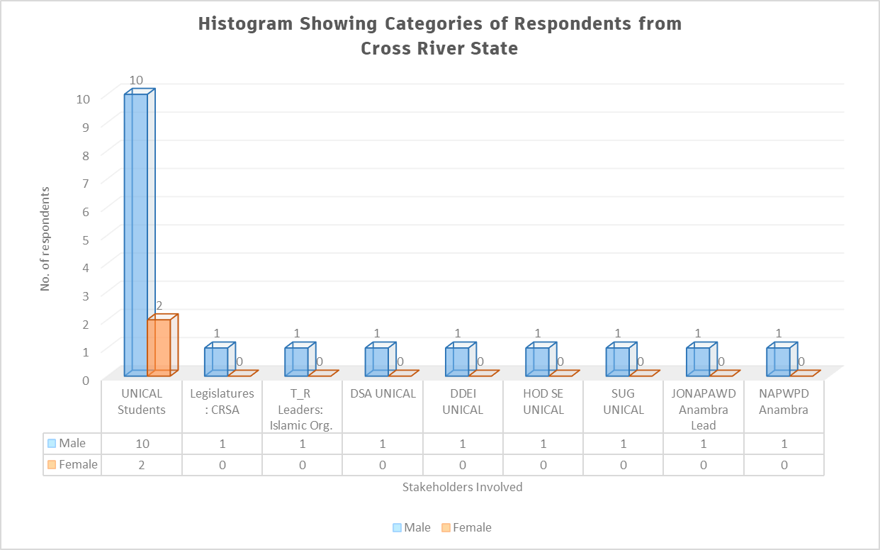
Figure 2.20. A Histogram Showing Categories of Respondents Based on Gender for Cross River State

Figures 2.21a and 2.21b shows a pie chart indicating the percentages of the male and female respondents from Cross River State.
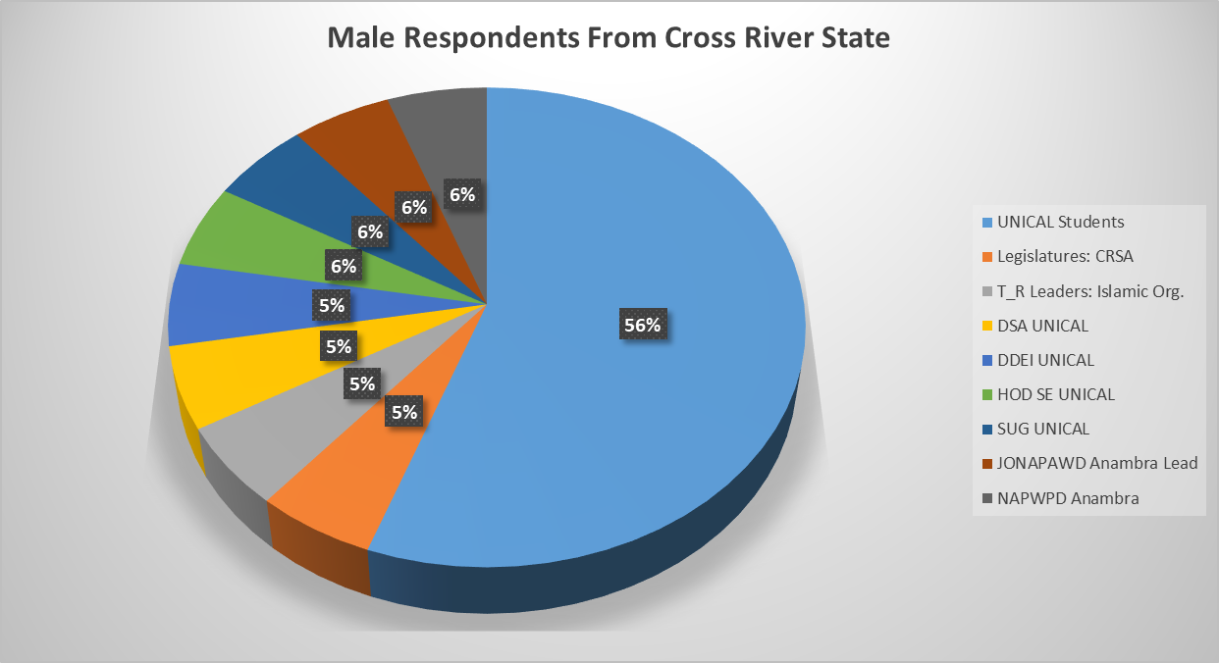
Figure 2.21a. Pie Chart Showing Number of Male Respondents (%) for
Cross River State

Figure 2.21b. Pie Chart Showing Number of Female Respondents (%) for
Cross River State
2.13.3 Analysis Socio-Demographic Information of Respondents from Cross River State
Table 2.61 presents the socio-demographic information of the 20 respondents from Cross River State. Column 2 of Table 2.61 indicated the ranges of age of respondents from Cross River State and columns 3 and 4 indicated the number of respondents and their corresponding percentages based on range of ages respectively.

Table 2.42. Analysis of Socio-demographic information of the respondents from
Cross River State
S/N | AGE OF  RESPONDENT  (years) | NO. OF  RESPONDENTS | RESPONDENTS No.  (%)
1 | 18 – 25 | 11 | 55
2 | 25 – 40 | 4 | 20
3 | 40 – 65 | 5 | 25
4 | 65 and above | 0 | 0
 | Total | 20 | 100

Figure 2.21c presents the socio-demographic information of respondents from Cross River State indicating their ranges of age (years) as well the number of persons participated in the interview. From both Table 2.31 and Figure 2.21c, 55% of the respondents from Cross River State are in the age range of 18 – 25 and 20% are between 25 – 40 years of age, and 25% ranged between 40 and 65 years. No respondents among the interviewees were found to have over 65 years of age.

Figure 2.21c. Socio-Demographic Information of Respondents Indicating Age Range (Cross River State)

2.13.4 Data Analysis of Respondents Based on Disability (Cross River State)
Table 2.43 presents the categories of respondents on the basis of disability and the number of respondents participated from each category in Cross River State. From the Table, 6 out of the 20 respondents doesn’t have any kind of disability and this number come from other stakeholders such as CRSA, PPWD, T_R leaders (Islamic Org.), UNICAL Staff, etc.

Table 2.43. Category of Respondents on the Basis of Disability (Cross River State)
S/N | DISABILITY | NO. OF RESPONDENT | RESPONDENTS NO.  (%)
1 | Physical (P) | 4 | 20
2 | Blind (B) | 2 | 10
3 | Leprosy/IDEA (L) | 0 | 0
4 | Albinism (Al) | 1 | 5
5 | Spinal cord injury (SCIAN) | 3 | 15
6 | Deaf (D) | 4 | 20
7 | Deaf/Blind (DB) | 0 | 0
8 | Psychosocial (Psy) | 0 | 0
9 | Mental (M) | 0 | 0
10 | None (N) | 6 | 30
 | Total | 20 | 100

Figure 2.22 presents a histogram indicating the categories of respondents participated in the interview exercise on the basis of disability. From the figure, for instance, the respondents without disability are six (6) out 20 with the corresponding percentage of 20. None of the respondents interviewed were found to be mental, deaf/blind or affected by leprosy.
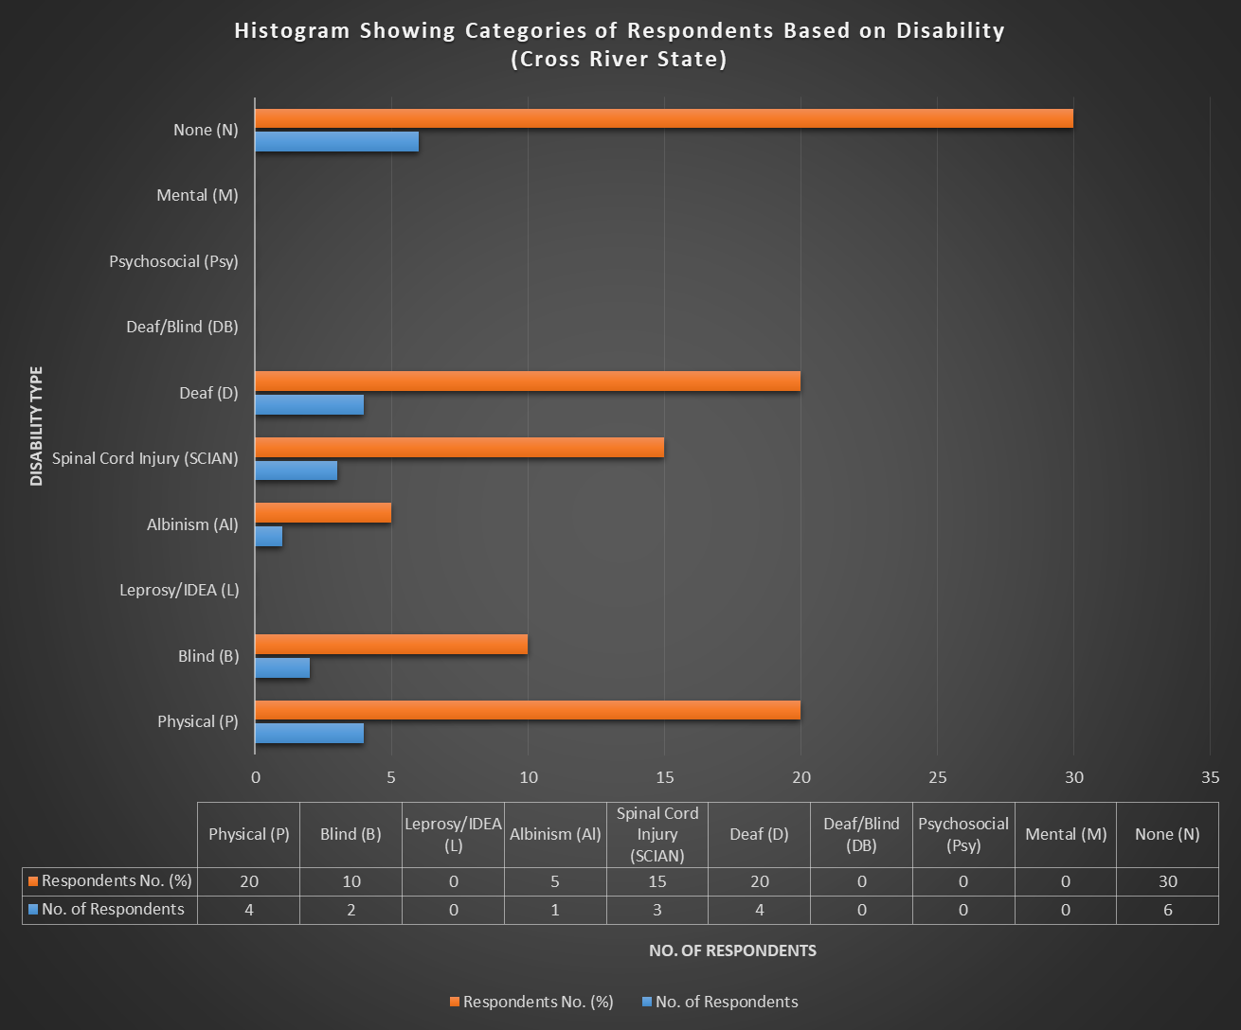
Figure 2.22. Categories of Respondents on the Basis of Disability (Cross River State)

2.13.5 Data Analysis on General Questions on IE Vis-à-vis SNE (Cross River State)
Table 2.44 presents the data analysis of the general questions on IE vis-à-vis SNE to the respondents participated in the interview exercise. In the Table, number of respondents and percentages of the statements 1 – 10 are indicated by the choices: Excellently Well, Well Enough, Partly Well and Not At All.

Table 2.44. Response to General Questions on Inclusive Education vis-à-vis Special Needs Education (Cross River State)
S/N | STATEMENT | Responses and  No. of Respondents
S/N | STATEMENT | Excellently Well | Well Enough | Partly Well | Not at All
1 | How well do you understand the concept of inclusive education? | 0  (0% of 20) | 5  (25% of 20) | 15  (75% of 20) | 0  (0% of 20)
2 | How well do you understand the concept of Special Needs Education? | 1  (5% of 20) | 2  (10% of 20) | 17  (85% of 20) | 0  (0% of 20)
3 | How well do you understand the Nigerian Discrimination Against Persons with Disabilities Act? | 1  (5% of 20) | 5  (25% of 20) | 14  (70% of 20) | 0  (0% of 20)
4 | How well do you understand Goal 4 of the Sustainable Development Goals? | 0  (0% of 20) | 2  (10% of 20) | 5  (25% of 20) | 13  (65% of 20)
5 | How well do you understand Article 24 of the Convention on the Rights of Persons with Disabilities? | 0  (0% of 20) | 1  (5% of 20) | 2  (10% of 20) | 17  (85% of 20)
6 | How well do you know national policies and reforms on education in Nigeria? | 0  (0% of 20) | 5  (25% of 20) | 10  (50% of 20) | 5  (25% of 20)
7 | How well do you know national plan on education in Nigeria? | 1  (5% of 20) | 2  (10% of 20) | 12  (60% of 20) | 5  (25% of 20)
8 | How well do you understand the difference between Special Needs and Inclusive Education? | 1  (5% of 20) | 3  (15% of 20) | 14  (70% of 20) | 2  (10% of 20)
9 | How well do you think learners with disabilities and without disabilities can co-learn? | 3  (15% of 20) | 12  (60% of 20) | 5  (25% of 20) | 0  (0% of 20)
10 | How well do you know the Salamanca Statement and framework for action on special needs education? | 0  (0% of 20) | 0  (0% of 20) | 0  (0% of 20) | 20  (100% of 20)

Table 2.44 shows the summary of the responses (%) by the respondents participated in the interview exercise. The table summarizes Table 2.44 above.

Table 2.45. Responses (%) on the General Concepts of IE vis-a-via SNE
(Cross River State)
STATEMENT | Response:  Excellently Well | Response:  Well Enough | Response:  Partly Well | Response:  Not At All
Statement 1 | 0% | 25% | 75% | 0%
Statement 2 | 5% | 10% | 85% | 0%
Statement 3 | 5% | 25% | 70% | 0%
Statement 4 | 0% | 10% | 25% | 65%
Statement 5 | 0% | 5% | 10% | 85%
Statement 6 | 0% | 25% | 50% | 25%
Statement 7 | 5% | 10% | 60% | 25%
Statement 8 | 5% | 15% | 70% | 10%
Statement 9 | 15% | 60% | 25% | 0%
Statement 10 | 0% | 0% | 0% | 100%

Figure 2.23 presents the responses by the respondents (in %) from Cross River State on the general concept of Inclusive Education vis-à-vis Special needs education. From this figure, about 75% of the respondents partially understand statement 1 which is referring to the general concepts of IE and none of the respondents knew the Salamanca statement and framework of action on special needs action which indicated 100% of the respondents stated that they don’t have idea on the scenario.

Figure 2.23. Responses on General Concepts of IE Vs SNE (Cross River State)
2.13.6 Analysis of Barriers faced by Person with Disabilities in Learning Environment (Cross River State)
Table 2.46 presents the Analysis of barriers faced by Person with Disabilities in learning environment around Cross River State. Each barrier was classified as options (a) to (e). From the Table, each option selected by the respondents has been ticked in their respective columns. In this case also, twenty (20) respondents from Cross River State and from learners with disabilities and other stakeholders in the State.
Table 2.46. Analysis of barriers faced by Person with Disabilities in Learning Environment

(Cross River State)
S/N | BARRIERS | (a) | (b) | (c) | (d) | (e)
1 | Physical Barriers: e.g  - Inaccessible services  - Long distances  - damaged infrastructure  - No ramp | 20  (100% of 20) | 20  (100% of 20) | 20  (100% of 20) | 20  (100% of 20)
2 | Institutional Barriers: e.g  - Limited availability of services,  - Limited technical capacity/training of service providers  - Policies and curriculum  - Funding | 20  (100% of 20) | 20  (100% of 20) | 20  (100% of 20) | 20  (100% of 20)
3 | Attitudes and Perceptions: e.g.  - Stigma  - Fear  - Bullying and harassment  - Discrimination | 18  (90% of 20) | 17  (85% of 20) | 16  (80% of 20) | 17  (85% of 20)
4 | Communication Barriers: e.g.  - No Assistive Technology Devices  - No Brail  - No Sign language Interpreters  - Obstacles to access or conveying information  - Untrained staff | 20  (100% of 20) | 20  (100% of 20) | 20  (100% of 20) | 17  (85% of 20) | 20  (100% of 20)
5 | Intersectional Identities: e.g.  - Age  - Ethnicity  - Religion,  - Poverty,  - Gender | 18  (90% of 20) | 16  (80% of 20) | 20  (100% of 20) | 15  (75% of 20) | 0  (0% of 20)

Figure 2.47 present the histogram on data analysis with regard to the barriers faced by Person with Disabilities in learning environment around Cross River State. We have 20 respondents in this section who participated in the interview. Some of the respondents identified all the barriers from (a) to (e), and some respondents identified some barriers and silent on the others. From both Table 2.65 and Figure 2.24, for instance, the physical barrier; 100% of the respondents (20 No,) ticked all options (a) to (d) as barriers faced by Person with Disabilities in their learning environment, i.e inaccessible services, long distances, damaged infrastructure and lack of ramp respectively.

Figure 2.24. Histogram Showing Barriers Faced by Person with Disabilities in Learning Environment_ Cross River State
2.13.7 Analysis of the Responses of Specific Questions to Learners with Disabilities (Cross River State)
Table 2.48 presents the analysis of the responses of specific questions to learners with disabilities (UNICAL students). The questions were administered to students from UNICAL in the South South geopolitical zone of the federation.
Table 2.48 Analysis of Responses of Specific Questions to Learners with Disabilities (UNICAL Students)_CROSS RIVER State
S/N | SPECIFIC QUESTIONS TO LEARNERS WITH DISABILITIES | RESPONSES BY  UNICAL STUDENTS | NO. OF RESPONSES (%)
1 | What are the problems you faces in school? (Interrogate on design co-learners, curriculum, develop assessment systems, teachers, staff and physical facilities, and formulate and adapt operation policies etc)? | Access to classrooms and hostels, e.g. Lack of ramps | 12  (100% of 12)
2 | Do you think the government is doing enough to support your parents to advance your right to education? | No enough support | 12  (100% of 12)
3 | How do you expect government/your school to help learners with disabilities get education easily? | - Provide scholarships for Person with Disabilities to ease their studies | 10  (83.3% of 12)
4 | What would enable you to access structures in equal matter? | To address problems associated with barriers | 12  (100% of 12)
5 | How are your relationships with your co-learners? Segregated, Integrated, Inclusive | Integrated and inclusive | 10  (83.3% of 12)
6 | How do you access/return information as the institution demands? | - My fellow colleagues and lecturers greatly assist | 10  (83.3% of 12)
7 | Is there funding for your student supports (scholarships, loans, etc.? Have you been able to access any? If yes, what the process of accessing it challenging or otherwise? | No adequate funding  No specific scholarship for Person with Disabilities | 12  (100% of 12)
6 | Do you experience any form of attitude that promotes any form of abuse, exploitation or exclusion at school? | Yes, | 8  (66.7% of 12)
7 | Are there specific coping strategies employed by you to address barriers faced at school? If so, what are they, and how can they be supported or strengthened? Who/What facilitated it | Yes, institutional barriers | 9  (75% of 12)
8 | Is there any form of remote and/or home-based learning initiatives with close engagement of focused support to enable you to catch up, prevent drop-out and/or re-enroll in formal education? | No | 10  (83.3% of 12)

2.13.8 Analysis of Hierarchy of the Structures that Support Person with Disabilities in Learning Environment (Cross River State)
Table 2.49 presents the data analysis on the hierarchy of the structures that support Person with Disabilities in the learning environment for Cross River PEA analysis on IE in the South South part of Nigeria.

Table 2.49. Analysis Hierarchy of Structures that Support Person with Disabilities in Learning Environment (Cross River State)
S/N | SUPPORT AREA | TICKED BY RESPONDENTS  (UNICAL STUDENTS)
1 | School Governing Body | - Respondents  (83.3% of 12)
2 | Traditional/Religious Entities | - Respondents  (66.7% of 12)
3 | Counselling Learning Support Specialist (Remedial Teacher) | - Respondents  (75% of 12)
4 | Career Advisor | - Respondents  (83.3% of 12)
5 | Parents | 12 Respondents  (100% of 12)
6 | JONAPWD | 12 Respondents  (100% of 12)
7 | Disability Commission | 12 Respondents  (100% of 12)
8 | Co-students | - Respondents  (75% of 12)
9 | Other (please specify) | 0  (0% of 12)

From Table 2.49, for instance, 66.7% (10 No. out 12 students) of the respondents ticked governing body as a hierarchical structure that support Person with Disabilities around Cross River State, 100% of the respondents each ticked career advisor, parents, JONAPWD, and disability commission as the most preferable areas that Person with Disabilities needs more support in the learning environment.

2.14 ANALYSIS OF NON-NUMERICAL (TEXT) DATA FOR PEA ON IE IN CROSS RIVER STATE
This section presents the non-numerical (text) data collated from the various stakeholders in Cross River State such as learners with disabilities (UNICAL Students), representative of learning institution (UNICAL), Cross River State Assembly (CRSA), T_R leaders in the state, etc
2.14.1 ANALYSIS OF RESPONSES FOR JONAPWD LEAD/CLUSTER HEADS /GOVERNMENT (Cross River State)
Table 2.50 presents the data on the responses to the questions administered to Cross River JONAPWD Lead/Cluster Heads/Government on the implementations of policies of IE.
Table 2.50. Data Presentation on the Responses to Questions for Cross River JONAPWD Lead/Cluster Heads/Government (CRSA)_CROSS RIVER STATE
S/N | Question | Responses
1 | What is the context of education for persons with disabilities in the state? (Interrogate on design curriculum, develop assessment systems, teachers, staff and physical facilities, and formulate and adapt operation policies etc)? | Facilities such as physical should be disability friendly
2 | What do you think about the progress of Inclusive Education Vis-à-vis Special Needs Education? | SNE is describes as a system of education for persons with special needs
3 | What are the means you employ to collate data on rates of enrolments of Person with Disabilities in relations to education (primary, secondary, tertiary educational institutions, vocational training, lifelong learning courses, as compared to others, disaggregated by sex, age, disability, minority or indigenous background, grade and level of education)? The progress of Inclusive Education Vis-à-vis Special Needs Education? | No means, unless in collaboration with other stakeholders such as MOE, Agencies for disability matters, etc
4 | What are the methods of awareness raising campaigns and activities employed to promote inclusive education (Please insert whether: government, students, education staff, families and the general public of the duty to provide, and the right to inclusive education and related benefits for society)? | Advocacy support
5 | How is the budget allocated to ensure the right of Person with Disabilities to inclusive education in mainstream settings, as compared to budget allocated to segregated/separated education settings, whether in mainstream or special schools? | The CRSA is ready to support budget implementation for IE.
6 | What are the consultation processes undertaken to ensure the active involvement of Person with Disabilities, notably parents of children with disabilities, including through their representative organizations, in the design, implementation and monitoring of laws, regulations, policies and programmes, related to education initiatives and reform? | No any
7 | What proportion of received complaints on the right to education alleging discrimination on the basis of disability and/or involving children, youth and adults with disabilities that have been investigated and adjudicated? How have they been addressed? | Not at all
8 | Have you ever purposely visited any of the learning institutions belonging to either Federal or State government or private in your state to witness the implementation of policies leading to equal education rights for person with disabilities? If not, why? If yes, what were your findings? | Not aware
9 | Have you ever visited any of the relevant Agencies/Boards and Parastatals, National Commission for Persons with Disabilities and/or State Agencies for Disability Matters for details implementations of equal rights for Person with Disabilities? Please explain? | Yes, visited Ministry for Social Development Cross River State
10 | Does your Ministry/Agencies/Association/Cluster provide any forms of training of technical personnel “on managing inclusive education and delivering special needs education? | Not at all
11 | Are there any ongoing engagements with the private sector to support the education rights of Person with Disabilities? | No
12 | Have your agencies/association procured or received any learning aid for Person with Disabilities in the past? | No

Table 2.51 presents the data on the responses to the questions administered to Learning Institution (DSA UNICAL) on the implementations of policies of IE in Cross River State.

Table 2.51. Data Presentation on the Responses to Questions for Learning Institution (DSA UNICAL)_CROSS RIVER STATE
S/N | Question | Responses
1 | What are the realities with learners and persons with disabilities in the institution? (Interrogate on design curriculum, develop assessment systems, teachers, staff and physical facilities, and formulate and adapt operation policies etc.)(ambiguous) | - Lack of adequate trained staff  - Lack of operational policies that regulates Person with Disabilities in UNICAL
2 | What are the means you employ to collate data on rates of enrolments of learners with disabilities in relation to their education? | During students registration
3 | Does your curriculum/ policies reflect disability requirements? Please explain | No
4 | Do you have a percentage for actualizing disability inclusion in your annual budget? If yes, what are the specified needs? | No
5 | What are the methods of awareness raising campaigns and activities employed to promote inclusive education (or education rights) and inform students and staff, and the general public of the duty to provide, and the right to inclusive education and related benefits for society? | None
6 | What are the consultation processes undertaken to ensure the active involvement of persons with disabilities, notably parents of children with disabilities, including through their representative organizations, in the design, implementation and monitoring of laws, regulations, policies and programmes, related to education initiatives and reform of the institution? | None
7 | What proportion of received complaints on the right to education alleging discrimination on the basis of disability and/or involving children, youth and adults with disabilities that have been investigated and adjudicated? How have they been addressed? | No
8 | Have you ever engaged any association/agency/Department on the implementation of policies leading to equal education rights for persons with disabilities? If not, why? If yes, what were your findings? | No, because I don’t know the existence of such association/agencies
9 | Are there ongoing any form of engagements with the private sector to support the educational rights of Person with Disabilities? Please enlist | Not aware
10 | Does your Institution provide any forms of training of technical personnel “on managing inclusive education and delivering special needs education? Please elaborate | No
11 | Has your institution procured or received any learning aid for Person with Disabilities in the past? Please explain? | Not aware

Table 2.52 presents the data on the responses to the questions administered to Learning Institution (DDEI UNICAL) on the implementations of policies of IE in Cross River State.
Table 2.52. Data Presentation on the Responses to Questions for Learning Institution (DDEI UNICAL)_CROSS RIVER STATE
S/N | Question | Responses
1 | What are the realities with learners and persons with disabilities in the institution? (Interrogate on design curriculum, develop assessment systems, teachers, staff and physical facilities, and formulate and adapt operation policies etc.)(ambiguous) | - No adequate staff strength  - No operational policies
2 | What are the means you employ to collate data on rates of enrolments of learners with disabilities in relation to their education? | No special means unless through students registration
3 | Does your curriculum/ policies reflect disability requirements? Please explain | Yes, to some extent because we have standard library for visually impaired persons
4 | Do you have a percentage for actualizing disability inclusion in your annual budget? If yes, what are the specified needs? | None yet, because it is awaiting approval by the University
5 | What are the methods of awareness raising campaigns and activities employed to promote inclusive education (or education rights) and inform students and staff, and the general public of the duty to provide, and the right to inclusive education and related benefits for society? | Currently working on it, to be commenced during next matriculation program
6 | What are the consultation processes undertaken to ensure the active involvement of persons with disabilities, notably parents of children with disabilities, including through their representative organizations, in the design, implementation and monitoring of laws, regulations, policies and programmes, related to education initiatives and reform of the institution? | None at this moment
7 | What proportion of received complaints on the right to education alleging discrimination on the basis of disability and/or involving children, youth and adults with disabilities that have been investigated and adjudicated? How have they been addressed? | This is done under Department of Special Education
8 | Have you ever engaged any association/agency/Department on the implementation of policies leading to equal education rights for persons with disabilities? If not, why? If yes, what were your findings? | Yes
9 | Are there ongoing any form of engagements with the private sector to support the educational rights of Person with Disabilities? Please enlist | None
10 | Does your Institution provide any forms of training of technical personnel “on managing inclusive education and delivering special needs education? Please elaborate | No
11 | Has your institution procured or received any learning aid for Person with Disabilities in the past? Please explain? | Yes, a standard library has been setup equipped with computers and embossment machines

Table 2.53 presents the data on the responses to the questions administered to Learning Institution (HOD SE UNICAL) on the implementations of policies of IE in Cross River State.
Table 2.53. Data Presentation on the Responses to Questions for Learning Institution (HOD SE UNICAL)_CROSS RIVER STATE
S/N | Question | Responses
1 | What are the realities with learners and persons with disabilities in the institution? (Interrogate on design curriculum, develop assessment systems, teachers, staff and physical facilities, and formulate and adapt operation policies etc.)(ambiguous) | - No proper design of curriculum  - No trained staff  - No operational policies
2 | What are the means you employ to collate data on rates of enrolments of learners with disabilities in relation to their education? | No special means unless during students departmental registration
3 | Does your curriculum/ policies reflect disability requirements? Please explain | No established curriculum
4 | Do you have a percentage for actualizing disability inclusion in your annual budget? If yes, what are the specified needs? | No budget provision
5 | What are the methods of awareness raising campaigns and activities employed to promote inclusive education (or education rights) and inform students and staff, and the general public of the duty to provide, and the right to inclusive education and related benefits for society? | None yet
6 | What are the consultation processes undertaken to ensure the active involvement of persons with disabilities, notably parents of children with disabilities, including through their representative organizations, in the design, implementation and monitoring of laws, regulations, policies and programmes, related to education initiatives and reform of the institution? | We have one time met with JONAPWD to discuss on the Person with Disabilities rights to education
7 | What proportion of received complaints on the right to education alleging discrimination on the basis of disability and/or involving children, youth and adults with disabilities that have been investigated and adjudicated? How have they been addressed? | All complains are usually channeled through departmental disciplinary committee
8 | Have you ever engaged any association/agency/Department on the implementation of policies leading to equal education rights for persons with disabilities? If not, why? If yes, what were your findings? | No
9 | Are there ongoing any form of engagements with the private sector to support the educational rights of Person with Disabilities? Please enlist | Yes, we contacted Dangote Cement Factory and others, but no response yet
10 | Does your Institution provide any forms of training of technical personnel “on managing inclusive education and delivering special needs education? Please elaborate | No
11 | Has your institution procured or received any learning aid for Person with Disabilities in the past? Please explain? | Yes, guide canes and crutches but still need more

Table 2.54 presents the data on the responses to the questions administered to Learning Institution (SUG UNICAL) on the implementations of policies of IE in Cross River State.
Table 2.54. Data Presentation on the Responses to Questions for Learning Institution (SUG UNICAL)_CROSS RIVER STATE
S/N | Question | Responses
1 | What are the realities with learners and persons with disabilities in the institution? (Interrogate on design curriculum, develop assessment systems, teachers, staff and physical data facilities, and formulate and adapt operation policies etc.)(ambiguous) | No idea
2 | What are the means you employ to collate data on rates of enrolments of learners with disabilities in relation to their education? | No idea
3 | Does your curriculum/ policies reflect disability requirements? Please explain | No idea
4 | Do you have a percentage for actualizing disability inclusion in your annual budget? If yes, what are the specified needs? | None
5 | What are the methods of awareness raising campaigns and activities employed to promote inclusive education (or education rights) and inform students and staff, and the general public of the duty to provide, and the right to inclusive education and related benefits for society? | None
6 | What are the consultation processes undertaken to ensure the active involvement of persons with disabilities, notably parents of children with disabilities, including through their representative organizations, in the design, implementation and monitoring of laws, regulations, policies and programmes, related to education initiatives and reform of the institution? | None
7 | What proportion of received complaints on the right to education alleging discrimination on the basis of disability and/or involving children, youth and adults with disabilities that have been investigated and adjudicated? How have they been addressed? | None
8 | Have you ever engaged any association/agency/Department on the implementation of policies leading to equal education rights for persons with disabilities? If not, why? If yes, what were your findings? | No
9 | Are there ongoing any form of engagements with the private sector to support the educational rights of Person with Disabilities? Please enlist | No
10 | Does your Institution provide any forms of training of technical personnel “on managing inclusive education and delivering special needs education? Please elaborate | No
11 | Has your institution procured or received any learning aid for Person with Disabilities in the past? Please explain? | No

Table 2.55 presents the data on the responses to the questions administered to T_R Leaders (Religious Leader: Islam_BMC, Cross River State) on the implementations of policies of IE.

Table 2.55. Data Presentation on the Responses to the questions for Religious Leader (Religion: IO_BMC, Cross River State)_CROSS RIVER STATE
S/N | Question | Responses
1 | What is your perception about Person with Disabilities? | Person with Disabilities are human being like us, as such deserve equal right
2 | What do you think about IE? | I don’t know such
3 | What do you think about SNE? | No idea on SNE
4 | Have you been approached by any person/entity/ etc. concerning the education of someone with a disability? If yes, what kinds of supports did you offer? | No
5 | Will your Organization do more to improve advocacy support for disability rights? | Yes, with available resources
6 | Any other comments? | At this moment, we concentrate on building mosque

2.15 THEMATIC METHOD OF ANALYSIS FOR NON-NUMERICAL (TEXT) DATA COLLATED FROM CROSS RIVER FOR PEA ANALYSIS FOR CROSS RIVER STATE
The following steps were strictly adhered in the analysis of non-numerical data collated for PEA in Cross River State.
Step 1: Familiarization of Collated Data from Cross River State
In this step, the responses of the administered questionnaires distributed to various stakeholders in Cross River State have been thoroughly read to have the general idea on the collated data.

Step 2: Coding of Non-numerical (Text) Collated Data from Cross River State
This includes highlighting or labelling certain words or group of words or even phrases in the data that all together indicates something that will grab the essence of the data.

Table 2.54 present the coding of the non-numerical collated data from Cross River State on IE for PEA Analysis.

Table 2.54. Analysis and Coding of Non-Numerical (Text) Data Collated for PEA on IE from
CROSS RIVER STATE
S/N | INTERVIEW  QUESTIONS | INTERVIEW  EXTRACT REPONSES BY VARIOUS RESPONDENTS | CODE(S)
 | POLITICAL CONTEXT OF IE IN CROSS RIVER STATE
1 | What is the context of education for persons with disabilities in the state? (Interrogate on design curriculum, develop assessment systems, teachers, staff and physical facilities, and formulate and adapt operation policies etc)? | - UNICAL has dedicated unit titled DDEI  - Physical structures in UNICAL are not disability friendly  - No reviewed curriculum for IE in UNICAL  - There is no adequate staff strength to handle IE according DDEI  - UNICAL has neither trained staff, operational policies nor designed curriculum to accommodate IE | - No Accessible structures for Person with Disabilities  - Review the Curriculum  - Training of teachers/lecturers
 | INCLUSIVE EDUCATION VIS-À-VIS SPECIAL NEEDS EDUCATION
2 | What do you think about the progress of Inclusive Education Vis-à-vis Special Needs Education? | - IE is described as educational that treats everyone equally, while SNE is the one for persons with special needs | - IE & SNE Policies difference
 | ENROLMENTS/DATA OF PERSON WITH DISABILITIES IN SCHOOLS_CROSS RIVER STATE
3 | What are the means you employ to collate data on rates of enrolments of Person with Disabilities in relations to education (primary, secondary, tertiary educational institutions, vocational training, lifelong learning courses, as compared to others, disaggregated by sex, age, disability, minority or indigenous background, grade and level of education)? The progress of Inclusive Education Vis-à-vis Special Needs Education? | - CRSA doesn’t have any means of data collation for Person with Disabilities unless in collaboration with MOE and Agency for disability matters  - According DSA, HOD SE and DDEI UNICAL, Person with Disabilities data is only collated during students registration | - No specific means of Data Collection unless in collaboration with MOE  - Data collation during sessional registration
 | METHODS OF PROMOTING INCLUSIVE EDUCATION_CROSS RIVER STATE
4 | What are the methods of awareness raising campaigns and activities employed to promote inclusive education (Please insert whether: government, students, education staff, families and the general public of the duty to provide, and the right to inclusive education and related benefits for society)? | - The only awareness campaign by CRSA is advocacy support  - UNICAL has a standard library for visually impaired persons according DDEI  - UNICAL is working towards awareness campaigns on educational rights of Person with Disabilities during Matriculation days  - T-R leaders in Calabar felt that Person with Disabilities deserves equal right to education like any other citizen | - CRSA advocates support for Person with Disabilities  - UNICAL does awareness campaign during matriculation ceremony
 | BUDGET ALLOCATION TO INCLUSIVE EDUCATION_CROSS RIVER STATE
5 | How is the budget allocated to ensure the right of Person with Disabilities to inclusive education in mainstream settings, as compared to budget allocated to segregated/separated education settings, whether in mainstream or special schools? | - CRSA supports budget allocation and implementation for IE  - UNICAL doesn’t have any budget provision for IE | - CRSA support budget allocations for IE  - No exclusive budget for IE
CONSULTATIONS AND MONITORING/IMPLEMENTATION OF LAWS & IE POLICIES IN
CROSS RIVER STATE

6 | What are the consultation processes undertaken to ensure the active involvement of Person with Disabilities, notably parents of children with disabilities, including through their representative organizations, in the design, implementation and monitoring of laws, regulations, policies and programmes, related to education initiatives and reform? | - No operational policies that regulates Person with Disabilities in UNICAL  - UNICAL doesn’t have any consultation process with Parent of Persons with Disabilities  - No operational policies that regulates Person with Disabilities in UNICAL  - UNICAL doesn’t have any form of consultations with Parent of Persons with Disabilities | - No operational policies in learning institutions in the State  - No consultations with Parent of Persons with Disabilities
 | COMPLAINTS ON DISCRIMINATION FOR Person with Disabilities
7 | What proportion of received complaints on the right to education alleging discrimination on the basis of disability and/or involving children, youth and adults with disabilities that have been investigated and adjudicated? How have they been addressed? | - No any form of complaint is received alleging discrimination on Person with Disabilities  - UNICAL receives complaints alleging discrimination to Person with Disabilities under Department of Special Education | - No complaints alleging discrimination for Person with Disabilities recorded
 | COURTESY VISIT TO INSTITUTIONS LEADING TO IMPLEMENTATIONS OF IE POLICIES
8 | Have you ever purposely visited any of the learning institutions belonging to either Federal or State government or private in your state to witness the implementation of policies leading to equal education rights for person with disabilities? If not, why? If yes, what were your findings? | - No any form of visitation to Institutions by CRSA  - CRSA visited Ministry for Social Development Cross River State | - No visitation of learning institutions by CRSA and other stakeholders
 | COURTESY VISIT TO AGENCIES FOR DISABILITY MATTERS/BOARDS/NCPWD
9 | Have you ever visited any of the relevant Agencies/Boards and Parastatals, National Commission for Persons with Disabilities and/or State Agencies for Disability Matters for details implementations of equal rights for Person with Disabilities? Please explain? | - The DSA UNICAL is not aware of the existence of any Agency for Disability matters | - CRSA visited Ministry for Social development Cross River State
 | TRAINING OF TECHNICAL PERSONNELS BY MINISTRIES/AGENCIES
10 | Does your Ministry/Agencies/Association/Cluster provide any forms of training of technical personnel “on managing inclusive education and delivering special needs education? | - No any form of training for technical personnel conducted by CRSA  - No adequate trained staff in UNICAL for IE  - UNICAL has never engaged any agency or department on the educational rights of Person with Disabilities  - No any form of training of technical personnel is recorded according HOD SE UNICAL | - No Intensive training of Staff and other technical personnel for managing Person with Disabilities
 | ENGAGEMENT OF PRIVATE SECTORS/PARTNERS
11 | Are there any ongoing engagements with the private sector to support the education rights of Person with Disabilities? | - No any form of engagement with private sector by CRSA  - The DSA UNICAL is not aware of any form of engagement the University has with private sectors to support the educational rights of Person with Disabilities  - The DSA and DDEI UNICAL is not aware of any form of training of technical personnel on managing IE and SNE  - The DSA UNICAL doesn’t know any form of engagement with private sectors on the educational rights of Person with Disabilities but HOD SE of the same institution consulted Dangote Cement for the support but no response | - No Partnership with private sectors, NGOs & CSOs
 | PROVISIONS OF LEARNING AIDS TO Person with Disabilities
12 | Have your agencies/association procured or received any learning aid for Person with Disabilities in the past? | - No any provision of learning aids for Person with Disabilities by CRSA  - The DSA UNICAL is not aware of the received or procurement of any learning aid for Person with Disabilities  - UNICAL has setup a standard library equipped with computers and embossment machines  - UNICAL received and/or procured guide canes and crutches for Person with Disabilities | - UNICAL has standard equipped library  - Procurement of guide canes and crutches for Person with Disabilities

Step 3: Theme(s) Generation for Cross River State Data
The created themes were read through and patterns were also created among them. Themes are generally broader than codes. In broad sense, several codes could be combined and also transform into single theme.

However, Table 2.45 present the data transformation from code to theme(s) for Cross River State data.

Table 2.55. Data Coding – Theme Transformation for Non-Numerical Data from
CROSS RIVER STATE
S/N | CODES | THEMES
1 | - No Accessible structures for Person with Disabilities  - Review the Curriculum  - Training of teachers/lecturers | Curriculum and infrastructural access
 | - IE & SNE Policies difference | IE/SNE policies
 | - No specific means of Data Collection unless in collaboration with MOE  - Data collation during sessional registration | No specific data collection method
 | - CRSA advocates support for Person with Disabilities UNICAL does awareness campaign during matriculation ceremony | Advocacy support
 | - CRSA support budget allocations for IE  - No exclusive budget for IE | Provision of exclusive budget for IE
 | - No operational policies in learning institutions in the State  - No consultations with Parent of Persons with Disabilities | No involvement of Parent of Persons with Disabilities in decisions
 | - No complaints alleging discrimination for Person with Disabilities recorded | No complaint alleging discrimination
 | - No visitation of learning institutions by CRSA and other stakeholders | No visitation
 | - CRSA visited Ministry for Social development Cross River State | There is visitation
 | - No Intensive training of Staff and other technical personnel for managing Person with Disabilities | No training
 | - No Partnership with private sectors, NGOs & CSOs | Partnership with private sectors
 | - UNICAL has standard equipped library Procurement of guide canes and crutches for Person with Disabilities | Procurement of learning aids

Step 4: Reviewing Theme(s) for Cross River State Data
In this steps, themes were checked and certified to be the accurate representation of the data sets. The themes were also really testified to be present in the data set.
Step 5: Defining and Naming Theme(s) for Cross River State Data
This involved formulating exactly what each theme mean and how it will help understand the data set.
Table 2.56 presents the definitions of the coded themes for non-numerical data from Cross River State.
Table 2.56. Definition of Themes for Non-Numerical Data from CROSS RIVER STATE
S/N | THEMES | Meaning
1 | Curriculum and infrastructural access | The physical structures are not disability friendly and the existing curriculum doesn’t reflect disability requirements
2 | IE/SNE policies | There exist National policy
3 | No specific data collection method | There was no standard method of enrolment of Person with Disabilities in learning institution unless during students sessional registration
4 | Advocacy support | CRSA and learning institutions support advocacy for Person with Disabilities in the State
5 | Provision of exclusive budget for IE | There was no exclusive budget for IE by the State government
6 | Involvement of Person with Disabilities in decisions | There was no involvement of Person with Disabilities in decision making
7 | No complaint alleging discrimination | No formal complaint on discrimination for Person with Disabilities
8 | No visitation | There was only record of courtesy visits to learning institutions but no agency on disability matters has been visited
9 | There is visitation
10 | No training | There was no training of technical personnel
11 | Partnership with private sectors | There was no any form of engagement with private sectors such as NGOs
12 | Procurement of learning aids | Some learning institutions in the State such as UNICAL has standard equipped library and there was record of procurement of learning aids

Step 6: Summary of PEA Analysis on Inclusive Education for Non-numerical Data From Cross River State
To implement the policies of IE in Cross River State:
- The UNICAL has dedicated unit for disability matters titled Diversity, Equality and Inclusivity.
- No specific method of data collation for enrollments of Person with Disabilities unless through students sessional registration
- There must revised curriculum that reflect disability requirements to accommodate IE policies in the State.
- There was no disability friendly structures in the learning institutions of Cross River State.
- There was no training of teachers/lecturers and other technical personnel to manage Person with Disabilities educational rights and wellbeing.
- Although no exclusive budget but Cross River State lawmakers is ready to support budget allocation for IE.
- There was neither IE operational policies nor involvement of Parent of Persons with Disabilities in decision making for the education of children.
- There was neither visitation by stakeholders to learning institution nor engagement of private sectors and/or NGOs/CSOs.
- There was communication barriers,.e.g. lack of sign language interpreters in lecture halls/theatres in learning institutions
- UNICAL has standard equipped library with the provision of softwares needed by Person with Disabilities and also procurement of learning aids for Person with Disabilities but inadequate in quantity.
2.15.1 GAPS IDENTIFIED IN PEA RESAERCH ON IE FOR CROSS RIVER STATE (SOUTH – SOUTH GEOPOLITICAL ZONE)
The gap(s) identified as a result of PEA analysis on IE around Cross River using “Thematic Method” of qualitative analysis include the following:
- Although the UNICAL has a dedicated unit to ensure the rights of Person with Disabilities in the State but there was no operational policies across the institutions in the State.
- There was no disability friendly structures in UNICAL and other institutions in Cross River State.
- There was no exclusive budget for IE in the Cross River State, e.g. UNICAL is a case study.
- No gap identified alleging discrimination for Person with Disabilities in Cross River State
- There was no skilled and trained teachers/lecturers for better implementation of Inclusive education policies in the institutions
- No engagement with private sectors and NGOs by the learning institutions and relevant stakeholders in the State.
- There was communication barriers,.e.g. lack of sign language interpreters in lecture halls/theatres in learning institutions.

2E:
ANALYSIS OF PEA RESULTS ON INCLUSIVE EDUCATION FROM
ONDO STATE
2.16 POLITICAL CONTEXT OF IE IN ONDO STATE
In order to ensure the rights of Person with Disabilities, the Ondo State government has created Agency for the Welfare of Persons with Disabilities (AWPWD) to be in charge of the welfare and rights of Person with Disabilities around the State.

2.17 ANALYSIS OF NUMERICAL DATA FOR PEA ON IE IN ONDO STATE
This section presents the numerical data collation/presentation and PEA analysis on IE from Ondo State in the South Western part of Nigeria.
2.17.1 Numerical Data Presentation and Analysis for PEA on IE in Ondo State
The numerical data collected from Ondo State was from the following categories of respondents, viz; Learners with disabilities (Adekunle Ajasin University, Akungba-Akoko (AAUA students)), JONAPWD Ondo Lead/Cluster Heads, AWPWD, T_R leaders (Olowo of Owo land), Learning institution (AAUA), etc.

2.17.1.1 Data Analysis by Category of Respondents from Ondo State
Table 2.56 presents the collated data by categories of respondents. For the purpose of data collection 20 persons including those with and without disabilities were interviewed across the different stakeholders involved in the PEA analysis on IE in the State. Detail of the categories of respondents considered in Ondo State were presented in Table 2.77 and these include learning institution (AAUA), AAUA staff and students, parents of persons with disabilities (PPWD), Representation from government sector such as AWPWD Ondo State HOD Special Education Unit (SEU) MOE Akure, and JONAPWD Ondo Lead/Cluster Heads in the State.

Figure 2.57 presents a histogram indicating categories and number of respondents from Kaduna State on the basis of gender.

Table 2.57. Distribution of Questionnaire by Category of Respondents (Ondo State)
Gender | AAUA  Students | Ondo State  Government |  | PPWD  Akure | T_R  Leaders  (Olowo of  Owo Land) | Learning Institution  (AAUA) |  |  | JONAPWD Lead Ondo/  Cluster Heads
Gender | AAUA  Students | AWPWD  Akure | HOD SEU MOE Akure | PPWD  Akure | T_R  Leaders  (Olowo of  Owo Land) | DSA  AAUA | SUG  Lead  AAUA | SUG  Sec  AAUA | NAPWPD  Akure | ACH  Akure | NAB  Cluster  Akure
Male | 8 | 1 | 1 | 1 | 1 | 1 | 1 | 1 | 1 | 1 | 1
Female | 2 | 0 | 0 | 0 | 0 | 0 | 0 | 0 | 0 | 0 | 0
Total | 10 | 2 |  | 1 | 1 | 3 |  |  | 3

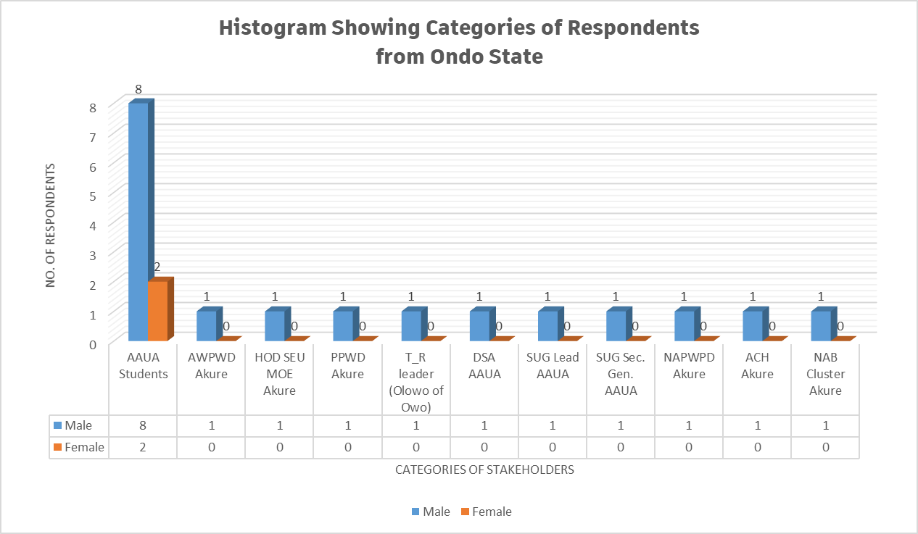
Figure 2.26. A Histogram Showing Categories of Respondents Based on Gender for Ondo State
Figures 2.26a and 2.26b shows a pie chart indicating the percentages of the male and female respondents from Ondo State.
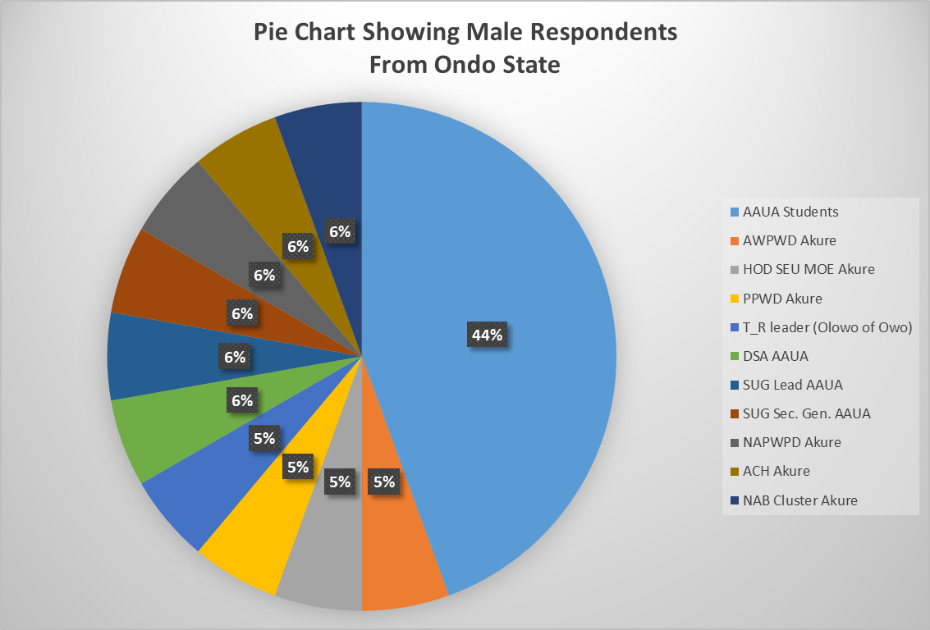
Figure 2.26a. Pie Chart Showing Number of Male Respondents (%) for
Ondo State

Figure 2.26a. Pie Chart Showing Number of Female Respondents (%) for
Ondo State
2.17.1.2 Analysis Socio-Demographic Information of Respondents from Ondo State
Table 2.58 presents the socio-demographic information of the respondents from Ondo State. Column 2 of Table 2.58 indicated the ranges of age of respondents from Ondo State and columns 3 and 4 indicated the number of respondents and their corresponding percentages based on range of ages respectively.

Table 2.58. Analysis of Socio-demographic information of the respondents from
Ondo State
S/N | AGE OF  RESPONDENT  (years) | NO. OF  RESPONDENTS | RESPONDENTS No.  (%)
1 | 18 – 25 | 10 | 50
2 | 25 – 40 | 4 | 20
3 | 40 – 65 | 5 | 25
4 | 65 and above | 1 | 5
 | Total | 20 | 100

Figure 2.27 presents the socio-demographic information of respondents from Cross River State indicating their ranges of age (years) as well the number of persons participated in the interview. From both Table 2.78 and Figure 2.27, 50% of the respondents from Ondo State are in the age range of 18 – 25 and 20% are between 25 – 40 years of age, 25% ranged between 40 and 65 years and 5% of the respondents are 65 years of age.

Figure 2.27. Socio-Demographic Information of Respondents Indicating Age Range (Ondo State)

2.17.1.3 Data Analysis of Respondents Based on Disability (Ondo State)
Table 2.59 presents the categories of respondents on the basis of disability and the number of respondents participated from each category in Ondo State. From the Table, 6 out of the 20 respondents doesn’t have any kind of disability and this number come from other stakeholders such as CRSA, PPWD, T_R leaders (Islamic Org.), UNICAL Staff, etc.

Table 2.59. Category of Respondents on the Basis of Disability (Ondo State)
S/N | DISABILITY | NO. OF RESPONDENT | RESPONDENTS NO.  (%)
1 | Physical (P) | 4 | 20
2 | Blind (B) | 2 | 10
3 | Leprosy/IDEA (L) | 0 | 0
4 | Albinism (Al) | 1 | 5
5 | Spinal cord injury (SCIAN) | 3 | 15
6 | Deaf (D) | 3 | 15
7 | Deaf/Blind (DB) | 0 | 0
8 | Psychosocial (Psy) | 0 | 0
9 | Mental (M) | 0 | 0
10 | None (N) | 7 | 35
 | Total | 20 | 100

Figure 2.59 presents a histogram indicating the categories of respondents who participated in the interview exercise on the basis of disability. From the figure, for instance, the respondents without disability are six (6) out 20 with the corresponding percentage of 20. None of the respondents interviewed were found to be mental, deaf/blind or affected by leprosy.
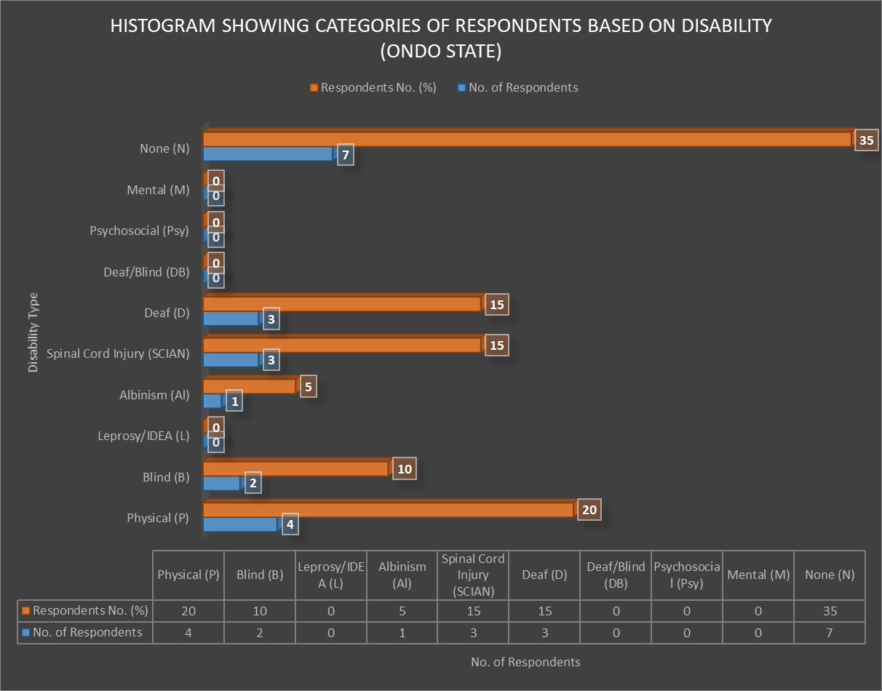
Figure 2.28. Categories of Respondents on the Basis of Disability (Ondo State)

2.17.1.4 Data Analysis on General Questions on IE Vis-à-vis SNE (Ondo State)
Table 2.60 presents the data analysis of the general questions on Inclusive Education vis-à-vis special needs education to the respondents who participated in the interview exercise. In the Table, number of respondents and percentages of the statements 1 – 10 are indicated by the choices: Excellently Well, Well Enough, Partly Well and Not At All.

Table 2.61. Response to General Questions on IE vis-à-vis SNE (Ondo State)
S/N | STATEMENT | Responses and  No. of Respondents
S/N | STATEMENT | Excellently Well | Well Enough | Partly Well | Not at All
1 | How well do you understand the concept of inclusive education? | 1  (5% of 20) | 6  (30% of 20) | 10  (50% of 20) | 3  (15% of 20)
2 | How well do you understand the concept of Special Needs Education? | 1  (5% of 20) | 4  (20% of 20) | 13  (65% of 20) | 2  (10% of 20)
3 | How well do you understand the Nigerian Discrimination Against Persons with Disabilities Act? | 3  (15% of 20) | 2  (10% of 20) | 10  (50% of 20) | 5  (25% of 20)
4 | How well do you understand Goal 4 of the Sustainable Development Goals? | 0  (0% of 20) | 1  (5% of 20) | 2  (10% of 20) | 17  (85% of 20)
5 | How well do you understand Article 24 of the Convention on the Rights of Persons with Disabilities? | 0  (0% of 20) | 1  (5% of 20) | 3  (15% of 20) | 16  (80% of 20)
6 | How well do you know national policies and reforms on education in Nigeria? | 0  (0% of 20) | 2  (10% of 20) | 6  (30% of 20) | 12  (60% of 20)
7 | How well do you know national plan on education in Nigeria? | 0  (0% of 20) | 2  (10% of 20) | 9  (45% of 20) | 9  (45% of 20)
8 | How well do you understand the difference between Special Needs and Inclusive Education? | 1  (5% of 20) | 7  (35% of 20) | 10  (50% of 20) | 2  (10% of 20)
9 | How well do you think learners with disabilities and without disabilities can co-learn? | 1  (5% of 20) | 11  (55% of 20) | 8  (40% of 20) | 0  (0% of 20)
10 | How well do you know the Salamanca Statement and framework for action on special needs education? | 0  (0% of 20) | 0  (0% of 20) | 0  (0% of 20) | 20  (100% of 20)

Table 2.61 shows the summary of the responses (%) by the respondents participated in the interview exercise. The Table summarizes Table 2.61 above.

Table 2.62. Responses (%) on the General Concepts of IE vis-a-via SNE (Ondo State)
STATEMENT | Response:  Excellently Well | Response:  Well Enough | Response:  Partly Well | Response:  Not At All
Statement 1 | 5% | 30% | 50% | 15%
Statement 2 | 5% | 20% | 65% | 10%
Statement 3 | 15% | 10% | 50% | 25%
Statement 4 | 0% | 5% | 10% | 85%
Statement 5 | 0% | 5% | 15% | 80%
Statement 6 | 0% | 10% | 30% | 60%
Statement 7 | 0% | 10% | 45% | 45%
Statement 8 | 5% | 35% | 50% | 10%
Statement 9 | 5% | 55% | 40% | 0%
Statement 10 | 0% | 0% | 0% | 100%

Figure 2.29 presents the responses by the respondents (in %) from Ondo State on the general concept of Inclusive Education vis-à-vis Special needs education. From this figure, about 50% of the respondents partially understand statement 1 which is referring to the general concepts of IE and none of the respondents knew the Salamanca statement and framework of action on special needs action which indicated 100% of the respondents stated that they don’t have idea on the scenario.

Figure 2.29. Responses on General Concepts of IE Vs SNE (Ondo State)
2.17.1.5 Analysis of Barriers faced by Person with Disabilities in Learning Environment (Ondo State)
Table 2.63 presents the Analysis of barriers faced by Person with Disabilities in learning environment around Ondo State. Each barrier was classified as options (a) to (e). From the Table, each option selected by the respondents has been ticked in their respective columns. In this case also, twenty (20) respondents from Ondo State and from learners with disabilities and other stakeholders in the State.
Table 2.63. Analysis of barriers faced by Person with Disabilities in Learning Environment

(Ondo State)
S/N | BARRIERS | (a) | (b) | (c) | (d) | (e)
1 | Physical Barriers: e.g  - Inaccessible services  - Long distances  - damaged infrastructure  - No ramp | 20  (100% of 20) | 20  (100% of 20) | 20  (100% of 20) | 20  (100% of 20)
2 | Institutional Barriers: e.g  - Limited availability of services,  - Limited technical capacity/training of service providers  - Policies and curriculum  - Funding | 20  (100% of 20) | 20  (100% of 20) | 20  (100% of 20) | 20  (100% of 20)
3 | Attitudes and Perceptions: e.g.  - Stigma  - Fear  - Bullying and harassment  - Discrimination | 20  (90% of 20) | 17  (85% of 20) | 16  (80% of 20) | 20  (100% of 20)
4 | Communication Barriers: e.g.  - No Assistive Technology Devices  - No Brail  - No Sign language Interpreters  - Obstacles to access or conveying information  - Untrained staff | 20  (100% of 20) | 20  (100% of 20) | 20  (100% of 20) | 17  (85% of 20) | 20  (100% of 20)
5 | Intersectional Identities: e.g.  - Age  - Ethnicity  - Religion,  - Poverty,  - Gender | 15  (75% of 20) | 16  (80% of 20) | 20  (100% of 20) | 20  (100% of 20) | 0  (0% of 20)

Figure 2.30 present the histogram on data analysis with regard to the barriers faced by Person with Disabilities in learning environment around Ondo. We have 20 respondents in this section who participated in the interview. All the respondents identified the barriers from (a) to (d). From both Table 2.64, for instance, for institutional barrier; 100% of the respondents (20 No,) ticked all options (a) to (d) as barriers faced by Person with Disabilities in their learning environment, i.e limited availability of services, limited technical capacity/training of service providers, policies and curriculum and funding respectively.
2.17.1.6 Analysis of the Responses of Specific Questions to Learners with Disabilities (Ondo State)
Table 2.65 presents the analysis of the responses of specific questions to learners with disabilities (students). The questions were administered to students from AAUA in the South Western geopolitical zone of the federation.
Table 2.65 Analysis of Responses of Specific Questions to Learners with Disabilities (AAUA Students)_Ondo State
S/N | SPECIFIC QUESTIONS TO LEARNERS WITH DISABILITIES | RESPONSES BY  AAUA STUDENTS | NO. OF RESPONSES (%)
1 | What are the problems you faces in school? (Interrogate on design co-learners, curriculum, develop assessment systems, teachers, staff and physical facilities, and formulate and adapt operation policies etc)? | - Inadequate accommodation facilities  - Transport facilities  - No trained teachers for IE policy implementation  - No assistive technology devices | 8  (80% of 10)
2 | Do you think the government is doing enough to support your parents to advance your right to education? | Government is not doing enough to support our parents | 10  (100% of 10)
3 | How do you expect government/your school to help learners with disabilities get education easily? | - Provide scholarship for Person with Disabilities  - Provide assistive technology devices, e. g. braille materials, digital recorders for Person with Disabilities | 10  (100% of 10)
4 | What would enable you to access structures in equal matter? | Provide learning aids | 10  (100% of 10)
5 | How are your relationships with your co-learners? Segregated, Integrated, Inclusive | Inclusive | 9  (90% of 10)
6 | How do you access/return information as the institution demands? | Through WhatsApp platform | 9  (90% of 10)
7 | Is there funding for your student supports (scholarships, loans, etc.? Have you been able to access any? If yes, what the process of accessing it challenging or otherwise? | Yes, but not adequate | 10  (100% of 10)
6 | Do you experience any form of attitude that promotes any form of abuse, exploitation or exclusion at school? | No | 7  (70% of 10)
7 | Are there specific coping strategies employed by you to address barriers faced at school? If so, what are they, and how can they be supported or strengthened? Who/What facilitated it | No | 8  (80% of 10)
8 | Is there any form of remote and/or home-based learning initiatives with close engagement of focused support to enable you to catch up, prevent drop-out and/or re-enroll in formal education? | No | 10  (100% of 10)

2.17.1.8 Analysis of Hierarchy of the Structures that Support Person with Disabilities in Learning Environment (Ondo State)
Table 2.66 presents the data analysis on the hierarchy of the structures that support Person with Disabilities in the learning environment for Ondo PEA analysis on IE in the South Western part of Nigeria.

Table 2.67. Analysis Hierarchy of Structures that Support Person with Disabilities in Learning Environment (Ondo State)
S/N | SUPPORT AREA | TICKED BY RESPONDENTS  (AAUA STUDENTS)
1 | School Governing Body | - Respondents  (80% of 10)
2 | Traditional/Religious Entities | - Respondents  (70% of 10)
3 | Counselling Learning Support Specialist (Remedial Teacher) | - Respondents  (60% of 10)
4 | Career Advisor | - Respondents  (100%)
5 | Parents | 10 Respondents  (100% of 10)
6 | JONAPWD | 10 Respondents  (100% of 10)
7 | Disability Commission | 10 Respondents  (100% of 10)
8 | Co-students | - Respondents  (70% of 10)
9 | Other (please specify) | 0  (0% of 10)

From Table 2.67, for instance, 80% (8 No. out 10 students) of the respondents ticked governing body as a hierarchical structure that support Person with Disabilities around Ondo State, 100% of the respondents each ticked parents, JONAPWD, and disability commission as the most preferable areas that Person with Disabilities needs more support in the learning environment.

2.18 ANALYSIS OF NON-NUMERICAL (TEXT) DATA FOR PEA ON IE IN ONDO STATE
This section presents the non-numerical (text) data collated from the various stakeholders in Ondo State such as learners with disabilities (AAUA students), learning institution (AAUA), Parent of Persons with Disabilities, government, e.g. HOD SEU MOE Akure, T_R leaders (Olowo of Owo land), etc.
2.18.1 ANALYSIS OF RESPONSES FOR JONAPWD FCT LEAD/CLUSTER HEADS /GOVERNMENT (ONDO STATE)
Table 2.68 presents the data on the responses to the questions administered to learning institution (DSA of AAUA) on the implementations of policies of IE in Ondo State.
Table 2.68. Data Presentation on the Responses to Questions for learning Institution (DSA of AAUA) _ONDO STATE
S/N | Question | Responses
1 | What are the realities with learners and persons with disabilities in the institution? (Interrogate on design curriculum, develop assessment systems, teachers, staff and physical facilities, and formulate and adapt operation policies etc.)(ambiguous) | - There is a hostel in AAUA designed to accommodate Person with Disabilities  - All new buildings in the institution are designed to be accessible to Person with Disabilities on wheelchairs
2 | What are the means you employ to collate data on rates of enrolments of learners with disabilities in relation to their education? | - No special criteria for data collation
3 | Do your curriculum/ policies reflect disability requirements? Please explain | No
4 | Do you have a percentage for actualizing disability inclusion in your annual budget? If yes, what are the specified needs? | No annual budget allocation for disability inclusion in AAUA
5 | What are the methods of awareness raising campaigns and activities employed to promote inclusive education (or education rights) and inform students and staff, and the general public of the duty to provide, and the right to inclusive education and related benefits for society? | None at this moment
6 | What are the consultation processes undertaken to ensure the active involvement of persons with disabilities, notably parents of children with disabilities, including through their representative organizations, in the design, implementation and monitoring of laws, regulations, policies and programmes, related to education initiatives and reform of the institution? | None at this moment
7 | What proportion of received complaints on the right to education alleging discrimination on the basis of disability and/or involving children, youth and adults with disabilities that have been investigated and adjudicated? How have they been addressed? | It was not recorded before
8 | Have you ever engaged any association/agency/Department on the implementation of policies leading to equal education rights for persons with disabilities? If not, why? If yes, what were your findings? | No
9 | Are there ongoing any form of engagements with the private sector to support the educational rights of Person with Disabilities? Please enlist | No
10 | Does your Institution provide any forms of training of technical personnel “on managing inclusive education and delivering special needs education? Please elaborate | No
11 | Has your institution procured or received any learning aid for Person with Disabilities in the past? Please explain? | No

Table 2.69 presents the data on the responses to the questions administered to learning institution (SUG of AAUA) on the implementations of policies of IE in Ondo State.
Table 2.69. Data Presentation on the Responses to Questions for learning Institution (SUG of AAUA) _ONDO STATE
S/N | Question | Responses
1 | What are the realities with learners and persons with disabilities in the institution? (Interrogate on design curriculum, develop assessment systems, teachers, staff and physical facilities, and formulate and adapt operation policies etc.)(ambiguous) | - Person with Disabilities have separate hostel with the provision of wheelchairs  - Person with Disabilities are also members of Students Representative Council (SRC)  - Person with Disabilities were allocated front seat in the lecture halls  - SUG paid periodic visit to hostel of Person with Disabilities to know their welfare
2 | What are the means you employ to collate data on rates of enrolments of learners with disabilities in relation to their education? | - No any other means
3 | Do your curriculum/ policies reflect disability requirements? Please explain | No
4 | Do you have a percentage for actualizing disability inclusion in your annual budget? If yes, what are the specified needs? | Not aware
5 | What are the methods of awareness raising campaigns and activities employed to promote inclusive education (or education rights) and inform students and staff, and the general public of the duty to provide, and the right to inclusive education and related benefits for society? | None at this moment
6 | What are the consultation processes undertaken to ensure the active involvement of persons with disabilities, notably parents of children with disabilities, including through their representative organizations, in the design, implementation and monitoring of laws, regulations, policies and programmes, related to education initiatives and reform of the institution? | None at this moment
7 | What proportion of received complaints on the right to education alleging discrimination on the basis of disability and/or involving children, youth and adults with disabilities that have been investigated and adjudicated? How have they been addressed? | Not aware
8 | Have you ever engaged any association/agency/Department on the implementation of policies leading to equal education rights for persons with disabilities? If not, why? If yes, what were your findings? | No
9 | Are there ongoing any form of engagements with the private sector to support the educational rights of Person with Disabilities? Please enlist | No
10 | Does your Institution provide any forms of training of technical personnel “on managing inclusive education and delivering special needs education? Please elaborate | No
11 | Has your institution procured or received any learning aid for Person with Disabilities in the past? Please explain? | No

Table 2.70 presents the data on the responses to the questions administered to Parent of Person with Disabilities Akure (Ondo State) on the implementations of policies of IE.

Table 2.70. Data Presentation on the Responses to the Questions for Parent of Person with Disabilities Akure_ONDO STATE
S/N | Question | Responses
1 | What do you think about Inclusive Education? | I don’t support IE
2 | What do you think about Special Needs Education? | Supported SNE because Person with Disabilities benefitted more in special schools
3 | Are you involved in decision making concerning your child’s education? At least explain how you are involved in your child’s education | Yes, I have been the chairman of the Parents Teachers Association (PTA) for School for the Visually Impaired Owo (SVIO) for long period of time
4 | What are some of the major barriers your child encounters in accessing education? | SVIO is wholly controlled by government with insufficient funding and under staff
5 | Do you think the nature of your child’s disability influences his or her educational progress in school? | Disability negatively influences the child’s education
6 | In your opinion, do information barriers exist? Is information regarding availability of assistance accessible to your child at school? | No information barrier
7 | Do prevailing perceptions of Person with Disabilities promote any form of abuse, exploitation or exclusion at school? | Prevailing perceptions of Person with Disabilities naturally promote abuse, exploitation or exclusion at school.
8 | Are there specific coping strategies employed by your child and facilitated by you or an Organization to address barriers your child faces at school? If so, what are they, and how can they be supported or strengthened? | Brothers of Person with Disabilities read and/or make voice recording of some books so that he will braille them
9 | Would schooling for your child with disability mean reduced means of livelihood? | Needs to spend more for Person with Disabilities than those without disabilities
10 | Do you perceive this as a barrier to sustaining income-generating opportunities and additional expenses at the household level? | Parent of Person with Disabilities are advised to encourage children
11 | Do you have any other advice, comment freely | Urged government to fulfil promises made for Person with Disabilities

Table 2.71 presents the data on the Responses to the questions to T_R Leader (Traditional Ruler: OOL Akure)_ONDO STATE

Table 2.71. Data Presentation on the Responses to the Questions for T_R Leader (Traditional Ruler: OOL Akure)_ONDO STATE
S/N | Question | Responses
1 | What is your perception about Person with Disabilities? | Person with Disabilities must be properly taken care of in order in order not to be dependents
2 | What do you think about IE? | IE is the best way to bring all learners together in the same place
3 | What do you think about SNE? | Supported SNE at primary and secondary school level and hence IE at tertiary institution level
4 | Have you been approached by any person/entity/ etc. concerning the education of someone with a disability? If yes, what kinds of supports did you offer? | No
5 | Will your Organization do more to improve advocacy support for disability rights? | Promised to support advocacy on the rights of Person with Disabilities

2.19 THEMATIC METHOD OF ANALYSIS FOR NON-NUMERICAL (TEXT) DATA COLLATED FROM ONDO FOR PEA ANALYSIS FOR ONDO STATE
The following steps were strictly adhered in the analysis of non-numerical data collated for PEA in Ondo State.
Step 1: Familiarization of Collated Data from Ondo State
In this step, the responses of the administered questionnaires distributed to various stakeholders have been thoroughly read to have the general idea on the collated data.
Step 2: Coding of Non-numerical (Text) Collated Data from State
This includes highlighting or labelling certain words or group of words or even phrases in the data that all together indicates something that will grab the essence of the data.
Table 2.89 present the coding of the non-numerical collated data from Ondo State on IE for PEA Analysis.

Table 2.72. Analysis and Coding of Non-Numerical (Text) Data Collated for PEA on IE from ONDO STATE
S/N | INTERVIEW  QUESTIONS | INTERVIEW  EXTRACT REPONSES BY VARIOUS RESPONDENTS | CODE(S)
 | POLITICAL CONTEXT OF IE IN ONDO STATE
1 | What is the context of education for persons with disabilities in the state? (Interrogate on design curriculum, develop assessment systems, teachers, staff and physical facilities, and formulate and adapt operation policies etc)? | - The Ondo State government established AWPWD for the right and wellbeing of Person with Disabilities in the State  - AAUA has not reviewed their curriculum to accommodate IE | - Curriculum Design,  - Staff Training required  - Lack of Infrastructural accessibility
 | INCLUSIVE EDUCATION VIS-À-VIS SPECIAL NEEDS EDUCATION
2 | What do you think about the progress of Inclusive Education Vis-à-vis Special Needs Education? | - A PPWD mentioned that SNE should be given emphasis more than IE | - IE & SNE Policies
 | ENROLMENTS/DATA OF PERSON WITH DISABILITIES IN SCHOOLS_ONDO STATE
3 | What are the means you employ to collate data on rates of enrolments of Person with Disabilities in relations to education (primary, secondary, tertiary educational institutions, vocational training, lifelong learning courses, as compared to others, disaggregated by sex, age, disability, minority or indigenous background, grade and level of education)? The progress of Inclusive Education Vis-à-vis Special Needs Education? | - AAUA has no specific criteria for data collation on the enrollments of Person with Disabilities  - No means of data collation by other stakeholders | - No specific means of Data Collation by AAUA and other stakeholders
 | METHODS OF PROMOTING INCLUSIVE EDUCATION_ONDO STATE
4 | What are the methods of awareness raising campaigns and activities employed to promote inclusive education (Please insert whether: government, students, education staff, families and the general public of the duty to provide, and the right to inclusive education and related benefits for society)? | - All new buildings in AAUA are to accommodate Person with Disabilities with provision of wheelchairs. There is currently a hostel to accommodate Person with Disabilities on wheelchairs in the campus  - No any other method of awareness in AAUA currently | - Accessibility of public buildings in AAUA with provision of wheelchairs
 | BUDGET ALLOCATION TO INCLUSIVE EDUCATION_ONDO STATE
5 | How is the budget allocated to ensure the right of Person with Disabilities to inclusive education in mainstream settings, as compared to budget allocated to segregated/separated education settings, whether in mainstream or special schools? | - No annual budget allocation for disability inclusion in AAUA  - SVIO is underfunded with inadequate number of staff | - No exclusive Budget Allocations for IE
CONSULTATIONS AND MONITORING/IMPLEMENTATION OF LAWS & IE POLICIES IN
ONDO STATE

6 | What are the consultation processes undertaken to ensure the active involvement of Person with Disabilities, notably parents of children with disabilities, including through their representative organizations, in the design, implementation and monitoring of laws, regulations, policies and programmes, related to education initiatives and reform? | - Parent of Persons with Disabilities spends on Person with Disabilities than normal child | - Consultations of Parent of Persons with Disabilities
 | COMPLAINTS ON DISCRIMINATION FOR Person with Disabilities
7 | What proportion of received complaints on the right to education alleging discrimination on the basis of disability and/or involving children, youth and adults with disabilities that have been investigated and adjudicated? How have they been addressed? | - AAUA has not received any complaint alleging discrimination on Person with Disabilities  - There is a PWD who is an SRC member in AAUA  - Person with Disabilities were allocated front seat in lecture halls  - SUG representative paid visit periodically to hostel designed for Person with Disabilities  - A PPWD has been the PTA Chairman for longer period of time | - No Complaints alleging Discrimination for Person with Disabilities
 | COURTESY VISIT TO INSTITUTIONS LEADING TO IMPLEMENTATIONS OF IE POLICIES
8 | Have you ever purposely visited any of the learning institutions belonging to either Federal or State government or private in your state to witness the implementation of policies leading to equal education rights for person with disabilities? If not, why? If yes, what were your findings? | - T-R leaders promised to give more advocacy support to Person with Disabilities | - Courtesy Visit to Institutions
 | COURTESY VISIT TO AGENCIES FOR DISABILITY MATTERS/BOARDS/NCPWD
9 | Have you ever visited any of the relevant Agencies/Boards and Parastatals, National Commission for Persons with Disabilities and/or State Agencies for Disability Matters for details implementations of equal rights for Person with Disabilities? Please explain? | - No any form of visitation is recorded by stakeholders | - Courtesy Call/Visit to Agencies
 | TRAINING OF TECHNICAL PERSONNELS BY MINISTRIES/AGENCIES
10 | Does your Ministry/Agencies/Association/Cluster provide any forms of training of technical personnel “on managing inclusive education and delivering special needs education? | - Skilled and trained teachers for IE are necessary as disability negatively influenced child’s education  - No any form of training for technical personnel is recorded in AAUA | - Intensive Staff Training of Teachers on IE and SNE
 | ENGAGEMENT OF PRIVATE SECTORS/PARTNERS
11 | Are there any ongoing engagements with the private sector to support the education rights of Person with Disabilities? | - No engagement with private sector is recorded  - No any other form of engagement with other department/agencies and/or private sector is recorded in AAUA | - No Partnership with private sectors, NGOs & CSOs
 | PROVISIONS OF LEARNING AIDS TO Person with Disabilities
12 | Have your agencies/association procured or received any learning aid for Person with Disabilities in the past? | - No any procurement or received of learning aids is recorded in AAUA in the past  - Some Person with Disabilities asked their colleagues to make voice recordings of some books so that they will braille them | - Learning Aids/Assistive Devices

Step 3: Theme(s) Generation
The created themes were read through and patterns were also created among them. Themes are generally broader than codes. In broad sense, several codes could be combined and also transform into single theme.
However, Table 2.90 present the data transformation from code to theme(s).

Table 2.73. Data Coding – Theme Transformation for Non-Numerical Data from
ONDO STATE
S/N | CODES | THEMES
1 | - Curriculum Design,  - Staff Training required  - Lack of Infrastructural accessibility | Curriculum and staff training
 | - IE & SNE Policies | IE/SNE policies
 | - No specific means of Data Collation by AAUA and other stakeholders | Data enrolment
 | - Accessibility of public buildings in AAUA with provision of wheelchairs | Infrastructural access
 | - No exclusive Budget Allocations for IE | Budget allocation
 | - Consultations of Parent of Persons with Disabilities | Involvement of Person with Disabilities
 | - No Complaints alleging Discrimination for Person with Disabilities | Discrimination for Person with Disabilities
 | - Courtesy Visit to Institutions | Visitation to institutions
 | - Courtesy Call/Visit to Agencies | Visitation to agencies
 | - Intensive Staff Training of Teachers on IE and SNE | Staff training
 | - No Partnership with private sectors, NGOs & CSOs | Engagement of private sectors
 | - Learning Aids/Assistive Devices | Learning aids

Step 4: Reviewing Theme(s)
In this steps, themes were checked and certified to be the accurate representation of the data sets. The themes were also really testified to be present in the data set.
Step 5: Defining and Naming Theme(s)
This involved formulating exactly what each theme mean and how it will help understand the data set.
Table 2.73 presents the definitions of the coded themes for non-numerical data from Ondo State.

Table 2.73. Definition of Themes for Non-Numerical Data from Ondo State
S/N | CODES | THEMES
1 | Curriculum and staff training | The existing curriculum should be reviewed to reflect disability requirements
2 | IE/SNE policies | There exist National policy on IE
3 | Data enrolment | Major stakeholders doesn’t have specific method of data collation including AAUA
4 | Infrastructural access | Physical structures in learning institutions are disability friendly
5 | Budget allocation | IE is not funded by the State government
6 | Involvement of Person with Disabilities | Person with Disabilities are not involved in decision making
7 | Discrimination for Person with Disabilities | There was no official complaint on discrimination for Person with Disabilities
8 | Visitation to institutions | There was no courtesy visits to learning institutions and agencies on disability matters
9 | Visitation to agencies
10 | Staff training | There was no training of technical staff to manage Person with Disabilities
11 | Engagement of private sectors | Private sectors were not engaged by stakeholders
12 | Learning aids | There was no record of procurement of learning aids by AAUA and other stakeholders

Step 6: Summary/Conclusion of PEA Analysis on Inclusive Education in Ondo State
To implement the policies of IE in Ondo State:
- The established AWPWD by the Bauchi State government may greatly enhance the educational rights and wellbeing of Person with Disabilities in the State.
- There must revised curriculum that reflect disability requirements to accommodate IE policies in the State.
- No specific method of data collation unless through students sessional registration.
- There is the need for intensive training of teachers and other technical personnel.
- No visitation to the relevant stakeholders is recorded by AWPWD or other stakeholders.
- There was no accessibility to old public Infrastructures in AAUA and other institutions in Ondo State but all new buildings are now designed to be disability friendly. There is currently a disability friendly hostel in AAUA that is disability friendly and with provision of wheelchairs for students with special needs.
- There was no any form of engagement with AWPWD and learning institutions in the State like AAUA.
- There is need for due consultations of Parent of Persons with Disabilities to be involved in decision making for education of their children.
- There was no official complaints alleging discrimination on Person with Disabilities in the learning institutions in the State.
- No procurement of learning aids/assistive devices is recorded by AAUA and other relevant stakeholders.
- There was communication barriers,.e.g. lack of sign language interpreters in lecture halls/theatres in learning institutions
2.19.1 GAPS IDENTIFIED IN PEA RESAERCH ON IE FOR ONDO STATE
(SOUTH – WEST GEOPOLITICAL ZONE)
The gap(s) identified as a result of PEA analysis on IE around Ondo using “Thematic Method” of qualitative analysis include the following:
- Although the Ondo government created AWPWD to ensure the rights of Person with Disabilities in the State but still lack the implementations of the policies.
- There was no accessibility to old public Infrastructures in AAUA but all new buildings are designed to be disability friendly.
- There was no exclusive budget for IE in the institutions of Ondo State, e.g. AAUA.
- No gap identified alleging discrimination for Person with Disabilities in Ondo State
- No skilled and trained teachers/lecturers for better implementation of Inclusive education policies in the institutions
- No provision of learning aids/assistive devices for Person with Disabilities
- No engagement with private sectors and NGOs by the learning institutions and relevant stakeholders in the State.
- There was communication barriers,.e.g. lack of sign language interpreters in lecture halls/theatres in learning institutions

2F:
ANALYSIS OF PEA RESULTS ON INCLUSIVE EDUCATION FROM
BAUCHI STATE

2.14. POLITICAL CONTEXT OF IE IN BAUCHI STATE
In order to ensure the rights of Person with Disabilities, the Bauchi State government has created Agency for Persons with Disabilities (APWD) to be in charge of the welfare and rights of Person with Disabilities around the State.

2.14.1 ANALYSIS OF NUMERICAL DATA FOR PEA ON IE FOR BAUCHI STATE
This section presents the numerical data presentation/collation and PEA analysis on IE Bauchi State in the North East geopolitical zone part of Nigeria.

2.14.1 Numerical Data Presentation and Analysis for PEA on IE for Bauchi State
The numerical data collected from Bauchi State was from the following categories of respondents, viz; learning institution (Abubakar Tatari Ali Polytechnic (ATAP)), learners with disabilities (ATAP students), APWD Bauchi State, T_R leader (District Head of Bauchi (DHB)), PPWD, JONAPWD Bauchi lead/Cluster Heads, etc.

2.14.2 Data Analysis by Category of Respondents from Bauchi State
Table 2.74 presents the distribution of data by categories of respondents. 16 persons were interviewed across the different stakeholders listed above.

Figure 2.31 present the graph showing the categories of respondents from Bauchi State participated in the exercise based on the gender sensitive.

Gender | ATAP  Students | Bauchi State  Government |  | T_R  Leaders  (DHB) | PPWD  Bauchi | Learning Institution  (ATAP) | JONAPWD Lead Bauchi/  Cluster Heads
Gender | ATAP  Students | APWD  Bauchi | MOE  Bauchi | T_R  Leaders  (DHB) | PPWD  Bauchi | Learning Institution  (ATAP) | JONAPWD | CLUSTER  HEAD
Male | 7 | 1 | 1 | 1 | 1 | 1 | 1 | 1
Female | 2 | 0 | 0 | 0 | 0 | 0 | 0 | 0
Total | 9 | 1 | 1 | 1 | 1 | 1 | 2

Table 2.92. Distribution of Questionnaire by Categories of Respondents (Bauchi State)

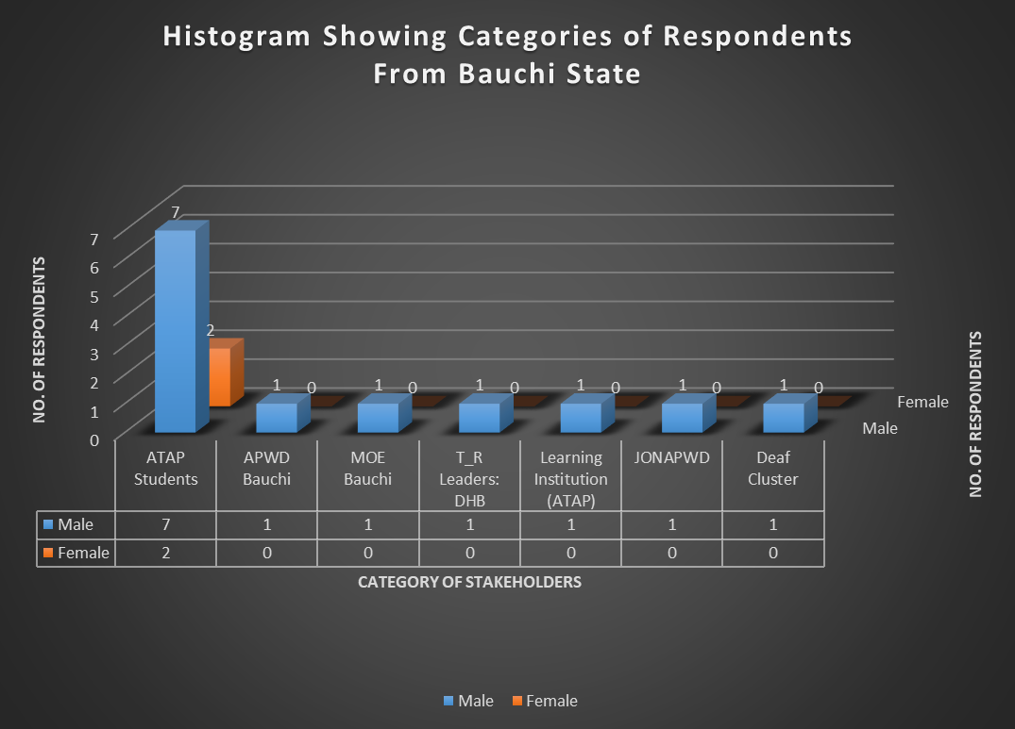
Figure 2.31. Histogram Showing Categories of Respondents From Bauchi State Based on Gender Sensitive
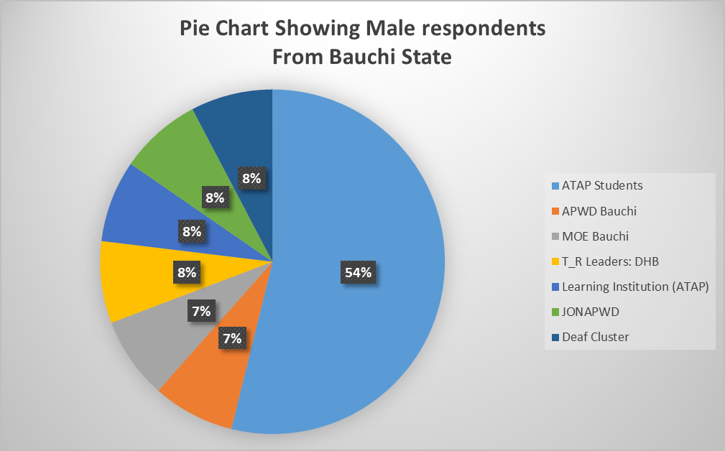
Figure 2.32a. Pie Chart Showing Number of Male Respondents (%) for
Bauchi State

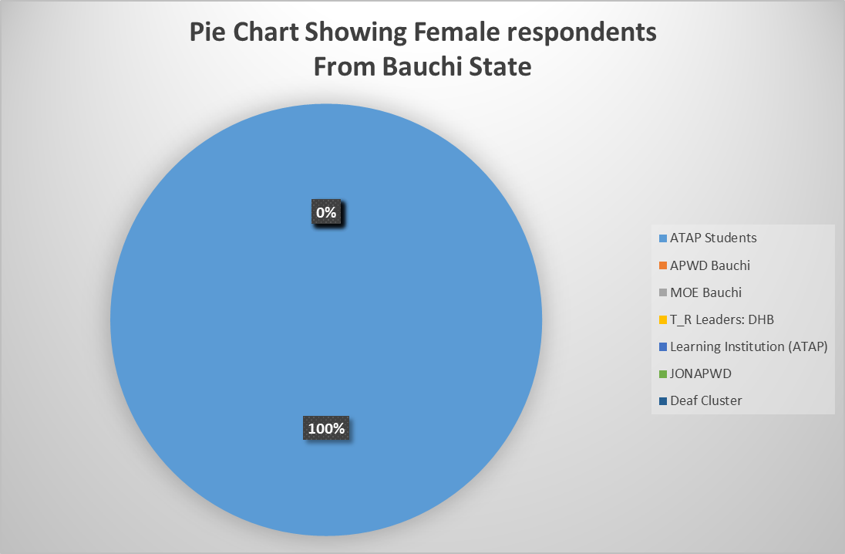
Figure 2.32a. Pie Chart Showing Number of Female Respondents (%) for
Bauchi State
2.14.4 Analysis of Socio-Demographic Information of Respondents from Bauchi State
Table 2.75 presents the socio-demographic information of the respondents from Bauchi State. Column 2 of Table 2.75 indicated the ranges of age of respondents from Bauchi State and columns 3 and 4 indicated the number of respondents and their corresponding percentages based on range of ages respectively.

Table 2.75. Analysis of Socio-demographic information of the respondents
from Bauchi State
S/N | AGE OF  RESPONDENT  (years) | NO. OF  RESPONDENTS | RESPONDENTS No.  (%)
1 | 18 – 25 | 8 | 53.3
2 | 25 – 40 | 3 | 20
3 | 40 – 65 | 3 | 20
4 | 65 and above | 1 | 6.7
 | Total | 15 | 100

Figure 2.33 presents the socio-demographic information of respondents from Cross River State indicating their ranges of age (years) as well the number of persons participated in the interview. From both Table 2.75 and Figure 2.10, 53.3% of the respondents from Bauchi State are in the age range of 18 – 25 and 20% are between 25 – 40 and 40 – 65 years of age, 6.7% are above 65 years of age.

Figure 2.33. Socio-Demographic Information of Respondents Indicating Age Range (Bauchi State)

2.14.5 Data Analysis of Respondents Based on Disability (Bauchi State)
Table 2.76 presents the categories of respondents on the basis of disability and the number of respondents participated from each category. From the Table, 4 out of the 15 respondents doesn’t have any kind of disability and this number come from other stakeholders such as APWD, PPWD, T_R leader (i.e. District Head of Bauchi (DHB)) and Staff ATAP.

Table 2.76. Category of Respondents on the Basis of Disability (Bauchi State)
S/N | DISABILITY | NO. OF RESPONDENT | RESPONDENTS NO.  (%)
1 | Physical (P) | 2 | 13.3
2 | Blind (B) | 2 | 13.3
3 | Leprosy/IDEA (L) | 0 | 0
4 | Albinism (Al) | 1 | 6.7
5 | Spinal cord injury (SCIAN) | 3 | 20
6 | Deaf (D) | 3 | 20
7 | Deaf/Blind (DB) | 0 | 0
8 | Psychosocial (Psy) | 0 | 0
9 | Mental (M) | 0 | 0
10 | None (N) | 4 | 26.7
 | Total | 15 | 100

Figure 2.34 presents a histogram indicating the categories of respondents who participated in the interview exercise on the basis of disability. From the figure, for instance, the respondents without disability are six (6) out 15 with the corresponding percentage of 20. None of the respondents interviewed were found to be mental, deaf/blind or affected by leprosy.

Figure 2.34. Categories of Respondents on the Basis of Disability (Bauchi State)

2.14.6 Data Analysis on General Questions on IE Vis-à-vis SNE (Bauchi State)
Table 2.77 presents the data analysis of the general questions on Inclusive Education vis-à-vis special needs education to the respondents who participated in the interview exercise. In the Table, number of respondents and percentages of the statements 1 – 10 are indicated by the choices: Excellently Well, Well Enough, Partly Well and Not At All.

Table 2.77. Response to General Questions on Inclusive Education vis-à-vis Special Needs Education (Bauchi State)
S/N | STATEMENT | Responses and  No. of Respondents
S/N | STATEMENT | Excellently Well | Well Enough | Partly Well | Not at All
1 | How well do you understand the concept of inclusive education? | 0  (0% of 15) | 2  (13.3% of 15) | 12  (80% of 15) | 1  (6.7% of 15)
2 | How well do you understand the concept of Special Needs Education? | 0  (0% of 15) | 1  (6.7% of 15) | 12  (80% of 15) | 2  (13.3% of 15)
3 | How well do you understand the Nigerian Discrimination Against Persons with Disabilities Act? | 0  (0% of 15) | 2  (13.3% of 15) | 10  (66.7% of 15) | 3  (20% of 15)
4 | How well do you understand Goal 4 of the Sustainable Development Goals? | 0  (0% of 15) | 1  (6.7% of 15) | 1  (6.7% of 15) | 13  (86.7% of 15)
5 | How well do you understand Article 24 of the Convention on the Rights of Persons with Disabilities? | 0  (0% of 15) | 1  (6.7% of 15) | 3  (20% of 15) | 11  (73.3% of 15)
6 | How well do you know national policies and reforms on education in Nigeria? | 1  (6.7% of 15) | 2  (13.3% of 15) | 10  (66.7% of 15) | 2  (13.3% of 15)
7 | How well do you know national plan on education in Nigeria? | 1  (6.7% of 15) | 2  (13.3% of 15) | 7  (46.7% of 15) | 5  (33.3% of 15)
8 | How well do you understand the difference between Special Needs and Inclusive Education? | 0  (0% of 15) | 2  (13.3% of 15) | 5  (33.3% of 15) | 8  (53.3% of 15)
9 | How well do you think learners with disabilities and without disabilities can co-learn? | 1  (6.7% of 15) | 9  (60% of 15) | 5  (33.3% of 15) | 0  (0% of 15)
10 | How well do you know the Salamanca Statement and framework for action on special needs education? | 0  (0% of 15) | 0  (0% of 15) | 0  (0% of 15) | 15  (100% of 15)

Table 2.56 shows the summary of the responses (%) by the respondents from Bauchi who participated in the interview exercise. The Table summarizes Table 2.56 above.

Table 2.78. Responses (%) on the General Concepts of IE vis-a-via SNE (Bauchi State)
STATEMENT | Response:  Excellently Well | Response:  Well Enough | Response:  Partly Well | Response:  Not At All
Statement 1 | 0% | 33.3% | 80% | 6.7%
Statement 2 | 0% | 6.7% | 80% | 13.3%
Statement 3 | 0% | 13.3% | 66.7% | 20%
Statement 4 | 0% | 6.7% | 6.7% | 86.7%
Statement 5 | 0% | 6.7% | 20% | 73.3%
Statement 6 | 6.7% | 13.3% | 66.7% | 13.3%
Statement 7 | 6.7% | 13.3% | 46.7% | 33.3%
Statement 8 | 0% | 13.3% | 33.3% | 53.3%
Statement 9 | 6.7% | 60% | 33.3% | 0%
Statement 10 | 0% | 0% | 0% | 100%

Figure 2.35 presents the responses by the respondents (in %) from Bauchi State on the general concept of Inclusive Education vis-à-vis Special needs education. From this figure, about 50% of the respondents partially understand statement 1 which is referring to the general concepts of IE and none of the respondents knew the Salamanca statement and framework of action on special needs action which indicated 100% of the respondents stated that they don’t have idea on the scenario.

Figure 2.35. Responses on General Concepts of IE Vs SNE (Bauchi State)

2.14.7 Analysis of Barriers faced by Person with Disabilities in Learning Environment (Bauchi State)
Table 2.58 presents the Analysis of barriers faced by Person with Disabilities in learning environment around Bauchi State. Each barrier was classified (a) to (e). From the Table, each option selected by the respondents has been ticked in their respective columns. In this case also, fifteen (15) respondents from Bauchi State and from learners with disabilities and other stakeholders in the State.
Table 2.79. Analysis of barriers faced by Person with Disabilities in Learning Environment

(Bauchi State)
S/N | BARRIERS | (a) | (b) | (c) | (d) | (e)
1 | Physical Barriers: e.g  - Inaccessible services  - Long distances  - Damaged infrastructure  - No ramp | 15  (100% of 15) | 15  (100% of 15) | 15  (100% of 15) | 15  (100% of 15)
2 | Institutional Barriers: e.g  - Limited availability of services,  - Limited technical capacity/training of service providers  - Policies and curriculum  - Funding | 15  (100% of 15) | 15  (100% of 15) | 15  (100% of 15) | 15  (100% of 15)
3 | Attitudes and Perceptions: e.g.  - Stigma  - Fear  - Bullying and harassment  - Discrimination | 15  (100% of 15) | 14  (93.3% of 15) | 14  (93.3% of 15) | 13  (86.7% of 15)
4 | Communication Barriers: e.g.  - No Assistive Technology Devices  - No Brail  - No Sign language Interpreters  - Obstacles to access or conveying information  - Untrained staff | 15  (100% of 15) | 15  (100% of 15) | 15  (100% of 15) | 15  (100% of 15) | 15  (100% of 15)
5 | Intersectional Identities: e.g.  - Age  - Ethnicity  - Religion,  - Poverty,  - Gender | 12  (80% of 15) | 11  (73.3% of 15) | 15  (100% of 15) | 15  (100% of 15) | 0  (0% of 15)

Figure 2.36 present the histogram on data analysis with regard to the barriers faced by Person with Disabilities in learning environment around Bauchi State. We have 15 respondents in this section who participated in the interview. From both Table 2.79 and Figure 2.36, for instance, the attitudes and perceptions barrier; none of the respondents identified all the barriers from (a) to (e). 93.3% (28 No.) of the respondents (15 No,) ticked option (a) as a barrier faced by Person with Disabilities in their learning environment, i.e stigma. Therefore, for attitudes and perceptions barrier, 93.3%, 90%, 86.7% and 90% of the respondents involved in Bauchi PEA analysis respectively ticked stigma, fear, bullying & harassment and discrimination.

Figure 2.36. Histogram Showing Barriers Faced by Person with Disabilities in Learning Environment_ Bauchi State
2.14.8 Analysis of the Responses of Specific Questions to Learners with Disabilities (Bauchi State)
Table 2.80 presents the analysis of the responses of specific questions to learners with disabilities (ATAP Students). The questions were administered to students from ATAP in the North Eastern geopolitical zone of the federation.
Table 2.80 Analysis of Responses of Specific Questions to Learners with Disabilities (ATAP Students)_Bauchi State
S/N | SPECIFIC QUESTIONS TO LEARNERS WITH DISABILITIES | RESPONSES BY  ATAP STUDENTS | NO. OF RESPONSES (%)
1 | What are the problems you faces in school? (Interrogate on design co-learners, curriculum, develop assessment systems, teachers, staff and physical facilities, and formulate and adapt operation policies etc)? | - Inaccessible structures for Person with Disabilities  - Abuse, stigma and harassment by lecturers  - No trained teachers for IE policy implementation  - No assistive technology devices | 8  (88.9% of 9)
2 | Do you think the government is doing enough to support your parents to advance your right to education? | Although government give us inadequate support to our education but also not doing enough to support our parents | 9  (100% of 9)
3 | How do you expect government/your school to help learners with disabilities get education easily? | By providing all the necessary supports such as awarding scholarship and provision of all the necessary assistive devices | 8  (88.9% of 9)
4 | What would enable you to access school in equal matter? | - Eliminate barriers associated with physical structures  - Provision of braille and other assistive devices  - Assign sign language interpreters in lecture halls | 9  (100% of 9)
5 | How are your relationships with your co-learners? Segregated, Integrated, Inclusive | Integrated and Inclusive | 9  (90% of 9)
6 | How do you access/return information as the institution demands? | With personal computer and braille | 7  (77.8% of 9)
7 | Is there funding for your student supports (scholarships, loans, etc.? Have you been able to access any? If yes, what the process of accessing it challenging or otherwise? | Benefitted scholarship once | 6  (66.7% of 9)
6 | Do you experience any form of attitude that promotes any form of abuse, exploitation or exclusion at school? | No, | 7  (77.8% of 9)
7 | Are there specific coping strategies employed by you to address barriers faced at school? If so, what are they, and how can they be supported or strengthened? Who/What facilitated it | Yes | 8  (88.8% of 9)
8 | Is there any form of remote and/or home-based learning initiatives with close engagement of focused support to enable you to catch up, prevent drop-out and/or re-enroll in formal education? | No | 8  (88.9% of 9)

2.14.9 Analysis of Hierarchy of the Structures that Support Person with Disabilities in Learning Environment (Bauchi State)
Table 2.81 presents the data analysis on the hierarchy of the structures that support Person with Disabilities in the learning environment for Bauchi PEA analysis on IE in the North Eastern part of Nigeria.

Table 2.81. Analysis Hierarchy of Structures that Support Person with Disabilities in Learning Environment (Bauchi State)
S/N | SUPPORT AREA | TICKED BY RESPONDENTS  (ATAP STUDENTS)
1 | School Governing Body | - Respondents  (100% of 9)
2 | Traditional/Religious Entities | - Respondents  (88.9% of 9)
3 | Counselling Learning Support Specialist (Remedial Teacher) | - Respondents  (60% of 9)
4 | Career Advisor | - Respondents  (100% of 9)
5 | Parents | 9 Respondents  (100% of 9)
6 | JONAPWD | 9 Respondents  (100% of 9)
7 | Disability Commission | 9 Respondents  (100% of 9)
8 | Co-students | - Respondents  (100% of 9)
9 | Other (please specify) | 0  (0% of 9)

From Table 2.81, for instance, 100% (9 No. out 9 students) of the respondents ticked governing body as a hierarchical structure that support Person with Disabilities around Bauchi State, 100% of the respondents each ticked parents, JONAPWD, and disability commission as the most preferable areas that Person with Disabilities needs more support in the learning environment.

2.14.10 ANALYSIS OF NON-NUMERICAL (TEXT) DATA FOR PEA ON IE IN BAUCHI STATE
This section presents the non-numerical (text) data collated from the various stakeholders in Bauchi State such as learning institution; Abubakar Tatari Ali Polytechnic (ATAP staff), learners with disabilities (ATAP students), Parent of Persons with Disabilities in Bauchi state, government such as Agency for Persons with Disabilities (APWD) Bauchi, T_R leaders like District Head of Bauchi (DHB), JONAPWD Bauchi Lead/Cluster Heads etc.
2.14.11 DATA PRESENTATION ANALYSIS OF RESPONSES FOR JONAPWD BAUCHI LEAD/CLUSTER HEADS /GOVERNMENT (BAUCHI STATE)
Table 2.82 presents the data on the responses to the questions administered to JONAPWD Bauchi Leads/Cluster Heads/Government (APWD Bauchi) on the implementations of policies of IE.

Table 2.82. Data Presentation on the Responses to Questions for Bauchi JONAPWD Lead/Cluster Heads/Government (APWD Bauchi)_BAUCHI STATE
S/N | Question | Responses
1 | What is the context of education for persons with disabilities in the state? (Interrogate on design curriculum, develop assessment systems, teachers, staff and physical facilities, and formulate and adapt operation policies etc)? | - The Bauchi State government created APWD in 2013 to ensure the welfare and rights of Person with Disabilities.  - The government provides learning aids to Person with Disabilities
2 | What do you think about the progress of Inclusive Education Vis-à-vis Special Needs Education? | - The Person with Disabilities attends public schools with free scholarship from government  - Learning materials are provided to Person with Disabilities every academic session
3 | What are the means you employ to collate data on rates of enrolments of Person with Disabilities in relations to education (primary, secondary, tertiary educational institutions, vocational training, lifelong learning courses, as compared to others, disaggregated by sex, age, disability, minority or indigenous background, grade and level of education)? The progress of Inclusive Education Vis-à-vis Special Needs Education? | Data is collated through the schools attended by Person with Disabilities, but no actual figure at present
4 | What are the methods of awareness raising campaigns and activities employed to promote inclusive education (Please insert whether: government, students, education staff, families and the general public of the duty to provide, and the right to inclusive education and related benefits for society)? | No any
5 | How is the budget allocated to ensure the right of Person with Disabilities to inclusive education in mainstream settings, as compared to budget allocated to segregated/separated education settings, whether in mainstream or special schools? | The APWD has currently proposed a budget that has passed the State Assembly and currently awaiting the approval of His Excellency (HE) the Executive Governor of Bauchi State
6 | What are the consultation processes undertaken to ensure the active involvement of Person with Disabilities, notably parents of children with disabilities, including through their representative organizations, in the design, implementation and monitoring of laws, regulations, policies and programmes, related to education initiatives and reform? | JONAPWD is being consulted by the agency when need arises
7 | What proportion of received complaints on the right to education alleging discrimination on the basis of disability and/or involving children, youth and adults with disabilities that have been investigated and adjudicated? How have they been addressed? | We have never received any kind of complain, only that the Agency has recently visited Special Education School in Bauchi and was not impressed with the food given by Person with Disabilities and reported to MOE for action.
8 | Have you ever purposely visited any of the learning institutions belonging to either Federal or State government or private in your state to witness the implementation of policies leading to equal education rights for person with disabilities? If not, why? If yes, what were your findings? | Even last year, the Agency visited Aminu Sale College of Education in the State and was highly impressed with how Person with Disabilities are being taken care of by the College
9 | Have you ever visited any of the relevant Agencies/Boards and Parastatals, National Commission for Persons with Disabilities and/or State Agencies for Disability Matters for details implementations of equal rights for Person with Disabilities? Please explain? | - Yes, both at local government and state level.  - Scholarship Board has been recently visited by APWD to know how super need students would be supported by the board
10 | Does your Ministry/Agencies/Association/Cluster provide any forms of training of technical personnel “on managing inclusive education and delivering special needs education? | Yes, we organized for capacity building workshop for Person with Disabilities in the State
11 | Are there any ongoing engagements with the private sector to support the education rights of Person with Disabilities? | Yes, with NGOs to ensure the educational rights of Person with Disabilities in the State
12 | Have your agencies/association procured or received any learning aid for Person with Disabilities in the past? | Yes, from individuals and organizations

Table 2.83 presents the data on the responses to the questions administered to Learning Institution (ATAP staff) on the implementations of policies of Inclusive Education.
Table 2.83. Data Presentation on the Responses to Questions for Learning Institution (ATAP staff)_BAUCHI STATE
S/N | Question | Responses
1 | What are the realities with learners and persons with disabilities in the institution? (Interrogate on design curriculum, develop assessment systems, teachers, staff and physical facilities, and formulate and adapt operation policies etc.)(ambiguous) | - Person with Disabilities enjoy free education in ATAP  - We provide computers to visually impaired students and wheelchair users
2 | What are the means you employ to collate data on rates of enrolments of Person with Disabilities in relations to education (primary, secondary, tertiary educational institutions, vocational training, lifelong learning courses, as compared to others, disaggregated by sex, age, disability, minority or indigenous background, grade and level of education)? The progress of Inclusive Education Vis-à-vis Special Needs Education? | Only during students registration. We don’t have accurate data for students enrolments
3 | Does your curriculum/policies reflect disability requirements? Please explain? | Our curriculum need to be reviewed to incorporate aspects of SNE. Our NCE students only takes course titled Special education
4 | Do you have a percentage for actualizing disability inclusion in your annual budget? If yes, what are the specified need? | We budgeted for the purchase of equipments for Person with Disabilities
5 | What are the methods of awareness raising campaigns and activities employed to promote inclusive education (or education rights) and inform students and staff, and the general public of the duty to provide, and the right to inclusive education and related benefits for society? | No any plan
6 | What are the consultation processes undertaken to ensure the active involvement of persons with disabilities, notably parents of children with disabilities, including through their representative organizations, in the design, implementation and monitoring of laws, regulations, policies and programmes, related to education initiatives and reform of the institution? | We now give consideration to Person with Disabilities unlike before
7 | What proportion of received complaints on the right to education alleging discrimination on the basis of disability and/or involving children, youth and adults with disabilities that have been investigated and adjudicated? How have they been addressed? | None
8 | Have you ever engaged any association/agency/Department on the implementation of policies leading to equal education rights for person with disabilities? If not, why? If yes, what were your findings? - Are there ongoing any form of engagements with the private sector to support the educational rights of Person with Disabilities? Please enlist | None
9 | Does your Institution provide any forms of training of technical personnel “on managing inclusive education and delivering special needs education? Please elaborate? | Nothing official
10 | Does your institution procured or received any learning aid for Person with Disabilities in the past? Please explain? | No

Table 2.84 presents the data on the responses to the questions administered to Parent of Persons with Disabilities Bauchi on the implementations of policies of IE.

Table 2.84. Data Presentation on the Responses to Questions for Parent of Persons with Disabilities Bauchi_BAUCHI STATE
S/N | Question | Responses
1 | What do you think about Inclusive Education? | It is a good practice
2 | What do you think about Special Needs Education? | SNE is good but IE is better
3 | Are you involved in decision making concerning your child’s education? At least explain how you are involved in your child’s education | Yes, mostly
4 | What are some of the major barriers your child encounters in accessing education? | SNE or IE are available in Kuje, FCT
5 | Do you think the nature of your child’s disability influences his or her educational progress in school? | Yes
6 | In your opinion, do information barriers exist? Is information regarding availability of assistance accessible to your child at school? | We get information from WhatsApp platform created for Parent of Persons with Disabilities, but nothing for assistance
7 | Do prevailing perceptions of Person with Disabilities promote any form of abuse, exploitation or exclusion at school? | No
8 | Are there specific coping strategies employed by your child and facilitated by you or an Organization to address barriers your child faces at school? If so, what are they, and how can they be supported or strengthened? | We got hearing aid for my deaf child
9 | Would schooling for your child with disability mean reduced means of livelihood? | It is economically boring
10 | Do you have any other advice, comment freely | No

Table 2.85 presents the data on the responses to the questions administered to T_R Leaders (Traditional Ruler: DHB) on the implementations of policies of IE.

Table 2.85. Data Presentation on the Responses to Questions for T_R Leader (Traditional Ruler: DHB)_BAUCHI STATE
S/N | Question | Responses
1 | What is your perception about Person with Disabilities? | Although they have one kind of disability, Person with Disabilities are human beings like and can add value to the society
2 | What do you think about IE? | I understand is an educational system that gives everyone equal opportunity in academic peruse
3 | What do you think about SNE? | I believed there is ability is disability because I personally have a daughter who is a physically challenged and also a graduate. The problem we don’t encourage Person with Disabilities
4 | Have you been approached by any person/entity/ etc. concerning the education of someone with a disability? If yes, what kinds of supports did you offer? | Yes
5 | Will your Organization do more to improve advocacy support for disability rights? | Yes, we will do more to ensure the rights and wellbeing of Person with Disabilities
6 | Any other comments? | Please fully commit yourself to the success of this research work. I really commend all the contributors of the research.

2.14.12 THEMATIC METHOD OF ANALYSIS FOR NON-NUMERICAL (TEXT) DATA COLLATED FROM BAUCHI FOR PEA ANALYSIS FOR BAUCHI STATE
The following steps were strictly adhered in the analysis of non-numerical data collated for PEA in Bauchi State in the North Eastern part of Nigeria.
Step 1: Familiarization of Collated Data from Bauchi State
In this step, the responses of the administered questionnaires distributed to various stakeholders have been thoroughly read to have the general idea on the collated data.

Step 2: Coding of Non-numerical (Text) Collated Data from Bauchi State
This includes highlighting or labelling certain words or group of words or even phrases in the data that all together indicates something that will grab the essence of the data. Table 2.104 present the coding of the non-numerical collated data from Bauchi State on IE for PEA Analysis.

Table 2.86. Analysis and Coding of Non-Numerical (Text) Data Collated for PEA on IE from BAUCHI STATE
S/N | INTERVIEW  QUESTIONS | INTERVIEW  EXTRACT REPONSES BY VARIOUS RESPONDENTS | CODE(S)
 | POLITICAL CONTEXT OF IE IN BAUCHI STATE
1 | What is the context of education for persons with disabilities in the state? (Interrogate on design curriculum, develop assessment systems, teachers, staff and physical facilities, and formulate and adapt operation policies etc)? | - Some Parent of Persons with Disabilities in Bauchi considered IE as a good practice  - The Bauchi State government created APWD for the rights and wellbeing of all Person with Disabilities in the State  - Curriculum needs to be reviewed to incorporate SNE and/or IE  - Many stakeholders considered Person with Disabilities as human and as such should be treated like everyone in the society | - Preserve Person with Disabilities Rights in Bauchi  - Curriculum Review  - Staff Training &  - Infrastructure Modification to Person with Disabilities access
 | INCLUSIVE EDUCATION VIS-À-VIS SPECIAL NEEDS EDUCATION
2 | What do you think about the progress of Inclusive Education Vis-à-vis Special Needs Education? | - Although SNE is good but IE is better  - IE is an educational system that treats everyone equally  - SNE gives emphasis on students with needs  - There is ability in disability | - Non implementation of IE policies  - SNE creates exceptional environment for Person with Disabilities
 | ENROLMENTS/DATA OF PERSON WITH DISABILITIES IN SCHOOLS_BAUCHI STATE
3 | What are the means you employ to collate data on rates of enrolments of Person with Disabilities in relations to education (primary, secondary, tertiary educational institutions, vocational training, lifelong learning courses, as compared to others, disaggregated by sex, age, disability, minority or indigenous background, grade and level of education)? The progress of Inclusive Education Vis-à-vis Special Needs Education? | - No specific method of data collation unless through schools during registration but no actual figure | - No specific method of Data Collection
 | METHODS OF PROMOTING INCLUSIVE EDUCATION_BAUCHI STATE
4 | What are the methods of awareness raising campaigns and activities employed to promote inclusive education (Please insert whether: government, students, education staff, families and the general public of the duty to provide, and the right to inclusive education and related benefits for society)? | - The state government provides scholarship for Person with Disabilities in the state  - No awareness campaign by some stakeholders  - Person with Disabilities welfare not to expectations  - APWD organizes capacity building workshop for Person with Disabilities  - The APWD engages NGOs to ensure disability rights  - Person with Disabilities in ATAP were given scholarship  - No any plan by ATAP to promote IE  - Parent of Persons with Disabilities receives no assistance in Bauchi. The sponsorship of the children reduces the means of livelihood of Parent of Persons with Disabilities  - T_R leaders are ever ready to the welfare and wellbeing of Person with Disabilities in the State | - Establishment of APWD by Bauchi State government  - Institution (e.g. ATAP) has no specific plan to accommodate IE  - Scholarship provision by State Government  - T_R leaders gives advocacy supports to Person with Disabilities educational rights
 | BUDGET ALLOCATION TO INCLUSIVE EDUCATION_BAUCHI STATE
5 | How is the budget allocated to ensure the right of Person with Disabilities to inclusive education in mainstream settings, as compared to budget allocated to segregated/separated education settings, whether in mainstream or special schools? | - No exclusive budget specifically for IE  - Recently, the budget has been proposed by Bauchi APWD and is awaiting approval of HE the Executive Governor of Bauchi State  - ATAP recently budgeted for the purchase of equipments for Person with Disabilities | - APWD proposed budget to State government  - ATAP as a Case Study budgeted for Person with Disabilities
CONSULTATIONS AND MONITORING/IMPLEMENTATION OF LAWS & IE POLICIES IN
BAUCHI STATE

6 | What are the consultation processes undertaken to ensure the active involvement of Person with Disabilities, notably parents of children with disabilities, including through their representative organizations, in the design, implementation and monitoring of laws, regulations, policies and programmes, related to education initiatives and reform? | - Parents of Person with Disabilities are advised to send their children because sponsorship is being provided for their children  - The Agency is working towards consulting Parent of Persons with Disabilities through JONAPWD in decision making concerning their children  - Emphasis on IE is now considered in ATAP unlike before  - Parent of Persons with Disabilities are consulted through WhatsApp platform | - Move for Involvement of Parent of Persons with Disabilities in decision making by APWD  - ATAP emphasizes on IE
 | COMPLAINTS ON DISCRIMINATION FOR Person with Disabilities
7 | What proportion of received complaints on the right to education alleging discrimination on the basis of disability and/or involving children, youth and adults with disabilities that have been investigated and adjudicated? How have they been addressed? | - The Agency had forwarded complain to MOE on the quality of food given to Person with Disabilities at Bauchi Special Education School  - No complain is officially received alleging discrimination | - APWD supports Person with Disabilities wellbeing in the State  - No complaint alleging discrimination
 | COURTESY VISIT TO INSTITUTIONS LEADING TO IMPLEMENTATIONS OF IE POLICIES
8 | Have you ever purposely visited any of the learning institutions belonging to either Federal or State government or private in your state to witness the implementation of policies leading to equal education rights for person with disabilities? If not, why? If yes, what were your findings? | - The Agency paid courtesy visits to Institutions in the State to witness IE implementation | - APWD visits learning institutions in the State
 | COURTESY VISIT TO AGENCIES FOR DISABILITY MATTERS/BOARDS/NCPWD
9 | Have you ever visited any of the relevant Agencies/Boards and Parastatals, National Commission for Persons with Disabilities and/or State Agencies for Disability Matters for details implementations of equal rights for Person with Disabilities? Please explain? | - The Agency had visited Bauchi Scholarship Board on the need to provide sponsorship for Person with Disabilities with super needs in the State | - APWD visits relevant agencies/board such as Scholarship board
 | TRAINING OF TECHNICAL PERSONNELS BY MINISTRIES/AGENCIES
10 | Does your Ministry/Agencies/Association/Cluster provide any forms of training of technical personnel “on managing inclusive education and delivering special needs education? | - The Agency organizes capacity building workshop  - No any form of training of technical personnel by ATAP on IE | - Training of Technical personnel is required
 | ENGAGEMENT OF PRIVATE SECTORS/PARTNERS
11 | Are there any ongoing engagements with the private sector to support the education rights of Person with Disabilities? | - Some stakeholders e.g. APWD engaged NGOs rights of Person with Disabilities are preserved | - APWD engages NGOs
 | PROVISIONS OF LEARNING AIDS TO Person with Disabilities
12 | Have your agencies/association procured or received any learning aid for Person with Disabilities in the past? | - Previously, some stakeholders provide learning aids to Person with Disabilities through APWD such as computers, writing materials, etc  - ATAP has not received or procured learning aids in the past  - Some Parent of Persons with Disabilities received hearing aids for their deaf children | - Some stakeholders receive and distributes learning Aids

Step 3: Theme(s) Generation
Themes were created and read through and patterns were also created among them. Themes are generally broader than codes. In broad sense, several codes could be combined and also transform into single theme.

However, Table 2.87 present the data transformation from code to theme(s) for non-numerical data collated from Bauchi State.

Table 2.87. Data Coding – Theme Transformation for Non-Numerical Data from
BAUCHI STATE
S/N | CODES | THEMES
1 | - Preserve Person with Disabilities Rights in Bauchi  - Curriculum Review  - Staff Training & Infrastructure Modification to Person with Disabilities access | Training and infrastructure
 | - Non implementation of IE policies SNE creates exceptional environment for Person with Disabilities | IE policies
 | - No specific method of Data Collection | Enrollment of Person with Disabilities
 | - Establishment of APWD by Bauchi State government  - Institution (e.g. ATAP) has no specific plan to accommodate IE  - Scholarship provision by State Government  - T_R leaders gives advocacy supports to Person with Disabilities educational rights | Advocacy support
 | - APWD proposed budget to State government  - ATAP as a Case Study budgeted for Person with Disabilities | IE Budget
 | - Move for Involvement of Parent of Persons with Disabilities in decision making by APWD  - ATAP emphasizes on IE | Involvement of Person with Disabilities in decisions
 | - APWD supports Person with Disabilities wellbeing in the State  - No complaint alleging discrimination | Discrimination for Person with Disabilities
 | - APWD visits learning institutions in the State | Visitation
 | - APWD visits relevant agencies/board such as Scholarship board | Visitation
 | - Training of Technical personnel is required | Staff Training
 | - APWD engages NGOs | Private sector engagement
 | - Some stakeholders receives and distributes learning Aids | Learning aids/Assistive devices

Step 4: Reviewing Theme(s)
In this step, themes were checked and certified to be the accurate representation of the data sets. The themes were also really testified to be present in the data set.
Step 5: Defining and Naming Theme(s)
This involved formulating exactly what each theme mean and how it will help understand the data set.

Table 2.57 presents the definition of themes for non-numerical data from Bauchi State.

Table 2.88. Definition of Themes for Non-Numerical Data from BAUCHI STATE
S/N | THEMES | Meaning
1 | Training and infrastructure | There was no trained teachers and disability friendly structures in learning institutions
2 | IE policies | There exist National policy on IE and established State agency for disability matters
3 | Enrollment of Person with Disabilities | Unless during students sessional registration, no any specific method of enrolment of Person with Disabilities in the State
4 | Advocacy support | T_R leaders in the State support advocacy for Person with Disabilities
5 | IE Budget | No exclusive budget for IE
6 | Involvement of Person with Disabilities in decisions | There was no involvement of Person with Disabilities in decision making for matters that affect them
7 | Discrimination for Person with Disabilities | No any record of discrimination for Person with Disabilities
8 | Visitation | There was record of courtesy visits to learning institutions and other agencies for disability matters by the APWD
9 | Visitation
10 | Staff Training | There was no training of technical personnel
11 | Private sector engagement | The State agency for disability matters engages NGOs to support Person with Disabilities
12 | Learning aids/Assistive devices | The APWD receives and distributes learning aids to Person with Disabilities in the State

Step 6: Summary of PEA Analysis on Inclusive Education in Bauchi State
To implement the policies of IE in Bauchi State:
- The established APWD by the Bauchi State government may greatly enhance the educational rights and wellbeing of Person with Disabilities in the State. The agency has even proposed a budget that has been passed to HE through the State House of Assembly, which is awaiting approval.
- The only means of data collation on the enrollments of Person with Disabilities is through student’s registration. The agency should therefore liaise with learning institutions, MOE and State BOS office to know the actual figure of Person with Disabilities in the learning institutions. This may greatly help in the budget allocation.
- The existing curriculum must be revised and teachers/teachers must be trained to accommodate Person with Disabilities. Hence old public structures such lecture halls, hostels, public conveniences should be modified in order to be accessible to all Person with Disabilities including those on wheelchairs by provisions of ramps and/or grab rails.
- Parent of Persons with Disabilities and/or T_R leaders should be considered in decision making of their children. Currently, APWD consults Parent of Persons with Disabilities through JONAPWD State lead.
- Courtesy visits to learning institutions, boards/agencies on disability matters by APWD and relevant stakeholders may create a cordial relation leading to the implementations of laws and IE policies.
- There must be intensive training of technical personnel on managing IE in the State.
- Learning aids/assistive devices must be provided in sufficient quantities by the government and in partnership with NGOs and CSOs.
- There was no official complaints alleging discrimination for Person with Disabilities in the learning institutions.
- There was communication barriers,.e.g. lack of sign language interpreters in lecture halls/theatres in learning institutions

2.14.13 GAPS IDENTIFIED IN PEA RESAERCH ON IE FOR BAUCHI STATE
(NORTH – EAST GEOPOLITICAL ZONE)
The gap(s) identified as a result of PEA analysis on IE around Bauchi using “Thematic Method” of qualitative analysis include the following:
- Although the Bauchi government created APWD to ensure the rights of Person with Disabilities in the State but still lack the implementations of the policies.
- The public physical structures in the institutions such as classrooms, hostels, lecture theatres, public convenience, etc are generally not accessible to Person with Disabilities.
- There was no adequate funding to accommodate IE policies, even though, now the budget proposed by APWD has been passed to HE through the State House of Assembly which is awaiting approval.
- Discrimination for Person with Disabilities
- There was neither reviewed curriculum nor skilled trained teachers/lecturers to fully implement IE policies.
- There was no sufficient learning aids and/or assistive devices leading to the promotion of IE laws and policies to support Person with Disabilities in the learning environment across the institutions in the State
- Parent of Persons with Disabilities in the State were not involved in decision on the education of their children.
- As elders that are close to the society, T_R leaders should also be coopted in decision making concerning the educational rights of Person with Disabilities around their communities.
- There was communication barriers,.e.g. lack of sign language interpreters in lecture halls/theatres in learning institutions

