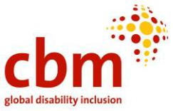
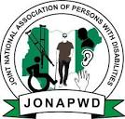
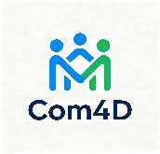
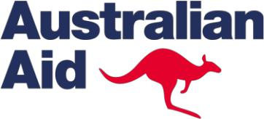

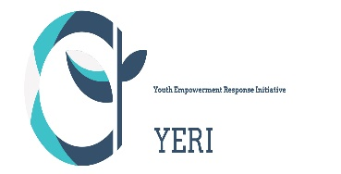

Youth Empowerment Response Initiative (YERI) and Community Partnership for Development (COMP4D) now Ajala Community Development Initiative (ACDI) Consortium, with Funding Support from Australian Aid through CBM Germany and Joint National Association of persons with disabilities (JONAPWD implemented a project on Promoting Interagency Standing Committee (IASC) guidelines for inclusive humanitarian action in Yobe state in 2023.
Purpose of Project
- To strengthening mechanisms and frameworks for the participations, coordination, promotion and protection of the rights of persons with disabilities in humanitarian actions in Yobe State.
- An attempt to stimulate evidence- based advocacy actions that are geared to address barriers to humanitarian program access/participation for people with disabilities.
Target Participants/Groups
- OPDs
- JONAPWDs members
- Government organizations (SEMA, Ministry of Humanitarian Affairs, Ministry of Youth and Social Development, Ministry of Health and Ministry of Women Affairs)
- Persons with Disabilities (Blind, Cripple, Leprosy, Deaf and Spinal cord injuries clusters) selected from across the 17 LGAs of Yobe state
- CSOs – Network of Yobe Civil Society Organizations
Disability Scorecard on Humanitarian Action
One of the program activity in the project implementation is the development of scorecard. In this regard a one-day training with 20 representatives from the organizations of persons with disabilities (OPDs) were engaged to develop disability scorecard on disaster responsiveness in Yobe state.
What Necessitated the Development of the Scorecard
The development of the IASC Disability Inclusion Scorecard under the YERI/COM4D project was necessitated by several critical gaps identified during humanitarian response in North East Nigeria, particularly in Yobe State:
- Limited Inclusion of Persons with Disabilities (PWDs): Despite the existence of the IASC Guidelines on Inclusion of Persons with Disabilities in Humanitarian Action, many humanitarian actors lacked practical tools to assess whether their interventions were truly inclusive.
- Absence of a Standardized Monitoring Tool: There was no simple, context-specific mechanism for Measuring disability inclusion across sectors (WASH, Health, Protection, Education, Food Security, etc.)
- Tracking compliance with IASC commitments at organizational and program levels
- Weak Accountability to PWDs and OPDs: Persons with disabilities and their representative organizations (OPDs) were often excluded from planning, implementation, and monitoring of humanitarian programs.
The scorecard was needed to:
- Strengthen accountability to affected populations
- Promote meaningful participation of OPDs
- Need for Evidence-Based Advocacy: OPDs required a practical tool to generate credible evidence that could be used to engage government and humanitarian actors on gaps and good practices in disability inclusion.
- Capacity Gaps Among Humanitarian Actors: Many agencies expressed willingness to include PWDs but lacked guidance on how to operationalize inclusion.
- The scorecard translated IASC principles into measurable and understandable indicators.
Testing and Use of the Scorecard
The scorecard was pilot-tested during the 2023 project implementation in selected humanitarian settings in Yobe State. OPDs, JONAPWDs members, and humanitarian actors jointly applied the tool to:
- Review projects and services
- Validate indicators against real-life experiences of PWDs
- Feedback from the testing phase was used to refine the indicators, making the scorecard practical, user-friendly, and context-appropriate.
Following the pilot:
The scorecard is still in use by some humanitarian agencies like the SEMA, Ministry of Humanitarian Affairs and state-level actors CSOs and Several OPDs continue to use it independently to monitor inclusion and engage duty bearers
Impact of the Scorecard at State Level (Yobe State)
- Improved Awareness of IASC Guidelines: State actors and humanitarian organizations now have better understanding of disability inclusion standards and their responsibilities.
- Strengthened Coordination Between Government, NGOs, and OPDs: The scorecard created a common reference point for dialogue between, State ministries and agencies, Humanitarian organizations, OPDs and disability networks e.g. Representative of PWDs in Social Protection Committee, Ministry of Humanitarian Affairs committed to create a desk office for PWDs
- Influence on Program Design and Implementation Some agencies have adjusted their interventions to Improve physical accessibility, include disability-disaggregated data e.g. 10% allocated for PWDs in every distribution of intervention in the LGAs by the state government. SEMA, Ministry of Humanitarian Affairs all compliance
- Integrate reasonable accommodation into service delivery – State university to upgrade buildings with RAMs provision, Free education for PWDs at the Yobe State University, Damaturu
- Enhanced Accountability Mechanisms: The scorecard has been used as a monitoring and self-assessment tool, encouraging agencies to review their performance against inclusion benchmarks.
Impact on Persons with Disabilities in Yobe State
- Increased Participation and Voice: Persons with disabilities, through OPDs, are now more actively involved in Project assessments. Monitoring humanitarian interventions
- Advocacy engagements with authorities and NGOs
- Improved Access to Humanitarian Services
- Yobe Disability Inclusion Working Group Platform created
- Establishment of People of Disability Commission is now a reality in Yobe State
Generally, the use of the scorecard has contributed to better consideration of:
- Accessibility of facilities
- Inclusive communication
- Targeted support for different impairment groups
- Empowerment of OPDs

